RESILIENT MALDIVES 2045: PROSPERITY FOR ALL
THE NATIONAL VISION AND DEVELOPMENT FRAMEWORK

Volume I, Section I

  - ZERO DRAFT
  - 31 January 2026

About Resilient Maldives 2025: Prosperity for All
The National Development Plan (NDP) “Resilient Maldives 2045: Prosperity for All” sets out the Maldives’ long-term development direction to 2045. It is a national-level framework designed to guide national choices over time – across political cycles, external shocks, and changing social, economic, and environmental conditions. The NDP is not a government programme or a collection of projects. It is a shared national reference that clarifies where the country is heading, why that direction has been chosen, and the principles that should guide decisions along the way.
Consultation and true representation are essential to the credibility of any Vision because it ensures the priorities reflect people’s lived realities – and not assumptions. By listening across communities, sectors, and generations, the Vision becomes a truer representation of national aspirations, challenges, and trade-offs, and establishes a basis for public trust. This process strengthens legitimacy, improves the quality of choices made, and builds shared ownership of the direction the country is taking.
This Vision was shaped through an extensive, nationwide consultation process that brought together 10,000+ voices from across the country. Engagement included ‘kurimagu sallas’ in 184 islands, meetings with 181 island and city councils, 102 focus group discussions, and 80 key informant consultations, alongside 20 expert roundtables that helped test ideas and strengthen evidence. In total, consultations covered 62 topics, supported by 24 policy and research submissions, as well as 100 children and youth submissions to ensure younger perspectives were heard. Public input was also gathered through 641 online survey responses, and the process culminated in seven visioning exercises at national forums, where themes were consolidated and validated.
The NDP provides an integrated national framework that links vision, long-term development models, strategic pillars, and enabling systems, grounded in the structural realities that shape development in the Maldives. Together, these elements articulate how economic transformation, social wellbeing, spatial development, environmental stewardship, and democratic governance must work as an interconnected system. The Plan explicitly addresses trade-offs and policy choices, clarifying not only what the Maldives seeks to pursue, but also what it will deliberately avoid in order to protect intergenerational equity, resilience, and national sovereignty.
This document is structured to serve multiple functions. It offers a common strategic reference for public policy, investment, and reform; a coherence framework for sector strategies, spatial plans, and five-year plans; and a transparency tool for citizens, clarifying the long-term logic behind national decisions. While it sets clear outcomes and system directions, it intentionally avoids prescribing detailed projects or timelines at this stage.
The National Development Plan is structured in two volumes. Volume I sets out the National Vision and Development Framework under Section I, including the strategic diagnosis, long-term development models, pillars, and enablers. Section II of Volume I will present the Implementation Plan, Monitoring and Evaluation Framework, and Financing Plan, developed as complementary but distinct instruments. Volume II comprises the Analytical Foundations and Technical Papers, providing the supporting analysis and evidence base. This structure safeguards the stability of long-term national direction, while enabling implementation to remain adaptive to evidence, institutional capacity, and changing conditions.
Taken together, the NDP establishes a disciplined, long-term approach to development – one that seeks to secure prosperity, resilience, and dignity for all Maldivians, across all islands and generations.

Table of Contents
Part A – National Intent and Strategic Frame 2
National Vision and Purpose 3
2. Why Long-Term Planning Matters for Maldives 9
Part B – Strategic Diagnosis 19
3. Where Maldives Stands Today 20
4. Future Risks, Trends, and Opportunities 31
Part C – The Long-Term Development Model 37
5. Maldives' Chosen Development Model 38
6. National Spatial Development Framework 52
Part D – Strategic Pillars 59
7. Pillar I: National Identity, Values and Culture 60
8. Pillar II: A Resilient, Productive, and Inclusive Economy 69
9. Pillar III: People, Well-being, and Social Systems 80
10.Pillar IV: Climate Resilience and Environmental Stewardship 89
11.Pillar V: Democratic Governance, Statehood, and Public Trust 96
Part E – Enablers and Systems 103
12.E1: Infrastructure Systems and National Connectivity 104
13.E2: State Capacity, Public Service, and Delivery Capacity 110
14.E3: Digital Public Systems and Trust Infrastructure 116
15.E4: Innovation, Research, and Knowledge Systems 122
16.E5: Macro-Fiscal Stability, Public Investment, and Financing Systems 128
17.E6: Legal, Regulatory, and Policy Coherence 134
18.E7: Implementation, Risk Management, and Adaptive Delivery 140
Concluding Statement: A Living National Framework to 2045 146
Annex I: Illustrative Regional Governance Model for Coordinated Development 148
Annex II: Spatial Reference for Policy Alignment with the National Urban Policy (Non-Exhaustive) 152

Table of Figures
Figure 1 - Vision for Maldives in 2045 3
Figure 2 - Structural Realities of Maldives' Future 10
Figure 3 - Maldives' Development Challenges 15
Figure 4 - Economic Structure and Productivity 22
Figure 5 - Labour Markets and Human Capital 23
Figure 6 - Public Finance, Debt, and Fiscal Space 25
Figure 7 - Access, Infrastructure, and Connectivity in Maldives 26
Figure 8 - Climate Resilience in Maldives 28
Figure 9 - Governance and Institutional Capacity 29
Figure 10 - Maldives' Future Risks, Trends, and Opportunities 31
Figure 11 - The Economic Development Model 38
Figure 12 - Social and Human Development Model 41
Figure 13 - Spatial Development Model 43
Figure 14 - Environment and Climate Model 45
Figure 15 - Governance and Institutional Model 47
Figure 16 - Key Strategic Trade-offs and Policy Choices 51
Figure 17 - The Archipelagic Settlement System 54
Figure 18 - Principles Guiding Spatial Development 58
Figure 19 - Pillar I: National Identity, Values and Culture 60
Figure 20 - Pillar II: A Resilient, Productive, and Inclusive Economy 69
Figure 21 - Effective Resource Allocation and Factor Productivity Core Framework Components 77
Figure 22 - Pillar III: People, Well-being, and Social Systems 80
Figure 23 - Pillar IV: Climate Resilience and Environmental Stewardship 89
Figure 24 - Pillar V: Democratic Governance, Statehood, and Public Trust 96
Figure 25 - E1: Infrastructure Systems and National Connectivity 104
Figure 26 - E2: State Capacity, Public Service, and Delivery Capacity 110
Figure 27 - E3: Digital Public Systems and Trust Infrastructure 116
Figure 28 - E4: Innovation, Research, and Knowledge Systems 122
Figure 29 - E5: Macro-Fiscal Stability, Public Investment, and Financing Systems 128
Figure 30 - E6: Legal, Regulatory, and Policy Coherence 134
Figure 31 - E7: Implementation, Risk Management, and Adaptive Delivery 140

Part A – National Intent and Strategic Frame

National Vision and Purpose

Vision for Maldives in 2045
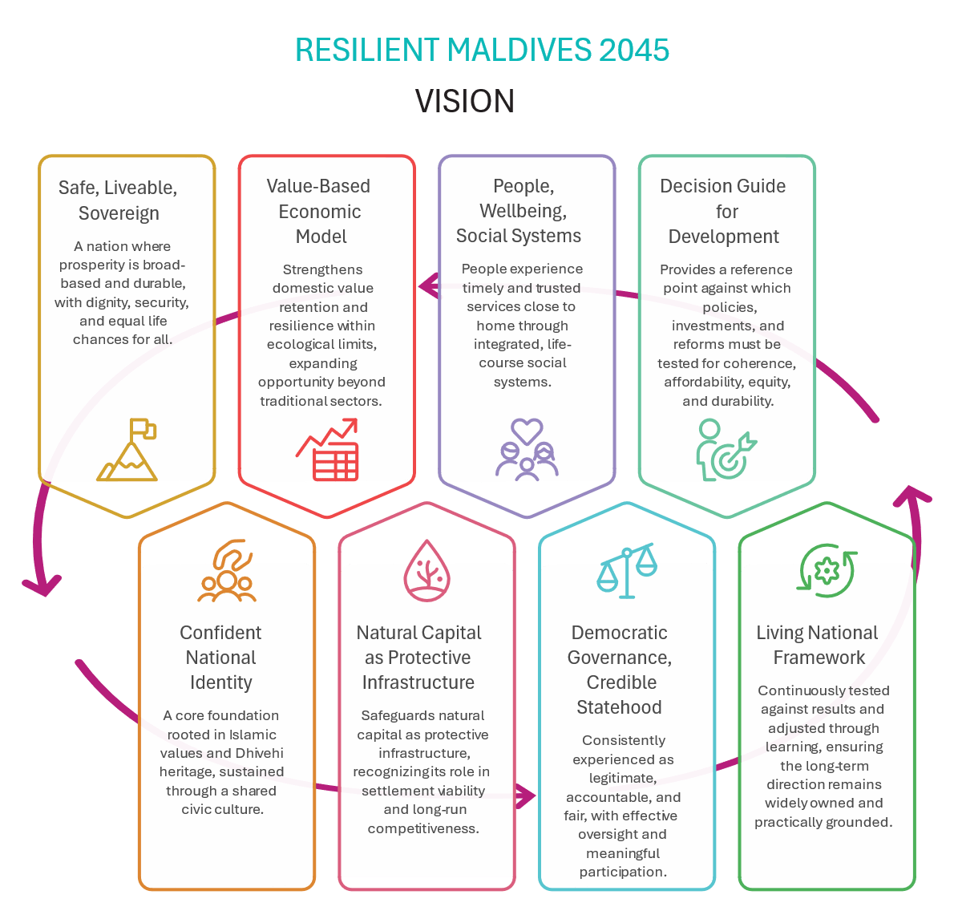
Figure 1 - Vision for Maldives in 2045
The Maldives’ long-term future depends on a clear and shared national destination – one capable of unifying citizens, institutions, and decision-makers across political cycles, and durable enough to guide choices under uncertainty. Resilient Maldives 2045: Prosperity for All sets that destination. It is grounded in the structural realities that define Maldivian development: a dispersed archipelago with high costs of access and service delivery; a small, open economy exposed to external shocks and import dependence; an environment that is not a sector but a condition of survival; rapid urban and demographic transitions; a society navigating complex changes and tensions in a still-young democracy; and governance and fiscal constraints that shape what can be sustained over time. The vision is therefore not an abstract aspiration detached from constraint. It is a commitment to pursue prosperity in a way the nation can afford, deliver, and uphold – across all islands and generations.
A core foundation of Resilient Maldives 2045 is a confident national identity rooted in Islamic values and Dhivehi heritage, sustained through a shared civic culture that is lived across all islands. By 2045, continuity in Islam, language, culture, and heritage will be protected within development choices so that they do not erode the relations, spaces, practices, and institutions through which identity is transmitted across generations. Dhivehi will remain a shared medium in education, public life, and service access, reducing exclusion and strengthening cohesion, while heritage places, cultural landscapes, and living traditions are safeguarded as national assets. These foundations are reinforced through core national values – continuity, respect, equity, participation, sustainability, democracy, and accountability – so that development is experienced as fair, inclusive, and principled, and so that shared belonging and social cohesion remain resilient under economic, technological, and environmental change. This focus does not mean an isolationist approach that spurns other cultures, but rather a joyous, confident, and respectful sharing of ‘Maldivianness’ on the global stage.
Prosperity will be built through a value-based, productivity-led economic model that strengthens domestic value retention and resilience within ecological limits. By 2045, Maldives will be a securely high-income country with broad-based national prosperity, where sustained economic growth translates into rising real incomes, more equitable wealth distribution for Maldivians, and economic security across regions and generations. Tourism will remain a global anchor but evolve as a high-value, sustainable visitor economy with deeper local supply chains and significantly higher Maldivian participation in ownership, management, and skilled roles. Fisheries and ocean resources will be managed as long-term national assets, shifting toward value addition, traceability, and sustainable market positioning. Food systems will reduce vulnerability through targeted climate-smart production linked to domestic demand. Emerging strategic activities – digital and creative services, selective innovation industries, and climate- and ocean-related research partnerships – will expand opportunity beyond traditional sectors, guided by feasibility, capability, and resilience contribution. This prosperity will be built within the remaining demographic window, ensuring the economy is structurally prepared to support an ageing population beyond 2045 through higher productivity, stronger savings, and durable fiscal and institutional foundations. It will be protected by disciplined macro-fiscal management and credible public investment: growth will not be pursued through debt-fuelled expansion that transfers hidden costs to future generations or undermines national autonomy.
Resilience will be treated as a national system condition. The Maldives will pursue development pathways that safeguard natural capital as protective infrastructure, recognising that reefs, mangroves, wetlands, and freshwater lenses underpin settlement viability, livelihoods, and long-run competitiveness. Climate resilience will be embedded in spatial planning, infrastructure standards, public investment decisions, and service continuity planning, with adaptation pathways guided by evidence, risk thresholds, and long-term habitability considerations. Environmental stewardship will not be approached as a residual constraint but as a core development discipline: the Maldives will not degrade natural ecosystems beyond ecological limits and will avoid maladaptive investments that lock the country into high-cost loss-and-rebuild cycles.
This vision is equally a commitment to people, wellbeing, and social systems as the foundation of national strength. By 2045, Maldivians will experience timely and trusted services close to home through integrated, life-course social systems. Health, education, skills, housing, protection, and inclusion are designed to work together rather than in silos. Quality will matter as much as coverage: the aim is reliable services, safe and cohesive communities, protection from violence and harm, and pathways for young people to transition into decent work and leadership. Equal participation by women and men, a vibrant civil society and the inclusion of vulnerable and marginalised groups, will be treated as development essentials rather than add-ons because a small island state cannot afford to waste talent, weaken cohesion, or tolerate avoidable exclusion.
The vision depends on democratic governance, credible statehood, and public trust as enduring foundations. By 2045, governance in the Maldives will be consistently experienced as legitimate, accountable, and fair: laws applied predictably, rights protected in practice, oversight institutions effective, political culture integrity-driven, and participation meaningful beyond electoral cycles. The state will be capable, disciplined, and coherent in delivery, not only focused on administrative expansion but on execution quality, integrity, and measurable outcomes across the archipelago. Digitalisation will serve inclusion and trust: interoperable public systems, secure data governance, and safeguards against misuse, bias, and disinformation will protect civic space and institutional legitimacy as technology transforms society.
This vision is intended to function as a decision guide for national development. It provides the reference point against which policies, investments, and reforms must be tested for coherence, affordability, equity, and durability. It clarifies the long-term model the Maldives is choosing and the paths it will deliberately avoid: volume-led growth as the dominant strategy; debt-driven expansion that compromises intergenerational fiscal stability; development that destroys natural capital and future habitability; uniform replication of services and infrastructure that is fiscally and operationally unsustainable; and state-led commercial expansion that weakens competition and productivity discipline. In doing so, it turns unavoidable trade-offs into transparent choices anchored in the long-term national interest.
The vision is designed as a living national framework that is continuously tested against results and adjusted through learning. Monitoring, evaluation, and adaptive delivery will be core state functions: progress will be tracked through outcomes, service quality, access equity, fiscal resilience, environmental thresholds, and public trust indicators. The NDP will remain open to refinement through sustained consultation with citizens, local councils, civil society, business, and sector experts, ensuring that the long-term direction remains widely owned and practically grounded. Through this approach, the Maldives commits to a national pathway that is not only ambitious, but credible: a future where prosperity is shared, resilience is built into the nation’s systems, and the country’s identity, sovereignty, and wellbeing endure across generations.

Core National Values and Principles
The NDP is founded on the following core values and principles. The core values are captured by the key terms and demonstrate what matters to Maldivians in national development. The principles indicate the accompanying action that would bring each core value into existence within the development process.
- Continuity
Protecting Islamic faith, sovereignty, Dhivehi culture, language, heritage, and environment.
- Respect
Instilling shared civic values that promote peace and social cohesion.
- Equity
Ensuring fairness, dignity, inclusion and non-discrimination across people and islands.
- Participation
Enabling citizens and communities to actively contribute and shape development.
- Sustainability
Implementing resilient development and environmental stewardship.
- Democracy
Actuating democratic legitimacy, equal rule of law and justice for everyone.
- Accountability
Executing evidence-based, transparent, and ethical governance with culture of integrity.
When values appear to be in conflict, the principles are a good measure of priority. Consideration of the principles can signal sequencing, the need for precaution or doing no harm, and protecting the best interests of those who are more vulnerable.

Intergenerational Equity and National Responsibility
Intergenerational equity matters critically to the Maldives: especially because development decisions can easily damage fragile ecosystems of the Maldives and do so in a context of intensifying climate risks. As a national responsibility to current and future generations, commitment to intergenerational equity ensures fair distributions of resources, opportunities, and burdens over time.
Development decisions today will determine whether future Maldivians inherit: a liveable territory; a safe and secure community; viable livelihoods and a fiscally sustainable state. The current Constitution fully and explicitly recognises the national duty to protect the environment and its diversity, yet the duty not to burden future generations with long-term fiscal debt is understated.
Intergenerational equity is ensured through the conservation of options, quality, and access for current and future generations. It covers natural resources and biodiversity, climate and the atmosphere, wellbeing, economic and fiscal stability, cultural and technical legacy, use of non-renewable natural resources – such as sand or the freshwater lens in the Maldives – and toxic waste and other practices that impose long-term harms on people and environment.
Ensuring intergenerational equity is a national responsibility that runs through the State, society, and individuals with differentiated responsibilities over time. The National Development Plan is committed to intergenerational equity through its approach and its focus on sustainability and resilience.

Alignment with Constitution and National Aspirations
Alignment with the Constitution is essential to the NDP’s legitimacy and durability as a long-term State framework. The vision, core national values and principles, and the constituent elements of this framework are designed to sit within – not above – the constitutional order, including the protection of rights, the rule of law, and the separation of powers. It also reflects national aspirations that have been expressed through the NDP consultations process and over decades through Maldivian development planning: a safe, dignified, and prosperous society sustained by justice, inclusion, and environmental stewardship across all islands.
As the NDP is legislated, implementation arrangements must therefore strengthen continuity without weakening constitutional safeguards. Existing checks and balances, meaningful pathways for public participation, and the broader rights framework must be preserved in both design and practice. Any constitutional amendments or enabling regulations associated with the NDP should not concentrate national planning powers, but rather establish clear coordination rules, roles, and accountability across relevant agencies, independent institutions, local councils, and stakeholders, so that long-term planning is enabled through facilitation and coherence rather than centralisation.

Why Long-Term Planning Matters for Maldives

The Case for a 20-Year Planning Horizon
A 20-year planning horizon matters for the Maldives because the country’s most critical development levers operate on long time cycles, not short political or budgetary terms. The country’s geography, climate exposure, demographic transition, and economic structure shape opportunity, cost, and risk over decades rather than years. Decisions taken today – particularly in relation to infrastructure, settlement patterns, public finance, human capital, and natural resource use – are path-dependent and create locked-in effects that are difficult and costly to reverse.
Long-term national development planning allows the State to confront these realities explicitly. It provides a framework to manage trade-offs, sequence difficult choices, and align near-term actions with long-term viability. Without such a horizon, development risks becoming reactive and fragmented, with the effects of short-term responses compounding into structural vulnerabilities.
The National Development Plan therefore serves not as a prediction of the future, but as a disciplined approach to navigating uncertainty. It establishes a shared national reference point against which public decisions can be assessed for coherence, affordability, and durability.

Structural Realities Shaping Maldives’ Future
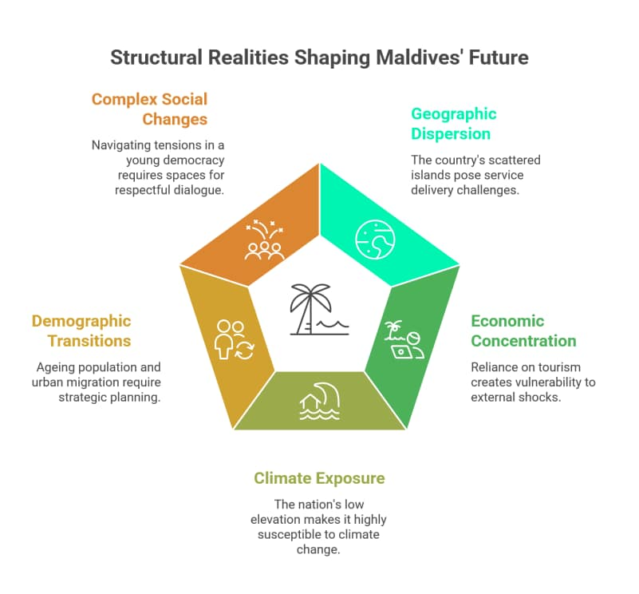
Figure 2 - Structural Realities of Maldives' Future

Geographic Dispersion and Service Delivery
Geography is the Maldives’ defining planning constraint: this is a country with a land mass of 298km² dispersed across roughly 90,000km² of ocean with a small population spread across 184 inhabited islands. There is limited local and inter-regional linkages and an economy base primarily constituted of separate resort and industrial islands. Movement patterns are strongly oriented toward the well-developed capital region. This spatial structure places travel time and cost burdens on households outside the main centre and reinforces dependence on Malé for higher-tier services and opportunities.
Dispersion also creates a structural mismatch between citizen expectations of public services and the economics of delivering them by raising the marginal cost of almost all – if not every – service provision. Many of the inhabited islands fall below population thresholds typically required to sustain consistently staffed and funded quality social infrastructure. Census data indicate that a majority of islands have populations below 1,000, while only a small number reach sizes that can independently support higher-order services. Dispersion also amplifies vulnerability in emergencies, requiring national-level responses to localised events.
Service delivery therefore fundamentally requires a catchment-based systems design. Access must be achieved through shared service areas, stronger inter-island mobility performance, and hybrid delivery models. Geography forces the Maldives to choose a service model that the country can afford and to build the infrastructure and institutions that can run it reliably for decades.

Economic Concentration and Vulnerability
The Maldivian economy is highly concentrated in a narrow set of activities, with tourism at its core. This concentration has delivered significant prosperity – accounting for a large share of GDP, foreign exchange earnings, fiscal revenues, and employment, and supported by strong linkages to construction, transport, trade, and services. At the same time, it creates structural fragilities. Long-term planning must therefore address three interlinked vulnerabilities arising from this economic concentration.
First, concentration amplifies the transmission channels of external shocks. Shocks to international travel, fuel prices, global income, or geopolitical stability are rapidly reflected in foreign exchange inflows, fiscal balances, and import capacity. The COVID-19 pandemic illustrated how quickly these channels can destabilise macroeconomic conditions in a small, open import-dependent island economy with limited buffers. Concentration also heightens fiscal vulnerability, where downturns rapidly drain reserves and widen deficits. Reducing this vulnerability requires credible fiscal reforms, connecting economic strategy to fiscal rules, subsidy reform, SOE governance, and investment prioritisation. Third, concentration produces its own reinforcing dynamic – especially when spillover value is weak and infrastructure to support advancement in other sectors remain limited. Other productive sectors in the Maldives continue to be under-scaled relative to their strategic importance.
Managing these concentration risks requires a long-term systematic and evidence-based approach to economic planning and resource allocation, with a focus on vulnerability reduction and actualisation of resilient growth, employment, and public finances.

Climate and Environmental Exposure
The climate and environment are structural conditions of survival and economic viability for the Maldives – not just sectors. With more than 80 percent of the land less than one metre above sea level and over 99 percent of national territory comprising ocean, the country exists at the physical intersection of marine and atmospheric systems where climate variability translates directly into risk.
Natural ecosystems function as critical infrastructure. Coral reefs, mangroves, wetlands, and freshwater lenses protect coastlines, regulate climate impacts, support livelihoods, safeguard health, housing, and infrastructure, and underpin tourism and fisheries. Environmental degradation therefore directly undermines economic performance, people’s wellbeing, and settlement viability. Degradation of the environment from any development initiative adds to the existing vulnerabilities of climate impacts.
Climate-sensitive events require government assistance every year: the frequency and intensity of which are expected to increase as climate impacts worsen. Maldives’ dispersed geography scales up the fiscal and logistical burdens of these events, with each island a separate site needing protection, response capacity, and infrastructure maintenance. Disaster response and climate adaptation costs can worsen debt dynamics unless climate finance is built into a long-run strategy.
The Maldives must invest heavily to protect people and assets from climate and environmental exposure, yet these investments must also avoid undermining or destroying the natural ecosystems that provide protection and sustainability. The structural nature of climate change and environmental exposure places hard constraints on development pathways. Hence, our development initiatives must avoid adding pressures on the already vulnerable ecosystems. Once ecological thresholds are crossed, restoration may be impossibly costly or even irreversible. Under these conditions, thoughtful choices in long-term development are a necessity to manage risk, affordability, and intergenerational equity.

Demographic and Urban Transitions
The Maldives is undergoing rapid demographic and urban transitions. While the country currently benefits from a demographic dividend, projections indicate a rapidly ageing population with longevity gains, lower fertility and changing dependency patterns. These shifts place pressure on labour markets, social protection systems, and public finances to redesign development priorities. Lower fertility eases demand on housing, schooling and infrastructure and opens space to proactively manage the burdens of productivity, pensions, long-term care, and chronic disease linked to ageing populations over the next decades. Beyond that horizon however, a sustainable higher-value economy can help people in the Maldives enjoy higher productivity, a stable population, and more equitable outcomes.
Internal migration continues to concentrate urban population and economic activity in the Greater Malé Region. Overcrowding, service strain, and land scarcity in the capital coexist with declining populations and service viability challenges in many outer atolls.
Demographic changes also include a rising foreign migrant workforce to meet the needs of Maldives’ growing economy. This call for changes to the planning baseline for providing services and utilities, managing social dynamics and strengthening labour regulation to protect both migrant and Maldivian workforces.
Managing demographic and urban transitions therefore requires acknowledging the structural relationships between population distribution, service viability, and economic opportunity, and making concordant long-term plans with foresight.

Complex Social Changes and Rising Tensions
Rising pressures on quality of life across islands are creating social conditions that strain everyday wellbeing and resilience. Stress and frustration leave less space to sustain the relationships that help people and communities navigate routine inconveniences, disagreements, and conflict. These relationships – rooted in connection, empathy and tolerance – have traditionally acted as the social “oil” that enables communities to function smoothly; when they weaken, frictions are more likely to escalate and grievances can spread more quickly.
These dynamics are compounded by an adversarial political culture that is often divisive and disrespectful, characterised by personalised attacks and misrepresentation, and the sensationalisation of issues. This conduct undermines the quality of public debate and corrodes public trust, even as citizens remain committed to representation and participation in governance and continue to see democracy as the pathway for that voice to be exercised. Politics sits between civil society and governance, shaping how the power of the state is granted by the people at elections, then exercised responsibly and used to represent diverse interests fairly in line with the constitution and law.
Sustaining progress therefore requires deliberate investment in dialogue that can bridge divides and manage disagreement without fracture. Respectful engagement and integrity in public and political conduct are essential conditions for producing cohesion and mutual support, and for preserving trust and problem-solving capacity across political cycles that long-term development choices depend on to be made, contested, and upheld over time.

Core Development Trade-offs and Paradoxes
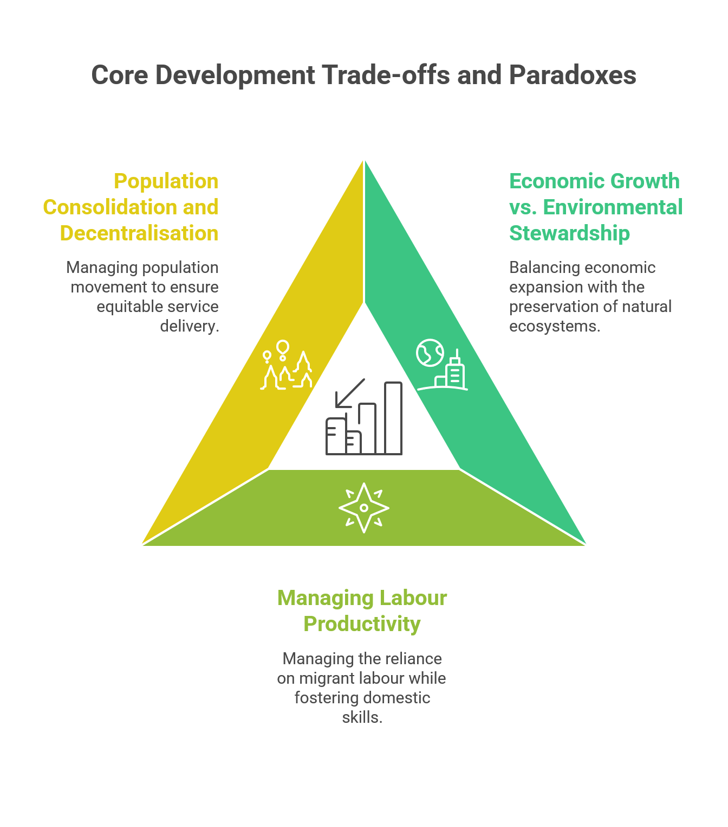
Figure 3 - Maldives' Development Challenges

Balancing Economic Growth and Environmental Stewardship
Economic growth in Maldives is closely tied to the use of land, lagoons, reefs, and coastal systems. Large-scale investments in housing, transport, tourism, and infrastructure often require physical transformation of natural environments, including reclamation, dredging, and habitat modification. These activities generate economic returns and service capacity, but they also alter ecosystems that communities value for cultural, livelihood, and ecological reasons.
Public consultations reveal a deep and persistent tension in how Maldivians view development and environmental protection. Many citizens – particularly younger generations – express a strong desire to preserve the “island character” of their communities, including natural coastlines, lagoons, and living spaces that define island life. At the same time, there is widespread demand for improved services, connectivity, housing, and economic opportunity, which in practice require land, infrastructure, and scale.
These expectations coexist with competing perspectives on cost and constraint. Some view environmental protection as imposing limits on development and raising costs, while others see environmental degradation as eroding long-term livelihoods, national competitiveness and the natural protections that safeguard the nation against climate risks. Similar paradoxes arise in the use of marine resources where pressures to maximise short-term economic activity can undermine the ecological systems that sustain fisheries and tourism over time.
For a small island nation with finite land and fragile ecosystems, it is not possible to fully preserve all natural spaces while simultaneously expanding infrastructure and services everywhere. Choices about land use, marine protection, and environmental thresholds therefore involve trade-offs that cannot be avoided through technical solutions alone. Balancing growth and stewardship require long-term planning that changes this core paradox from unmanaged implicit tension into an articulated and transparently governed strategy.

Economic Growth, Labour Productivity and Migrant Workforce Dependence
Economic growth in Maldives has been supported by a labour-intensive model, particularly in tourism, construction, and services. While this model has enabled rapid expansion, it has also shaped the structure of labour demand, favouring scale and availability over productivity gains. As a result, output growth has relied more on increases in labour input than on efficiency improvements.
Within this context, Maldives faces an inherent demographic constraint. As a small population economy, the absolute size of the domestic labour force is limited. Even under conditions of higher labour force participation, improved skills alignment, and reduced unemployment, the supply of local labour is unlikely to be sufficient to meet the demands of sustained economic expansion across multiple sectors. As economic activity expands, particularly in sectors with continuous or seasonal labour needs, labour demand can outpace the growth of the domestic workforce.
While the unemployment rate in the Maldivian workforce is low, labour underutilisation is a persistent concern with high levels of youth unemployment, NEET youth, and available potential jobseekers. Strengthening labour participation of young Maldivians through developing competencies, clear school-to-work pathways and job matching is critical to improving domestic workforce productivity.
Managing this paradox is therefore not a question of eliminating migrant labour, but of balancing productivity growth, skills development, labour participation and protection of rights within the Maldivian and migrant workforces. How this balance is achieved has implications for income growth, social cohesion, fiscal sustainability, and long-term competitiveness, making it a central structural consideration for national development planning.

Population Consolidation and Equitable Decentralised Development
The Maldives confronts a spatial planning paradox that is at the heart of long-term development: its dispersed island geography has long shaped the cost and feasibility of equitable service provision and constrained the potential for equitable economic growth. Delivering consistent public services, infrastructure, and economic opportunities across many small and remote islands has proven structurally expensive, particularly where population size and accessibility fall below thresholds required for viability. Over time, this has created strong incentives for internal migration toward the capital and its surrounding areas.
Population movement toward Malé is a rational response to the disproportionate distribution of service access, employment opportunities, and connectivity. The cumulative effect, across multiple political cycles, has been extreme concentration in the capital region – resulting in one of the most densely populated urban areas globally – alongside population decline in many outer islands.
This dynamic reinforces a negative feedback loop. As populations shrink in smaller islands, the per-capita cost of maintaining infrastructure and services increases, while local economic activity becomes harder to sustain and economic fragility increases. Efforts to replicate full-service provision on every island, regardless of scale or accessibility, risk fiscal strain, infrastructure duplication, and uneven service quality, without reversing underlying migration pressures or redressing the deep existing inequities. This is counterproductive and futile.
Equitable decentralised development requires a more precise reframing of how equity is understood in a geographically dispersed nation. Rather than equating equity with identical services in every location, long-term planning must balance consolidation and decentralisation in ways that preserve access, dignity, and opportunity while remaining fiscally and operationally viable. This implies the need for regional approaches that align settlement patterns, service delivery, and economic activity across connected islands, recognising that sustainable equitable development lies between full centralisation and full island-level duplication.

The NDP as a State Function, Not a Government Programme
Given these structural realities and trade-offs, the National Development Plan is framed as a core function of the State rather than a time-bound government programme. Its purpose is to provide continuity across political cycles, align public action around shared long-term objectives, and ensure that short-term decisions are evaluated against their long-term consequences.
Development outcomes emerge from the interaction of economic, social, spatial, fiscal, and environmental systems over time. A long-term plan provides the discipline required to manage these interactions coherently under conditions of uncertainty.
The NDP does not replace democratic choice or sectoral policy. It provides a shared framework within which choices can be made more transparently, consistently, and sustainably.

Chapter Conclusion
This chapter establishes why long-term, disciplined national planning is necessary for the Maldives. The structural realities and trade-offs outlined here frame the context for the strategic diagnosis that follows, which examines current conditions and emerging pressures shaping the country’s development path.

Part B – Strategic Diagnosis

Where Maldives Stands Today

Population, Demography, and Settlement Patterns
Maldives’ baseline geography creates a development condition that is deeply structural: the population is distributed across many inhabited islands over long distances of ocean, while higher-order services, job density, and movement demand concentrate toward the Greater Malé Region, making it one of the densest cities in the world and straining the capital region’s liveability and infrastructure capacity. This concentration is not just an urban planning issue; it shapes equity, fiscal cost, service reliability, labour mobility, and the feasibility of decentralised development across the country.
Demography provides opportunity and adds urgency. Nearly two-thirds of the population is under 35, representing the continued demographic dividend that the Maldives can capitalise on in order to prepare for an ageing population beyond 2045. Meanwhile, the investments in health and education have laid the groundwork for the current and emergent workforce to drive the transition towards higher productivity under strategic human capital development. Women represent an untapped potential labour-force, with high level of education but not in work. At the same time, the population aged 35 and under are entering adulthood amid housing and employment pressures that are spatially concentrated, while public systems remain thinly stretched across a large number of inhabited islands. The combined implication is clear: settlement dynamics cannot rely on a single-centre trajectory. A polycentric national model must be made feasible in daily life through service-capable hubs, reliable access systems, and differentiated pathways for smaller and more isolated islands.
Baseline logic therefore points to a practical settlement challenge: the country has high “basic service coverage” of islands, but the conditions for stable livelihoods and reliable higher-order services are uneven. The binding issue is not whether people value island life – it is whether the national system makes dignified, service-secure life viable across different settlement types without forcing migration as the default solution.

Rights, Well-being & Social Outcomes
For an upper-middle-income small island state with significant geospatial constraints, Maldives has achieved notable human development outcomes in health and education. However, headline indicators coexist with quality gaps, affordability pressures, and inequalities across geography and population groups. The baseline therefore needs to be held in two frames at once: achievements that reflect decades of investment, and divergence that signals stress points for the next development phase.
A closer scrutiny highlights that national averages mask uneven service quality and unequal lived experience. When adjusted for inequality, human development outcomes fall sharply, signalling that gains are not experienced evenly across communities or population groups. Inequalities between Malé and the atolls, and across smaller and more remote islands, are high, with multidimensional deprivation concentrated outside the Malé region. Inequitable social outcomes related to gender, disability and other marginalised groups persist. Variations in quality, reliability, inclusivity, and affordability – not merely coverage – increasingly define whether rights and wellbeing are realised in practice.
These pressures have contributed to the entrenchment of deep social concerns: loss of community cohesion, high rates of substance abuse and of gender-based and sexual violence, and increased rates in crime and violence. Effective intervention requires a life-course transitions approach that support people from early childhood onwards and help them avoid “falling through the cracks” during key transitional periods.
Efficacy in social support and protection is similarly central: even with substantial social protection spending, gaps in targeting, fragmentation across agencies, and siloed delivery can leave some groups underserved. When systems are stretched and geography raises delivery costs, the credibility of social protection depends not just on budget size but on coherence, reliability, and the time-critical ability to reach people where they live at the time of their need.
A rights-based framing remains foundational to the national baseline. Maldives has a constitutional framework with broad rights and entitlements. Yet the scope and protection of some rights – especially those relating to expression, civic space, and institutional accountability – can fluctuate across political contexts and are weakened through enforcement and accountability gaps. A rights-based approach underpins legitimacy, protects citizens and residents, and provides the trust conditions required for long-term development choices that involve trade-offs.

Economic Structure and Productivity
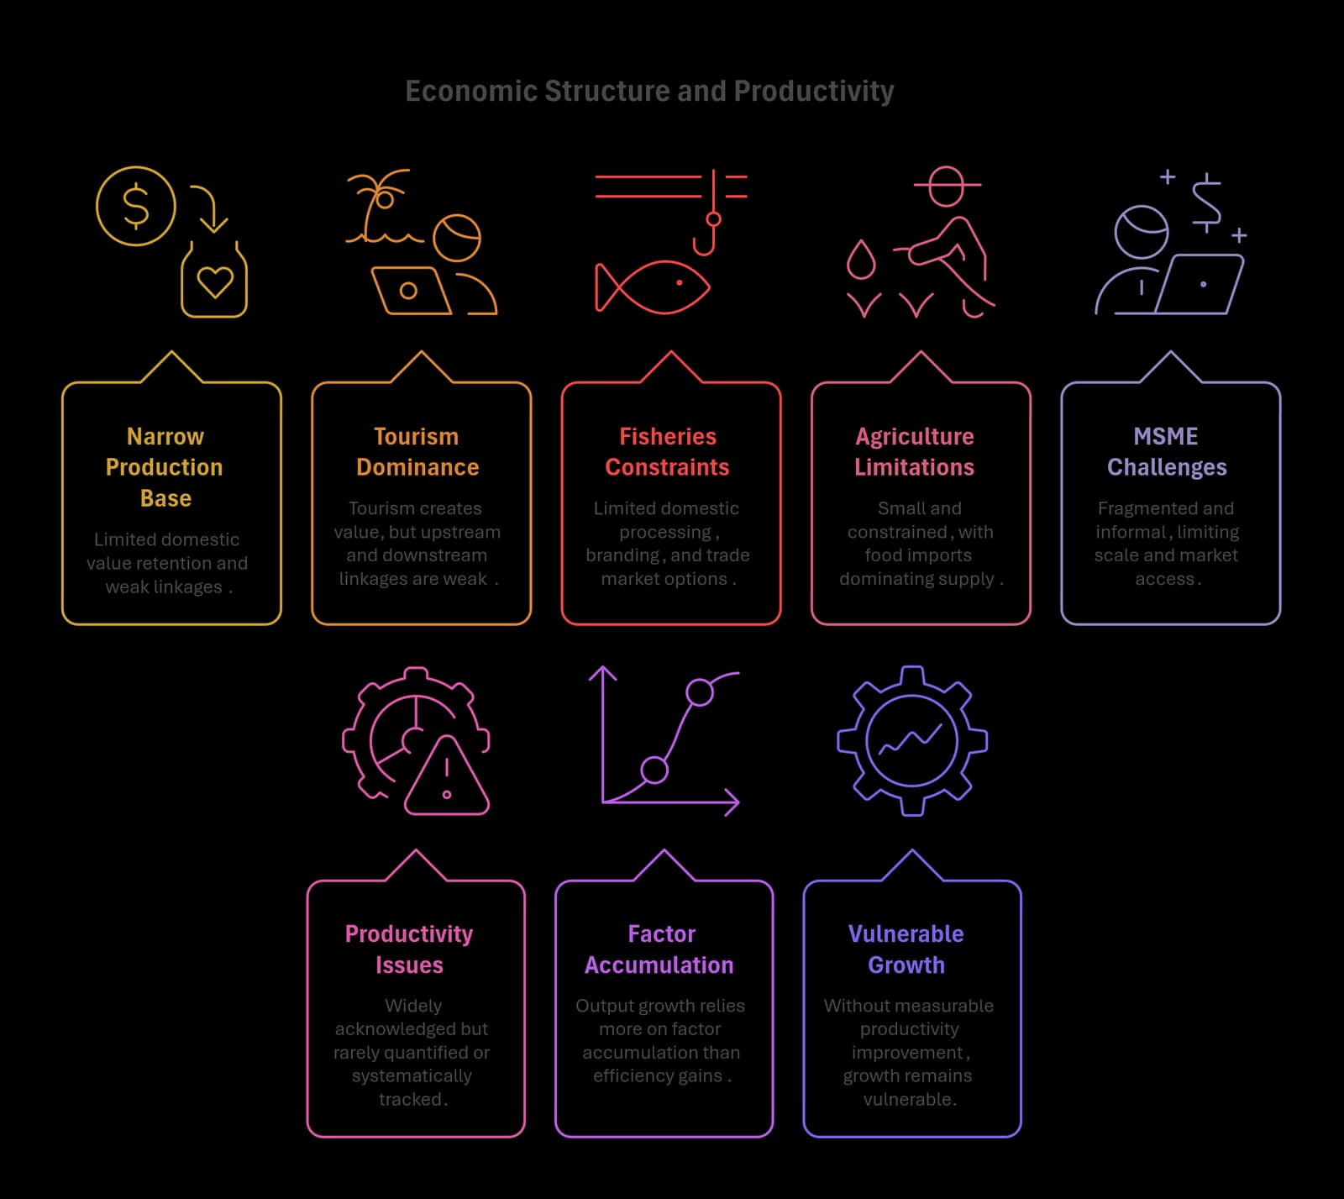
Figure 4 - Economic Structure and Productivity
The Maldivian economy is characterised by a narrow production base and limited domestic value retention. Tourism dominates value creation, yet upstream and downstream linkages remain weak, and a significant share of inputs – including food, construction materials, energy, and capital equipment – are imported. This structure creates persistent leakage of value abroad and ties growth to external exposure.
Fisheries remain strategically important but constrained in value capture, with limits in domestic processing, branding, trade market options, and downstream activity. Agriculture remains small and constrained, while food imports dominate supply even for products with potential local substitutability. MSMEs constitute the majority of firms yet are often fragmented and informal, thereby limiting scale, market access, finance, and technology uptake. These features reduce productivity gains and constrain income growth without increasing vulnerability.
Across sectors, productivity challenges are widely acknowledged but rarely quantified, benchmarked, or systematically tracked. The result is wide dispersion across firms, with a long tail of low-productivity activity. Output growth has relied more on factor accumulation than efficiency gains, while weak inter-sectoral linkages, informality, and limited capital deepening constrain the economy’s capacity to generate higher incomes and sustain growth without raising external risk.
This baseline matters because productivity is not a sector issue; within the broader context of geospatial structural limits, it is a system condition shaped by market structure, incentives, skills, technology adoption, logistics, and governance quality. Without a shift toward measurable productivity improvement and higher domestic value retention, growth remains vulnerable to shocks and weak at translating into broad-based prosperity.

Labour Markets and Human Capital
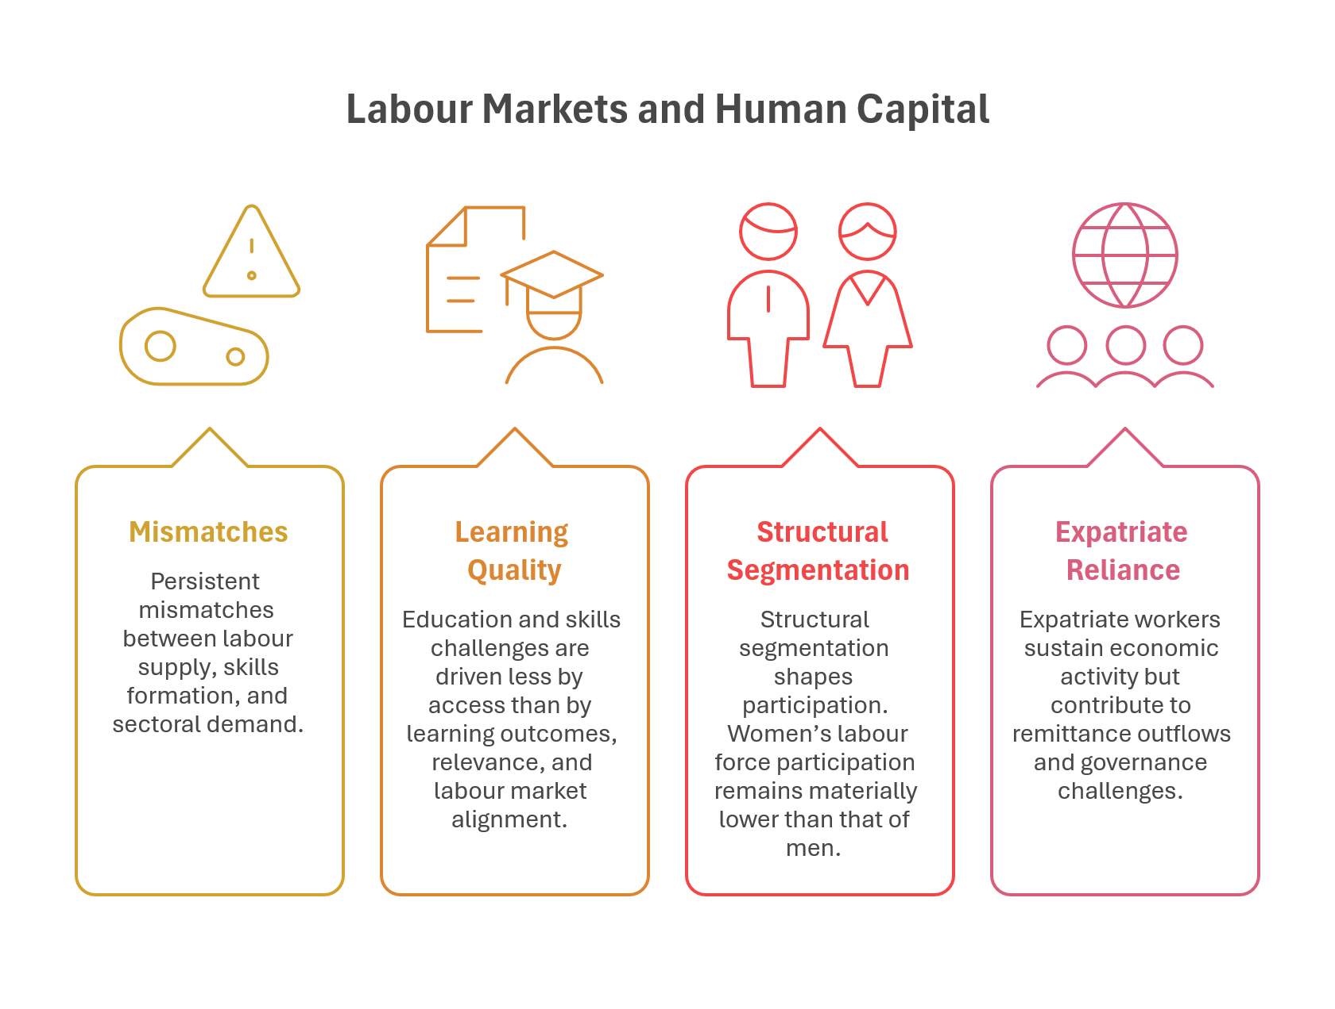
Figure 5 - Labour Markets and Human Capital
Labour market outcomes reflect persistent mismatches between labour supply, skills formation, and sectoral demand. Key growth sectors report recurring shortages of skilled and semi-skilled workers, while domestic participation in technical and productivity-enhancing roles remains limited. Employment growth has not consistently translated into higher productivity or improved job quality, with many roles offering limited progression and modest wage growth.
Education and skills formation challenges are not only about access; they are also about quality and alignment. While children can expect 12.4 years of schooling, learning-quality adjustment reduces this to 8.17 years – a gap that signals constraints in learning outcomes, performance in higher education and TVET, and later employability. This “hidden” quality gap can translate into frustration when young people compete in crowded labour markets but lack the competencies that employers and investors reward.
Structural segmentation shapes participation. Women’s labour force participation remains materially lower than that of men, limiting inclusive growth and labour supply expansion. They represent the largest untapped productivity and labour supply gains. Men’s underperformance in educational outcomes impede their chances of becoming competitive in high-productivity crowded labour markets. Informality is also substantial, and data gaps constrain analysis of mobility, productivity, and skills evolution. High youth unemployment and a significant share of young people not in education, employment, or training remain a concern. These reflect underutilisation of domestic human capital and weak incentives for firms to invest in training, mentoring, technology, and organisational upgrading. This weakens labour market integrity and long-run capability development.
Expatriate workers play a central role across the economy and is expected to continue to do so in the growing economy. Nonetheless, remittance outflows represent a persistent leakage from the domestic economy and migration flows have expanded in response to immediate labour demand within a system marked by enforcement gaps and limited coordination, resulting in situations of migrant exploitation, trafficking, and undocumented workers.
This baseline frames human capital as a binding constraint because quality, incentives, segmentation, and alignment prevent labour and skills from converting into productivity, decent work, and household resilience across the archipelago.

Public Finance, Debt, and Fiscal Space
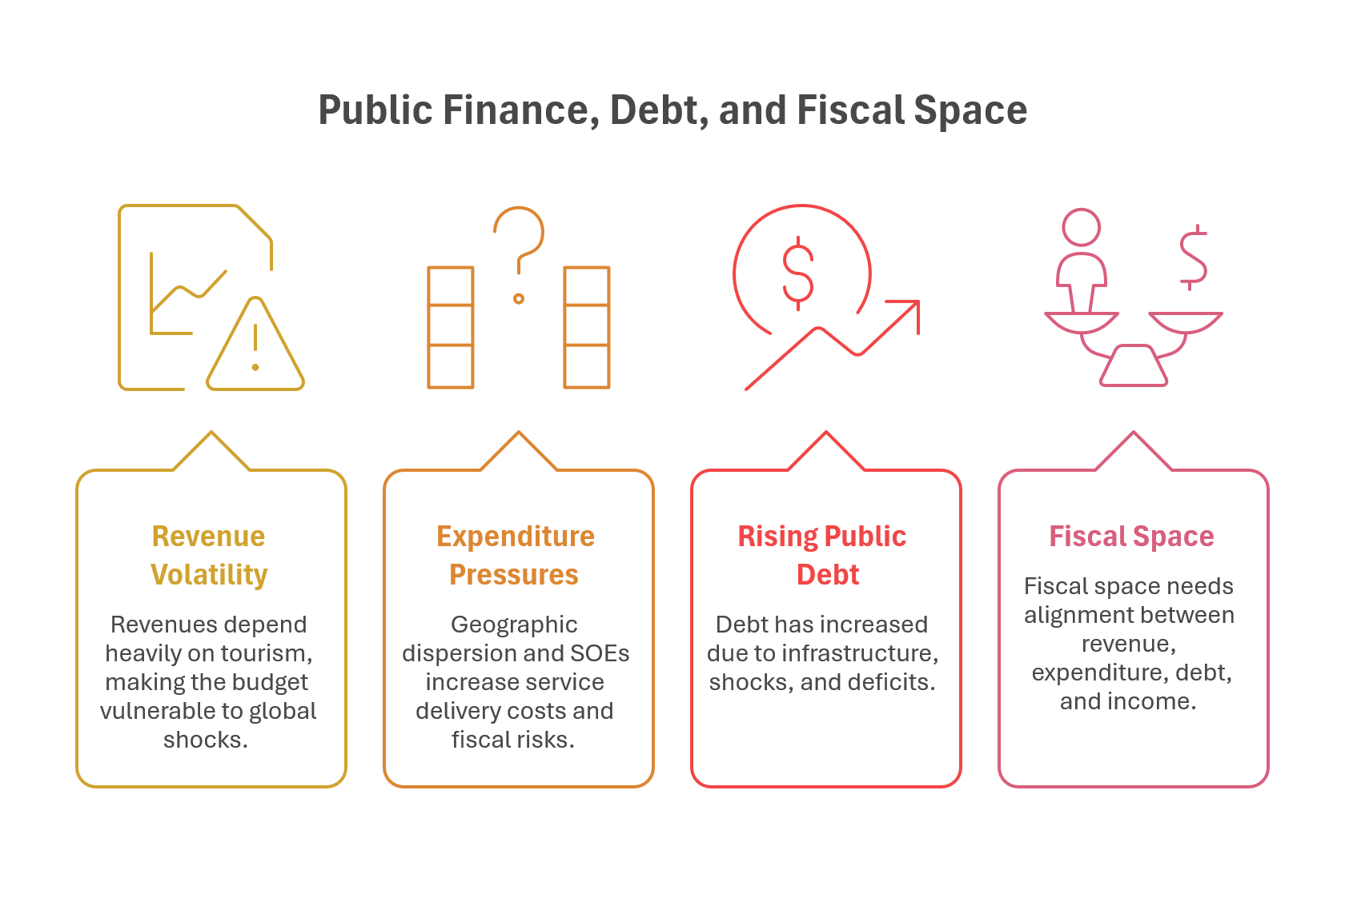
Figure 6 - Public Finance, Debt, and Fiscal Space
Public finances are closely tied to the structure and volatility of the economy. Revenues depend heavily on tourism-related taxes and fees, exposing the budget to global shocks. Import dependence increases exposure to exchange-rate and price volatility, while persistent fiscal imbalances interact with external vulnerabilities, reinforcing pressures on reserves and macro stability during periods of stress.
Expenditure pressures reflect both development needs and structural cost conditions. Geographic dispersion raises per-capita service delivery costs, while SOEs play a major role in utilities, housing, and infrastructure – delivering essential services but also creating significant fiscal risks. Subsidy and SOE-related expenditures have risen sharply over the last decade, materially changing the fiscal baseline.
Public debt has increased sharply since the COVID-19 pandemic, reflecting infrastructure expansion, repeated shocks, and persistent structural deficits. Beyond headline ratios, long-term liabilities, contingent risks, and climate-related obligations are not yet fully integrated into fiscal planning. Without adjustment, current patterns risk transferring costs to future generations through higher debt burdens, constrained public services, or reduced shock-response capacity. Fiscal space therefore needs to be understood not only as a short-term balance issue, but as alignment between revenue resilience, expenditure commitments, debt dynamics, and long-term income-generating capacity.

Access, Infrastructure and Connectivity
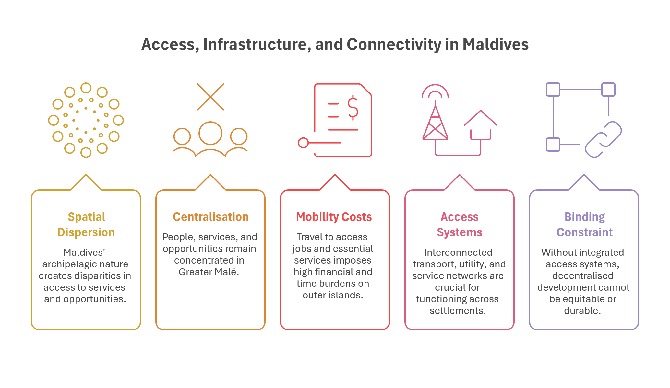
Figure 7 - Access, Infrastructure, and Connectivity in Maldives
In an archipelagic state, access shapes opportunity, equity, and the lived experience of development. Maldives’ geography creates a persistent structural condition in which higher-order services, employment density, and movement demand concentrate toward the Greater Malé area, while the population remains distributed across many inhabited islands. This pattern is not merely spatial; it influences fiscal cost, service reliability, labour mobility, and perceptions of fairness across regions.
Baseline conditions illustrate the scale of this constraint. A population of approximately 515,000 is distributed across 184 inhabited islands, with 51 percent residing in Greater Malé Region. Over 60 percent of domestic passenger movement originates or terminates in Malé, while households in outer atolls can spend a significant share of monthly income on travel to access essential services. Higher-order service capability remains similarly centralised, reinforcing the link between physical mobility, service access, and opportunity.
Historically, the dispersed island geography of Maldives has imposed high unit costs on the provision of public services and infrastructure outside the capital region. Small service catchments, physical distance, and reliance on centralised delivery models have made equitable access difficult to sustain, reinforcing spatial disparities in outcomes. Recent advances in digital connectivity, remote service delivery, and distributed systems are beginning to alter these cost structures. While these developments do not remove the underlying challenges of dispersion, they change the feasibility frontier for service delivery by reducing avoidable travel, extending service reach, and improving reliability across islands. This shift introduces new structural possibilities for access and equity, even as geographic constraints remain binding.
Access systems operate through interconnected transport, utility, and service networks that must function across small and dispersed settlements. Maritime connectivity remains the backbone of national mobility, complemented by air links between more distant atolls, but frequency, affordability, and reliability vary across regions. Utility systems – energy, water, sanitation, and waste – face similar scale and cost pressures, with coverage expanding faster than resilience, maintenance capacity, and service quality in smaller islands. Climate exposure, infrastructure ageing, and limited economies of scale further intensify these pressures, underscoring that access challenges are system-level rather than sector-specific.
Baseline conditions therefore point to a binding constraint: without integrated access systems, decentralised development cannot be equitable or durable. Equitable decentralisation depends on the convergence: of reliable physical connectivity, service-capable hubs and clusters; resilient utility systems that can function beyond single-island economics; and digital parity that enables services, learning, and work to operate across distance. Access and connectivity are foundational system conditions shaping whether geography becomes a persistent disadvantage or a manageable feature of national development across several – if not all – sectors.

Climate Resilience, Environment, and Natural Assets
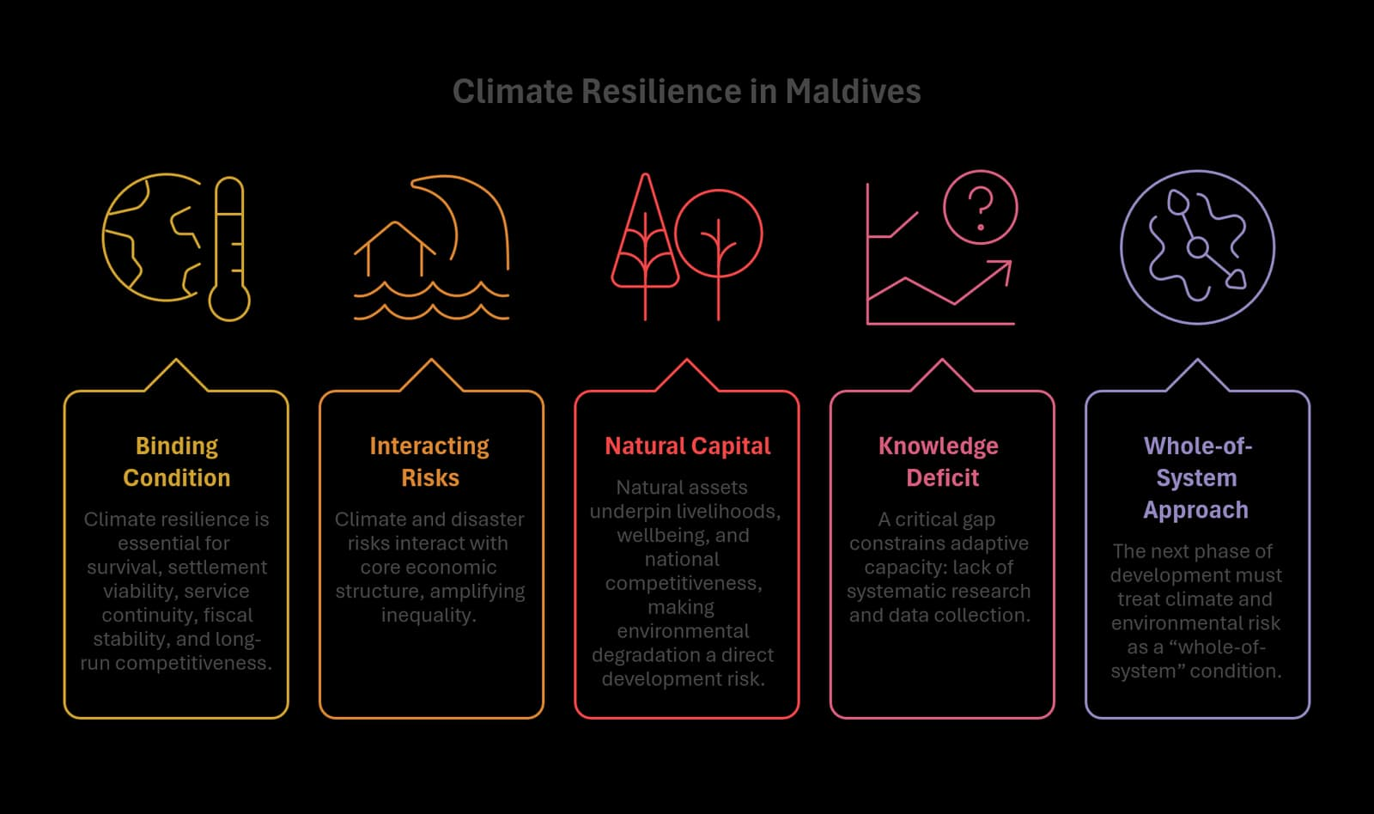
Figure 8 - Climate Resilience in Maldives
Climate resilience is not an “environment sector” issue in the Maldivian context; it is a binding condition for survival, settlement viability, service continuity, fiscal stability, and long-run competitiveness. Climate and disaster risks interact with core economic structure – including tourism and fisheries dependence, import intensity, and infrastructure exposure – and can amplify inequality by affecting households and islands with fewer buffers and fewer alternatives. Moreover, communities maintain direct relationships with local ecosystems; environmental degradation erode people’s health and wellbeing, housing security, public facilities, and community stability.
Natural assets underpin life, livelihoods, and national competitiveness. The baseline challenge is therefore dual: protecting and restoring natural capital that people and the economy depend on, while ensuring that development choices, such as extensive lagoon reclamation, do not increase exposure through settlement patterns, infrastructure design, or weak risk screening. In a small open economy with limited buffers, climate impacts can transmit into higher public costs, disrupted access, and reduced fiscal space, making resilience a macro-development constraint rather than a standalone theme.
A critical gap constrains the nation's adaptive capacity: the lack of systematic research and data collection to guide the sustainable use of ecosystems services, climate and disaster resilience responses – risking loss of biodiversity with significant economic value. This knowledge deficit makes it difficult to prioritise adaptation investments, evaluate intervention effectiveness, or establish early warning systems calibrated to Maldivian conditions. Such adaptative capacities must also factor in social and economic costs and protection pathways.
The implication for the NDP baseline is clear: the next phase of development must treat climate and environmental risk as a “whole-of-system” condition – shaping investment discipline, service standards, land and marine use choices, and the resilience of essential infrastructure – while maintaining the productivity and equity objectives of national development.

Governance and Institutional Capacity
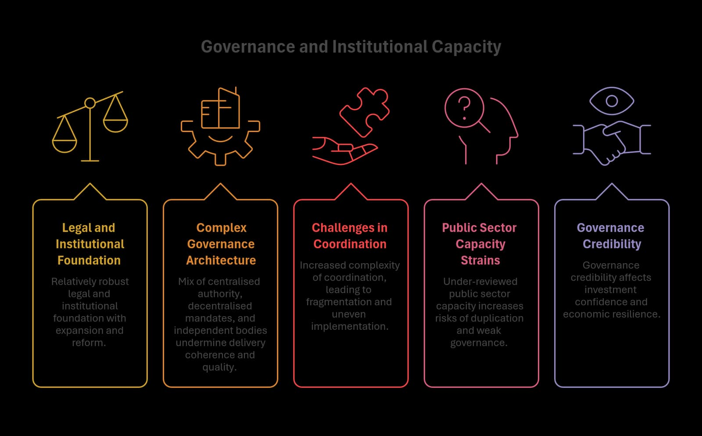
Figure 9 - Governance and Institutional Capacity
Governance and institutional capacity determine whether national priorities translate into reliable outcomes across a dispersed archipelago. The baseline challenge is not only policy design, but delivery coherence: coordination across institutions, consistency of enforcement, credibility of rules, and the ability to operate systems (not just projects) across islands with varying capability and scale.
The governance system today rests on a comparatively robust legal and institutional foundation, having undergone substantial institutional expansion, constitutional reform, and the establishment of independent oversight bodies over the past two decades.
The current governance architecture reflects a complex and evolving mix of centralised authority, decentralised mandates and constitutionally protected independent bodies. While this pluralism has broadened accountability on paper, it has also increased the complexity of coordination, contributing to fragmentation in policy formulation, short-termism, uneven implementation quality, and gaps in accountability. Where responsibilities are distributed across multiple agencies and levels, outcomes depend on clarity of roles, disciplined coordination, and feedback systems that enable learning and correction. Limited representation of women and young people further weakens institutional coherence, reducing the system’s ability to address cross-cutting and long-term priorities.
Under-reviewed public sector capacity and operating arrangements increase risks of duplication, weak governance, and unsustainable fiscal burdens. Justice, oversight and digital reforms have advanced, but delays, limited specialised capacity, fragmented data systems and data gaps along with weak feedback loops further constrain access, performance, evidence-based policymaking, and long-term planning, especially where the national system needs to track service quality, access, and risk across a complex geography.
Governance credibility directly affects investment confidence, financing costs, and the feasibility of productivity-led growth, whilst fiscal transparency, public investment governance, and SOE accountability are core dimensions of democratic trust and economic resilience.
This baseline frames governance as a horizontal determinant of development: it shapes equity across regions, investor confidence, service trust, and the credibility of long-term commitments under conditions of uncertainty.

Future Risks, Trends, and Opportunities
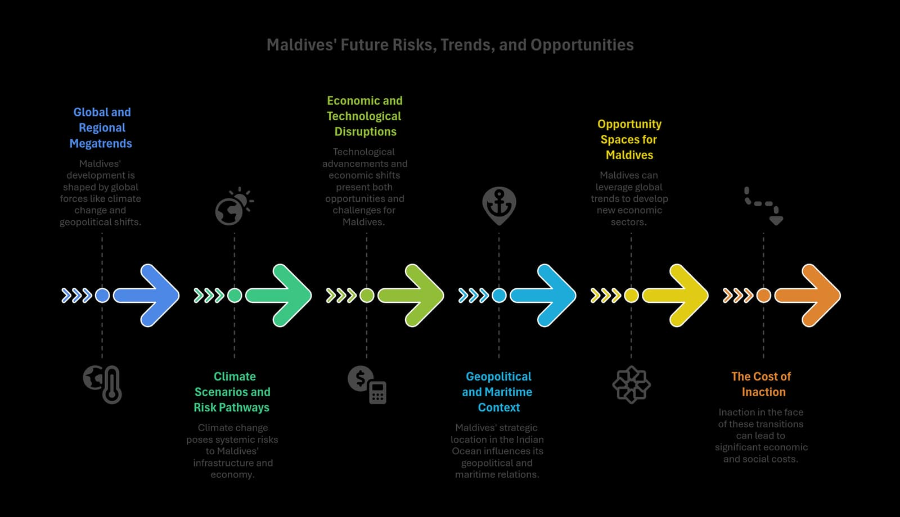
Figure 10 - Maldives' Future Risks, Trends, and Opportunities

Global and Regional Megatrends
Maldives’ development trajectory is increasingly shaped by global and regional forces that lie largely outside national control. Climate change, technological transformation, shifting geopolitical alignments, and evolving global norms around governance and sustainability are altering the conditions under which small, open, island societies and economies operate. These forces do not act independently; they interact with domestic social, economic, and political structures, geography, and institutional capacity to amplify risks and constrain choices.
Climate change is intensifying physical risks while reshaping global expectations around environmental responsibility, traceability, and sustainability. Tourism markets, fisheries exports, and access to finance are increasingly influenced by environmental performance, disclosure standards, and reputational considerations.
Global supply chains remain vulnerable to disruption, exposing import-dependent economies to price volatility, logistics shocks, and availability constraints, particularly for food, fuel, and construction materials. Household and family wellbeing and social protection adaptability are increasingly acknowledged as necessary elements of social resilience within this context.
Moreover, the global governance architecture is under strain from declining trust, polarisation, and misinformation as well as a growing fusion of state and corporate power. These directly undermine the state’s ability to manage requisite reforms that balance people’s wellbeing, fiscal responsibilities, and sustainable development. In this context, transparency, participation, and service responsiveness are essential to maintaining the credibility and legitimacy of the state and sustain public trust.
Geopolitical fragmentation and competition are reshaping maritime, trade, and security environments across the Indian Ocean region and beyond. For Maldives, these shifts affect trade routes, energy security, digital infrastructure, and access to external finance. Meanwhile, evolving norms around transparency, data governance, and institutional credibility influence investor confidence, aid relationships, and international partnerships.
Together, these trends establish a more uncertain, competitive, and conditional external environment for national development.

Climate Scenarios and Risk Pathways
Climate change represents a binding condition for Maldives’ future development rather than a sector-specific challenge. Rising sea levels, coastal erosion, flooding, heat stress, and ecosystem degradation directly affect settlement viability, infrastructure lifespan, service continuity, and natural assets that underpin the economy. These risks are cumulative and systemic, interacting with existing geographic dispersion and cost structures.
Climate impacts transmit through multiple pathways. Comprehensive preparation for different climate scenarios includes managing the social and economic impacts of such adaptation and responses. Physical damage to infrastructure increases maintenance and replacement costs, while repeated shocks disrupt access, resilience, livelihoods, and service delivery. Environmental degradation undermines tourism appeal and fisheries productivity, weakening income generation and fiscal revenues. It also notably affects people’s health and wellbeing, social cohesion, and community continuity. As adaptation costs rise, pressure on public finances intensifies, narrowing fiscal space, increasing exposure to debt and external financing conditions, and heightening social fractiousness. This reduces the manoeuvrability space for seeking sustainable equitable solutions.
Importantly, climate risk introduces trade-offs that cannot be avoided indefinitely. Decisions about where to invest, which assets to protect, and how to sequence development become increasingly constrained by long-term exposure and affordability. Without careful risk integration, climate impacts risk locking in costly patterns of infrastructure and settlement that are difficult to sustain over time. Climate resilience therefore shapes not only environmental outcomes, but the feasibility, equity, and durability of development choices across all sectors.

Economic and Technological Disruptions
Global economic and technological shifts are already reshaping key drivers within the Maldivian economy – productivity, competitiveness, and access to markets, though adoption remains uneven and spatially concentrated. Digital platforms, automation, data-driven services, and artificial intelligence are transforming value chains, altering labour demand, and changing how firms capture value. For Maldives, these changes interact with small market size, geographic dispersion, and skills constraints in ways that can widen productivity gaps if unevenly absorbed.
Technology adoption has the potential to reduce distance-related costs, improve service delivery and productivity, and expand participation. However, uneven access to digital infrastructure, skills, and organisational capability can reinforce disparities between firms, regions, and population groups. Platform dependence can compress margins in tourism and services, while data ownership and control increasingly shape bargaining power and value retention.
In fisheries and construction, traceability requirements, digital compliance systems, and technology standards are becoming prerequisites for market access rather than optional upgrades.
Global macroeconomic and financial-system shifts can impact significantly on Maldivian growth. As a small, open, import-dependent economy, Maldives is highly exposed to such shifts. These can limit fiscal space and tighten foreign exchange availability. Addressing emergent changes to the financial systems that can lead to macroeconomic volatility strengthens planning by linking strategy to buffers and contingency planning.
As digital government expands, risks related to data security, misinformation, bias, and regulatory capacity increase. Additionally, AI-related risks require particular attention because they intersect with public services and governance, amplifying disinformation risks, threatening fair elections and freedom of expression, and compounding socio-economic inequalities. Generative AI can also cause harms and risk personal safety and freedoms through deepfakes, non-consensual sexualised content and gender-based online violence. Awareness, ethical standards, oversight, and accountability are robust safeguards essential to protect public trust and safety, prevent misuse and reduce fraud and exposure.
These dynamics create a dual pressure: the cost of non-adoption rises, while the risks of poorly governed adoption increase. Managing this transition becomes a structural challenge rather than a purely technological one.

Geopolitical and Maritime Context
Maldives’ geographic position in the Indian Ocean gives it strategic significance disproportionate to its size. Control over a vast Exclusive Economic Zone, proximity to major shipping lanes, and the presence of undersea cables and maritime infrastructure position the country at the intersection of global trade, energy flows, and digital connectivity.
Geopolitical competition influences access to finance, infrastructure investment, and strategic partnerships, while also increasing scrutiny over sovereignty, security, and governance choices. External engagement can provide opportunities for investment and cooperation while introducing exposure to shifting alliances and conditionalities. Maritime governance, fisheries management, and environmental stewardship carry both economic and diplomatic implications in this context.
These dynamics affect development choices indirectly but powerfully. Decisions about infrastructure, connectivity, and external financing are increasingly entangled with geopolitical considerations, shaping long-term obligations and risk exposure. For a small state with limited buffers, maintaining strategic balance and institutional credibility becomes a central development challenge rather than a peripheral concern.

Opportunity Spaces for Maldives
Despite structural constraints, the Maldives enjoy several opportunity spaces that align with global demand shifts and the country’s distinctive characteristics. However, these emerge not as open-ended possibilities but as bounded spaces shaped by constraints, capability, and risk.
Higher-value tourism, fisheries value addition, selective industrial upgrading, digital and creative services, and climate-related finance instruments represent areas where global trends may align with national strengths. However, these opportunity spaces are conditional. They depend on productivity improvements, skills alignment, infrastructure reliability, environmental integrity, and governance credibility. Without these enabling conditions, attempts to expand into new activities risk reinforcing existing vulnerabilities or generating limited domestic value. Strategic selectivity and sequencing therefore matter as much as ambition.
The Maldives also holds comparative potential to become a platform for innovation and partnerships in small-island climate adaptation, blue and circular economy models, and ocean-based renewables. These opportunity areas draw directly on Maldivian geography and could generate research, product development, and international collaboration, but they require deliberate investment in higher education capacity, applied research ecosystems, and enabling institutional architecture.
In this context, the current demographic youth bulge and the untapped potential labour force represent human capital opportunity – with strategic improvements to labour utilisation, training and pathways to higher productivity, they constitute an opportunity space for the Maldives.
Attention can also be paid to developing regional hubs as specialised productivity engines, so that there is broader base to economic spatiality in the Maldives.
Opportunities linked to sustainability and climate finance illustrate this dynamic clearly. Global climate and biodiversity finance is increasingly oriented toward credible pipelines with measurable outcomes. While global interest in blue and green finance is growing, access depends on credible institutions, measurable outcomes, and long-term commitment. These requirements interact with fiscal capacity, data systems, and regulatory frameworks, reinforcing the importance of system-level readiness rather than isolated initiatives.
However, financing constraints, institutional capacity gaps, and skills shortages remain binding, and not all opportunities can be pursued simultaneously. Strategic selectivity and sequencing are therefore required to align limited capital, management capability, and institutional capacity with the highest-impact pathways.

The Cost of Inaction
The costs of inaction in the face of these transitions are cumulative and intergenerational: impacts accumulate, compound, deepen in severity, and grow in cost, while simultaneously weakening the capacity of state and society to protect wellbeing and the economy. Continued reliance on narrow growth drivers without productivity gains raises vulnerability to shocks and limits income growth. Weak integration of risk into planning can lock in high-cost infrastructure and settlement patterns that are difficult to reverse.
Climate inaction increases the likelihood that development gains are repeatedly converted into loss-and-rebuild cycles. Delayed adjustment increases exposure to enduring climate and environment damage, fiscal stress, and social fragmentation.
Human capital risks are equally cumulative. Inaction can deepen inequality, reduce trust in institutions, and weaken participation, particularly among youth and marginalised groups. Economically, it can erode competitiveness and reduce the ability to capture value from emerging opportunities resulting from a weak human capital base. Institutionally, it can undermine credibility and constrain future choices by exhausting fiscal and political capital. Even when not immediately visible or fully quantified, they manifest over time through reduced growth potential, diminished resilience, and lower wellbeing.
Taken together, these costs emphasise that inaction is not a neutral option. The development path itself is becoming riskier as external pressures intensify and internal constraints tighten. The challenge facing Maldives is not whether change is needed, but how to navigate transitions in a way that preserves stability, equity, and long-term national interest.

Part C – The Long-Term Development Model

Maldives' Chosen Development Model
This chapter sets out the core development models that collectively shape the National Development Plan’s approach to long-term prosperity, resilience, and equity. Together, these models define how economic growth, social and human development, spatial organisation, environmental stewardship, and governance are integrated into a coherent national development framework and strategic trade-offs to 2045.

The Economic Development Model
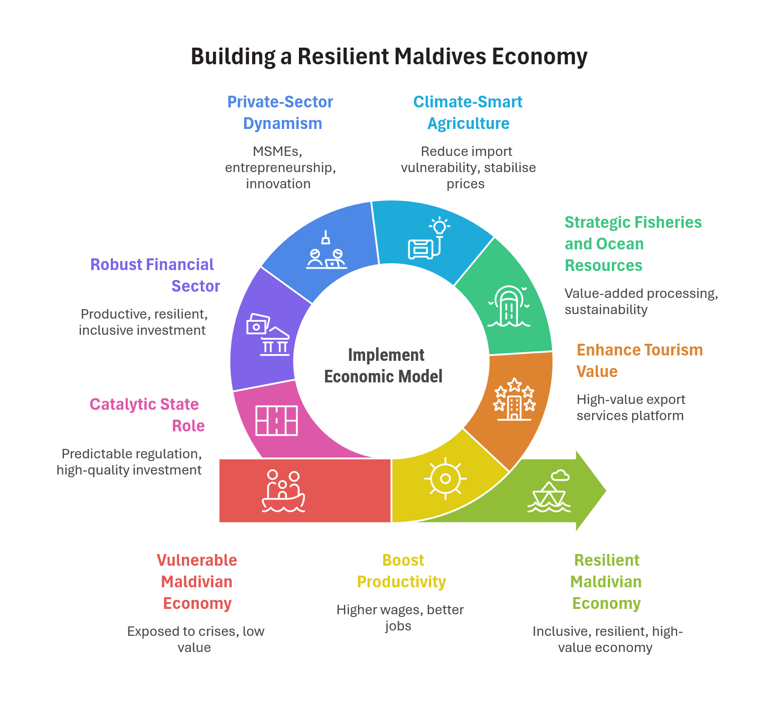
Figure 11 - The Economic Development Model
The National Development Plan adopts an economic development model designed to serve people first, while remaining viable within the structural realities of a small, open, archipelagic economy. The model functions as the unifying logic through which the objectives of industry transformation, inclusion and economic dignity, and economic resilience and long-term security are jointly delivered. Growth, inclusion, and resilience are treated as inseparable outcomes rather than sequential stages.
At its core, the model is built around value-based and participation-led growth, where long-term increases in national income translate into higher and more secure living standards for Maldivians across regions and generations. Economic success is measured not only by aggregate output, but by whether Maldivians can equitably access quality jobs, build assets, participate meaningfully in value chains, and feel protected from economic and external shocks. Inclusion, dignity, and security are therefore treated as core economic outcomes.
Sustained prosperity depends on raising productivity while broadening participation and voice in the creation of wealth. Productivity gains are pursued as the means through which higher income and wages, better job quality, and stronger domestic value retention become possible. At the same time, resilience is embedded as a structural requirement: growth that repeatedly exposes households, firms, or public finances to crises is neither inclusive nor durable. Macroeconomic stability, fiscal discipline, and environmental limits therefore form essential foundations for equitable wellbeing.
Tourism remains the anchor sector of the economy, but its role is redefined as a high-value export services platform rather than a volume-driven growth engine. Higher value per visitor, stronger local supply chains, and greater Maldivian participation in ownership, management, and skilled roles are central to this shift. Fisheries and ocean-based activities are repositioned as strategic contributors to resilience and value creation through value-added processing, sustainability compliance, and market integration. Agriculture is framed around targeted, climate-smart production that reduces import vulnerability and stabilises prices, particularly through linkages with domestic demand.
Within this model, the financial sector plays a supportive but essential role by allocating national savings toward productive, resilient, and inclusive investment. A sound banking system and well-governed financial intermediation support efficient capital allocation, Maldivian ownership of productive assets, and long-term value creation, with credit growth guided by productivity, risk discipline, and macroeconomic balance.
Private-sector dynamism is the primary driver of growth under this model. MSMEs, entrepreneurship, and innovation enable Maldivian ownership of productive assets and participation in value chains. The role of the state is primarily catalytic, shaping incentives through predictable regulation, competition policy, spatial planning, and high-quality public investment. The state retains strong regulatory disciplinary and safeguarding authority – to ensure universal access to essential affordable services, protect and enforce standards in public health and wellbeing, manage systemic and climate risks, and shape distributional outcomes so that growth is equitably shared and spatially balanced.
The model is grounded in long-run growth principles, where productivity, skills, capital formation, and innovation drive sustained income gains within environmental thresholds and minimum social foundations. Over time, productivity becomes the dominant source of growth, supported by capital accumulation, labour and skills development, and responsible management of natural and ocean resources. Spatial organisation and governance capacity are treated as integral economic policy instruments, ensuring coherence between growth, inclusion, and resilience objectives.

The Social and Human Development Model
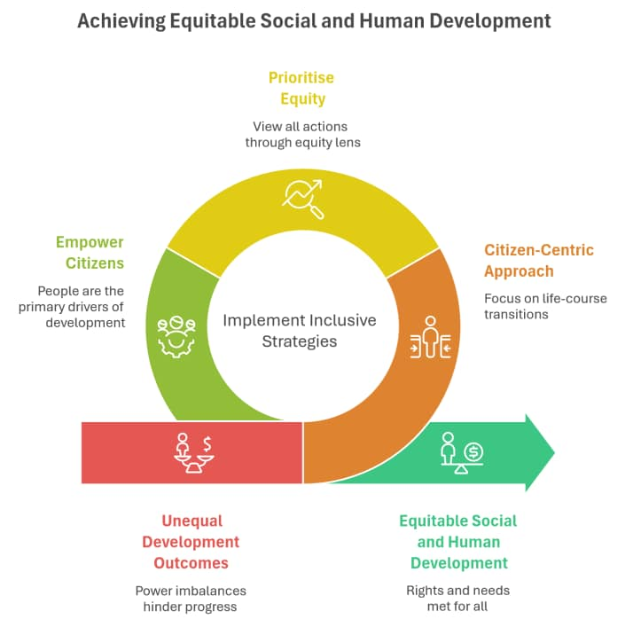
Figure 12 - Social and Human Development Model
The social and human development model guides decision-making related to the wellbeing of Maldivian people and residents, recognising the interconnected social systems that support their needs. It provides a framework for understanding how equitable, cohesive communities are built and how people’s capabilities and agency are strengthened across the life course.
The model operates across individual, community and national levels, focusing on personal needs and transitions, community and service ecosystems, and national social systems that deliver rights and essential services regardless of location, gender, age, disability, or income. Social systems serve both proactive and protective functions: promoting conditions that build people’s capabilities and agency while supporting people through vulnerability, harm, and disruption.
People are recognised as the primary drivers of development. Their aspirations, skills, and choices shape outcomes, while unequal power relations can distort development pathways and produce exclusion. Equity and empowerment therefore form the central lens of the model, which adopts an inclusive, citizen-centric life-course approach as its organising logic. Equity and empowerment necessarily require some changes to prevailing social structures, dynamics, and relationships.
This model acknowledges that people have diverse, changing needs, capabilities, and vulnerabilities over the different stages of their lives. Timely support during transitions can ensure equity, optimise outcomes, and prevent long-term harm or exclusion. This approach expands individual and community capacities, avoids preventable resource drains, and ensures shared benefits – through informed civic participation, cohesive social relations, labour productivity, reduced long-term costs, and economic resilience – to the nation, the economy and society. Investments in capacity will also underpin productivity-led growth and the transition to higher-value economic activity.
Progress is measured through real improvements in quality of life rather than aggregate economic growth alone. The model prioritises equitable access to social goods, agency- and rights-based practice, prevention-first investments, meaningful participation, collective action, and coordinated delivery across institutions and levels of government.
Operationally, the model relies on integrated social systems that anticipate life-course transitions, invest in prevention and universal services, integrate delivery close to home, and respond rapidly to vulnerability with a rights-based perspective. These systems are enabled by responsive feedback loops, sustainable financing, skilled workforces, clear standards, robust data, and accountability mechanisms. Success is measured through equitable outcomes in wellbeing, dignity, agency, inclusion, social cohesion and participation across population groups.

The Spatial Development Model
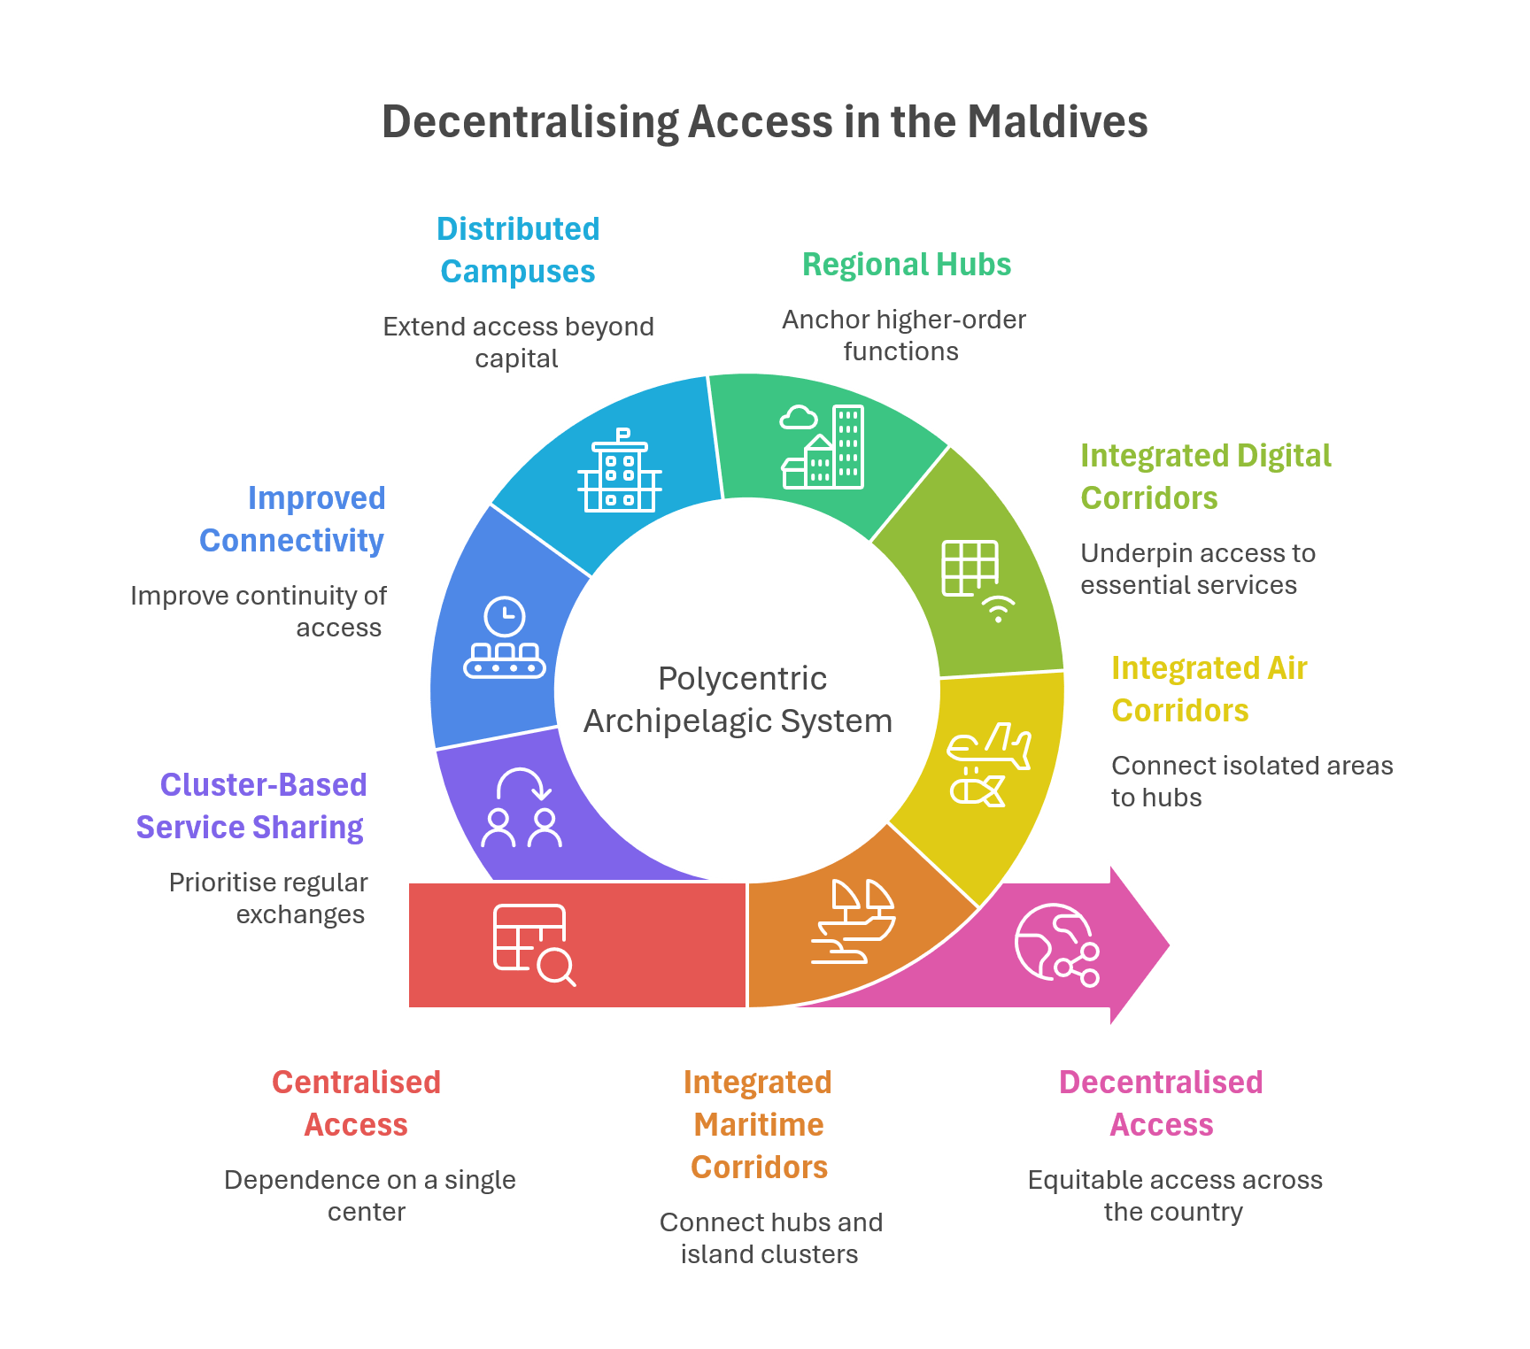
Figure 13 - Spatial Development Model
The spatial development model organises the Maldives as a polycentric archipelagic access system, comprising regional hubs and island clusters connected by integrated maritime, air, and digital corridors. Its objective is to ensure access to services, jobs, and markets without default dependence on a single centre, treating connectivity as a national system rather than a set of isolated projects.
Evidence shows that islands differ significantly in their catchments, clustering potential, and capacity to sustain higher-order functions. At different scales, the archipelago forms functional clusters, regional systems, and, at wider radiuses, multiple main regions. Persistent isolation in parts of the country requires differentiated spatial responses, combining regional self-reliance with air–sea integration.
Higher-order services follow service-catchment logic rather than administrative boundaries. Given population thresholds, tertiary-level functions are anchored in capable regional hubs, supported by distributed campuses of national services and multi-service hub complexes. Connectivity functions as the enabling “glue” of decentralisation, with performance assessed through travel-time equity, multimodal reliability, digital access, and resilience.
The Integrated National Public Ferry Network remains foundational to everyday access, though improvements in reliability and affordability are essential for decentralisation to be experienced as real. Service integration, including ferry–aviation coordination, reduces burdens for students, patients, and workers.
The model differentiates pathways across the settlement system. Cluster-based service sharing applies where proximity enables regular exchange, while “managed isolation” pathways using hybrid service models and targeted livelihood support can protect cultural and environmental assets in highly isolated islands. Equity is safeguarded through minimum access standards and ecological thresholds, ensuring consolidation does not reproduce congestion or environmental stress. Governance, planning, and investment are aligned to functional regions and hub catchments so that access and liveability outcomes are measurable and enforceable.

The Environmental and Climate Model
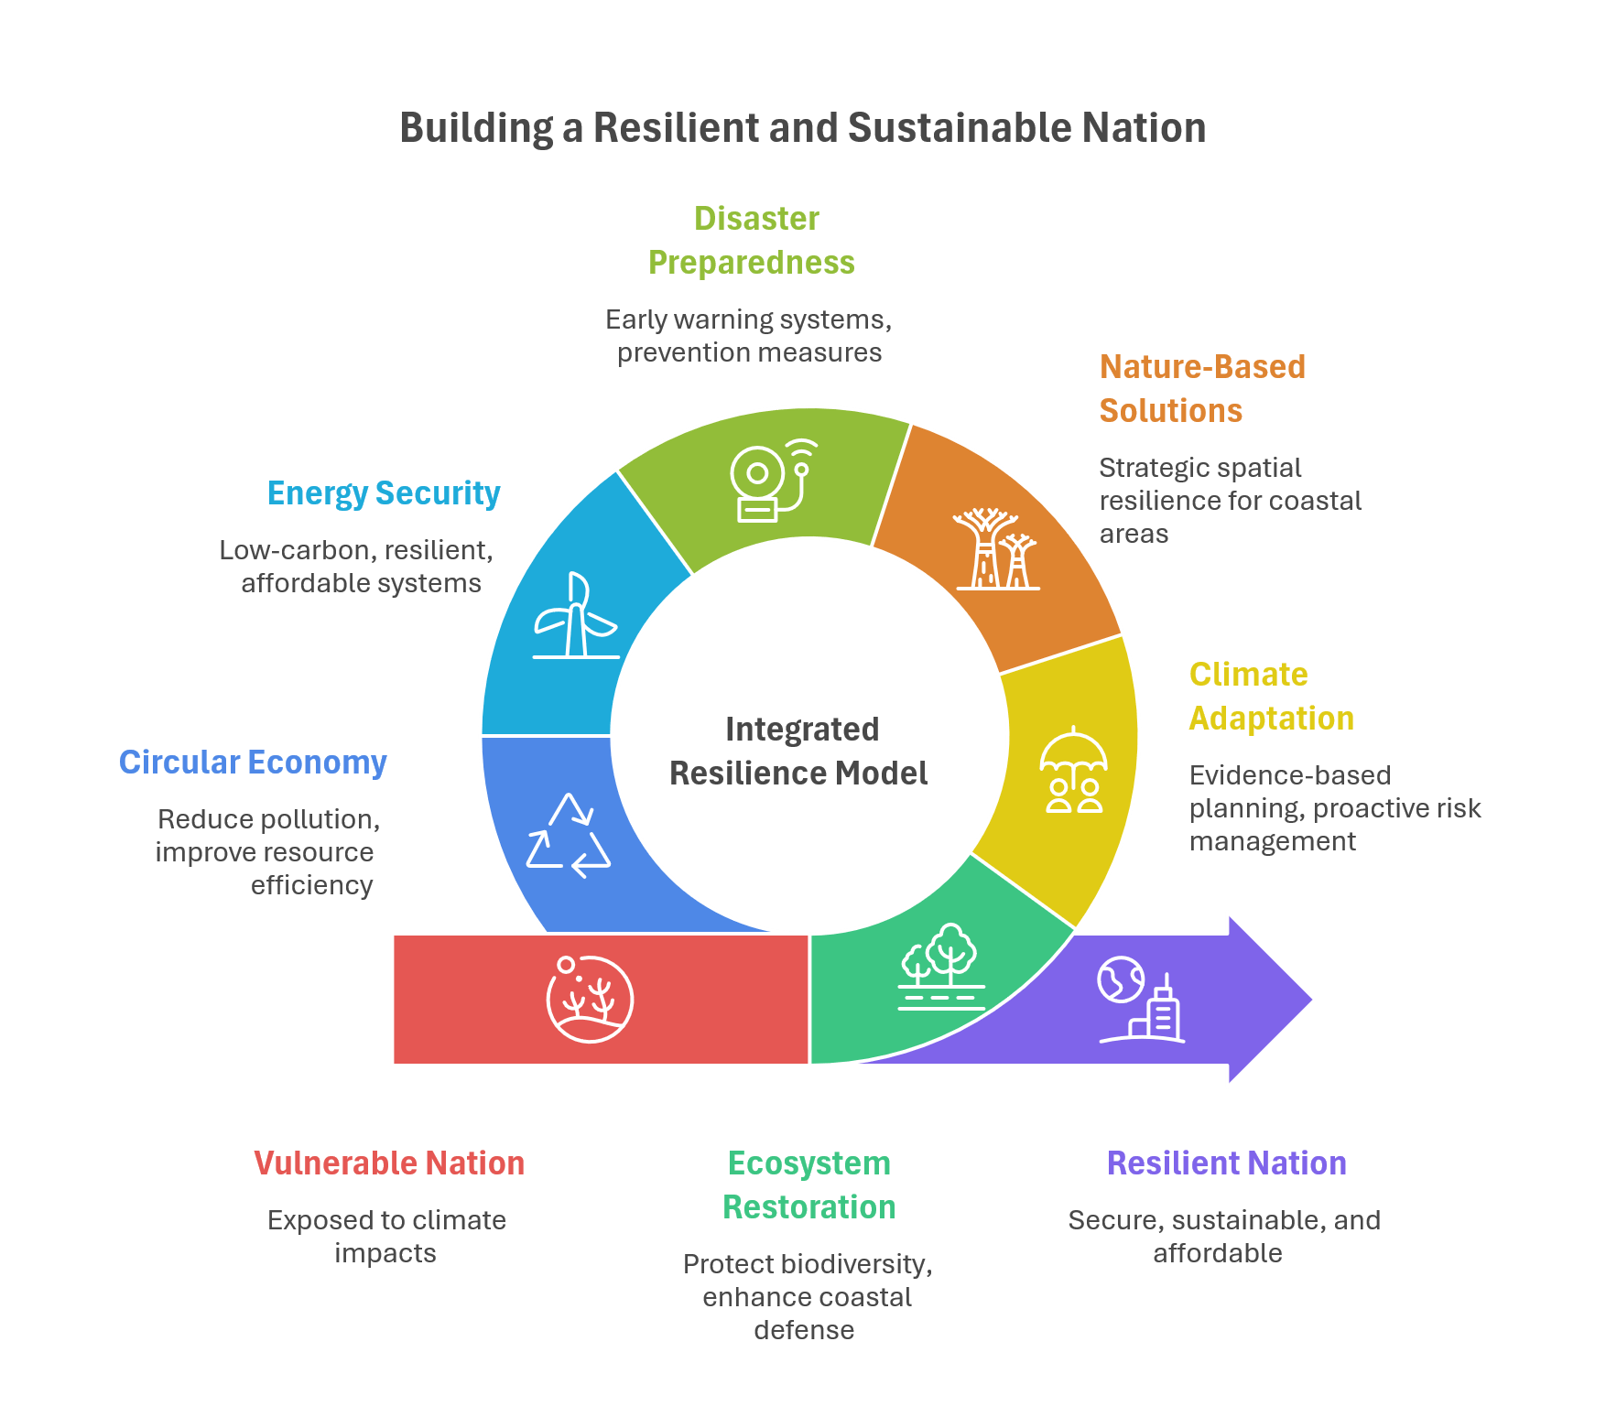
Figure 14 - Environment and Climate Model
The climate resilience and environmental stewardship model integrates environmental sustainability as a foundational condition for long-term wellbeing and prosperity. It explains how interconnected environmental, economic, and social drivers or pressures are addressed through coordinated institutional responses and adaptive pathways that safeguard natural capital and national habitability.
Development in the Maldives must operate within clear physical and ecological thresholds. Climate change poses existential risks through sea-level rise, intensified storms, and ecosystem degradation, undermining coastal protection, fisheries, tourism assets, and livelihoods. Economic activities, including unplanned lagoon reclamation and unsustainable resource use, can amplify these risks, while social dynamics such as urbanisation and rising consumption increase environmental pressure.
The model responds through a systemic logic linking diagnosis, governance, and outcomes. Strategic environmental assessment, integrated policy coordination, spatial planning, natural capital accounting, monitoring, research, and community engagement operate as a unified system. Phased adaptation pathways enable learning and adjustment over time.
Resilience and stewardship are embedded across sectors through ecosystem restoration, climate adaptation, nature-based coastal protection, disaster risk management, energy transition, and circular economy approaches. These can support long-term value creation in tourism, fisheries and international positioning. Outcomes are measured across ecosystem health, human wellbeing, and economic prosperity, which must advance together for sustainability to be meaningful. Effective implementation depends on political commitment, financing, institutional capacity, community stewardship, and international partnership.

The Governance and Institutional Model
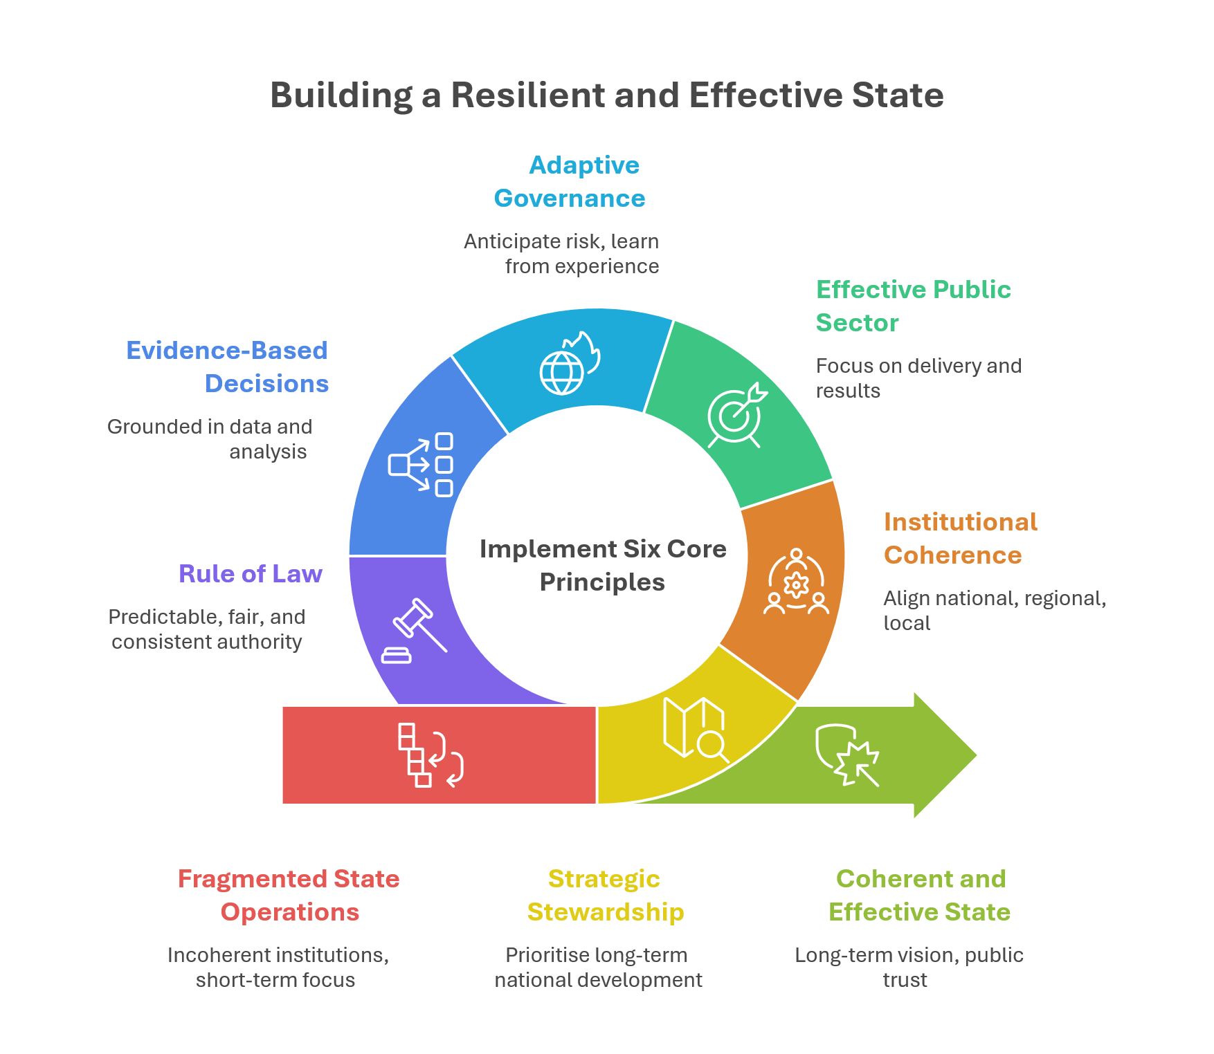
Figure 15 - Governance and Institutional Model
The governance and institutional model defines the operating logic through which the Maldivian state is organised to deliver the National Development Plan over a 20-year horizon. It establishes the operating logic of the state – how authority, coordination, delivery, and accountability are structured to support long-term development across political cycles.
The model responds to fragmentation, uneven delivery, and declining confidence in state performance by focusing on coherence, capability, and continuity as core governance requirements. It is anchored in six interrelated principles: strategic stewardship of long-term development; institutional coherence within a multi-level governance system; effective public sector capacity and performance; adaptive and anticipatory governance; evidence, digital systems, and information integrity; and rule of law, oversight, and institutional legitimacy.
Together, the six principles describe a state that takes the long-term view, aligns institutions across levels of government, and prioritise delivery and performance. Successful implementation would produce a development state that is more stable, credible, and effective, and one that that is able to deliver on priorities at scale while staying resilient under stress.
Operationally, the model functions through strategic stewardship of national priorities, coordinated delivery across institutions and territories, collaborative actions with non-state actors – civil society organisations, business associations, and professional bodies – in order to achieve its service delivery, monitoring and evaluation, and performance objectives, and accountability linked to outcomes and learning. Fiscal and institutional frameworks protect long-term commitments, while coordination mechanisms align national, regional, and local action. Illustrative options for regional coordination consistent with this governance model are provided in Annex I for implementation consideration. A human-centred orientation ensures citizens experience the state as a coherent, predictable, and capable system over time.

Key Strategic Trade-offs and Policy Choices
Achieving the Maldives’ long-term development vision requires explicit strategic choices. The National Development Plan therefore clarifies not only what the country will pursue, but also what it will deliberately avoid, to protect long-term resilience, equity, and national sovereignty.
First, the Maldives will not pursue volume-led growth as its dominant development model. Growth driven by expanding visitor numbers, labour inputs, or subsidy-supported activity delivers diminishing returns and increases vulnerability across tourism, labour markets, and public employment. The strategic shift is toward value- and productivity-led growth, anchored in skills, technology, firm-level innovation, and higher value creation per worker. Foreign labour will remain essential, but growth will no longer rely on labour volume as its primary engine. This creates space to prioritise labour participation, childcare and eldercare systems, skills alignment, and better matching into decent work. Value-led growth also requires stronger state capacity and credible institutions to manage transition.
A productivity-led model calls for explicit policies to manage labour market transition risks. Industries must increase absorption of the Maldivian workforce, especially young people, while managing foreign labour to fill remaining gaps. This requires trade-offs that balance efficiency, flexibility, fair work regulation, employer accountability, working conditions, and in-service training. Migrant labour brings valuable experience and diversity to the labour market and will continue to play a role; therefore, a coherent policy on foreign labour, its optimisation, and social implications is required.
Second, the country will not pursue debt-fuelled growth that compromises intergenerational fiscal stability. Financing consumption or low-efficiency investment through rising debt shifts costs onto future generations and constrains policy space. Growth will instead be anchored in investment efficiency, credible fiscal frameworks, and sustainable financing that preserves resilience and macroeconomic stability.
Third, the Maldives will not pursue development pathways that degrade natural capital beyond ecological limits. Tourism or resource-based activities that damage reefs, overwhelm waste systems, or undermine climate resilience are incompatible with long-term prosperity, particularly where benefits are concentrated to narrow groups while costs fall on communities. Development will be guided by environmental carrying capacity, precautionary regulation, and protection of marine and terrestrial ecosystems underpinning tourism, fisheries, and national habitability.
Fourth, the country will not pursue uniform spatial equalisation at the expense of strategic differentiation. Replicating identical economic activities and infrastructure across all islands risks inefficiency, quality dilution, and fiscal strain. Development will instead follow a differentiated spatial strategy that strengthens regional hubs and specialised clusters while ensuring universal access to essential services, connectivity, and opportunity. Differentiation must be paired with affordable mobility, housing options, and digital access, and avoid a two-tier society. As recognised in the spatial model, some islands will require hybrid solutions and tailored protections due to remoteness. This approach demands strong multi-level coordination, clear mandates, and transparent investment sequencing aligned with regional functionality.
Fifth, the Maldives will not pursue development that tolerates widening inequality or social fragmentation as an acceptable by-product of growth. Economic transformation that concentrates opportunity, services, or voice among limited groups – whether by island, income, gender, age, or legal status – undermines social trust and long-term stability. Development choices will therefore be assessed not only on efficiency and returns, but on their distributional impacts, contribution to social cohesion, and ability to strengthen shared citizenship. Growth that erodes dignity, fairness, or community bonds is incompatible with the national vision.
Sixth, the Maldives will not expand state-led commercial activity in ways that crowd out competitive markets. While the state plays a central role in regulation, coordination, and enabling infrastructure, long-term productivity depends on a dynamic, well-regulated private sector. Public intervention will focus on correcting market failures, addressing structural inequalities, de-risking investment, setting clear rules that align markets with long-term national goals, rather than substituting for them, and holding them accountable for agreed standards. A catalytic state must ensure markets work for people through fair pricing, quality services, rights protection, sustainable infrastructure investment, decent work, and opportunities for Maldivian asset ownership. This requires robust governance, enforceable contracts, procurement integrity, conflict-of-interest safeguards, and regulatory predictability.
In some islands or sectors, private provision may remain weak or absent even under a differentiated spatial model. Ensuring service delivery where markets will not form may therefore require explicit boundary-setting frameworks clarifying when the state acts as direct provider, regulator, or co-producer with private or community actors.
At the same time, the Plan recognises that some choices remain conditional. Activities with uncertain long-term environmental or economic risks will be approached cautiously, guided by scientific evidence, safeguards, and national consensus rather than irreversible commitments.
These strategic exclusions are not constraints on ambition. They are safeguards against development paths that deliver short-term gains at the expense of long-term equity, resilience, productivity, and sovereignty. By clearly defining what will not be pursued, the National Development Plan strengthens policy coherence and anchors credible development choices through to 2045.
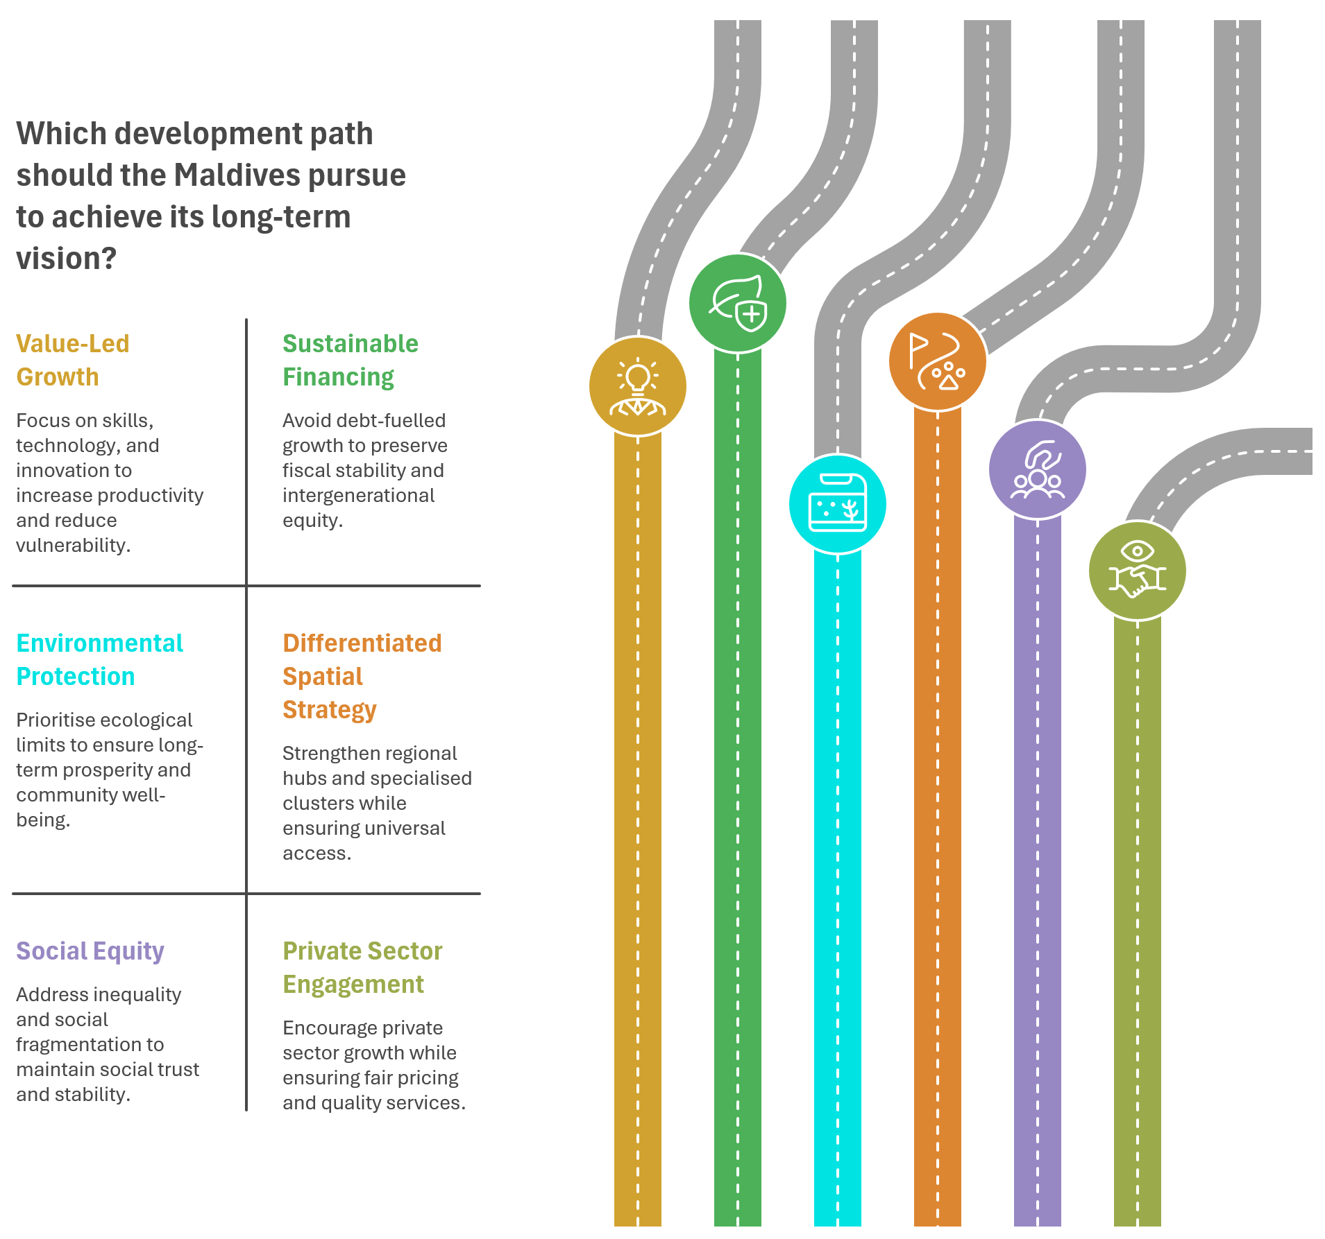
Figure 16 - Key Strategic Trade-offs and Policy Choices

National Spatial Development Framework

Purpose and Role of the National Spatial Development Framework
The National Spatial Development Framework (NSDF) provides the spatial organising logic for the National Development Plan. It translates national development objectives into high-level guidance on how people, services, economic activity, infrastructure, and public investment priorities are spatially structured across the Maldivian archipelago over the long term.
The Maldives functions not only as a dispersed settlement pattern, but as an archipelagic access system, in which geography, connectivity, and agglomeration potential fundamentally shape how equity, productivity, and resilience are experienced. The NSDF responds to this structural reality by setting a coherent territorial logic that aligns settlement roles, service access, and investment priorities across islands and regions.
The NSDF is not a land-use plan, investment programme, or project map. It functions as a strategic framework that:
- shapes national settlement patterns and access to services,
- guides the spatial logic of infrastructure and connectivity investment,
- supports fiscal sustainability and service viability, and
- strengthens resilience in a geographically dispersed, climate-vulnerable country.
Spatial organisation is therefore treated as a core development policy instrument, essential to delivering equity, productivity, and resilience, and foundational to realising national development objectives, rather than as a secondary or purely technical planning exercise.
The NSDF provides a common reference for sector strategies, public investment planning, and regional development decisions. It does not allocate resources or prescribe project-level decisions; rather, it ensures that spatial choices made through sector policies, plans, and investments reinforce – rather than undermine – the objectives of the NDP.
Where sector policies adopted under statute specify spatial regions, urban centres, or settlement classifications, these are recognised for alignment purposes as set out in the relevant annexes to this NDP.
Alignment with the NSDF is assessed on the basis of shared principles, intended outcomes, and spatial logic. Sector policies and frameworks may precede or follow the approval of the NDP, provided they are substantively consistent with these guiding principles and national development objectives.

Principles Guiding Spatial Development
The NSDF is guided by a set of core principles that apply consistently across regions and sectors.
Spatial equity as access, not uniformity
Equity is defined by people’s ability to access essential services, opportunities, and markets within reasonable time, cost, and reliability parameters, rather than by replicating identical infrastructure or functions on every island.
Service viability and scale
High-quality services require sufficient scale, skilled workforces, and reliable demand. Spatial development therefore prioritises viable service catchments and shared provision over fragmented duplication, while protecting service quality through appropriate delivery approaches.
Differentiation and specialisation
Islands and regions play different roles within the national settlement system. Spatial development recognises and supports differentiated pathways rather than pursuing uniform economic, service, or settlement models.
Connectivity as a public good
Maritime, air, and digital connectivity are treated as essential enablers of equity, economic participation, and national cohesion, forming the backbone of the archipelagic access system rather than discretionary infrastructure investments.
Resilience through ecological limits and system robustness
Spatial development operates within environmental thresholds, recognising climate risk, land constraints, and ecosystem capacity as binding conditions. National resilience is strengthened through a settlement system that avoids over-reliance on single locations, supports continuity of essential services, and maintains multiple access pathways under disruption.
Sequencing and prioritisation
Public investment is sequenced to reinforce spatial logic, ensuring that infrastructure, services, and economic activity develop in a coordinated, fiscally responsible, and environmentally sustainable manner.

The Archipelagic Settlement System
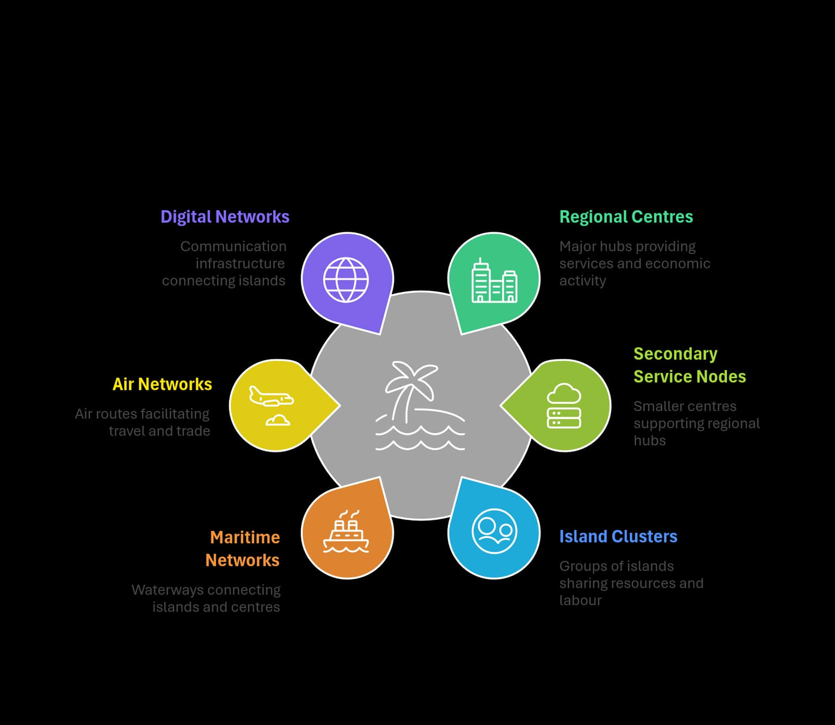
Figure 17 - The Archipelagic Settlement System
The Maldives functions as a polycentric archipelagic settlement and access system, composed of regional hubs, secondary service nodes, and island clusters connected through integrated maritime, air, and digital networks.
Rather than a single dominant centre serving the entire country, the NSDF supports a networked system of regions, each characterised by:
- identifiable service catchments,
- differentiated economic and social roles, and
- varying degrees of connectivity, integration, and self-reliance.
Spatial analysis confirms that islands differ significantly in population size and density, proximity to other islands and centres, accessibility to transport corridors, and capacity to sustain higher-order services. As a result, spatial planning is guided by functional regions and service catchments, rather than administrative boundaries alone.
At different spatial scales:
- nearby islands form clusters for shared services, labour markets, and livelihoods,
- clusters aggregate into regional systems supported by capable centres, and
- regions connect into national networks through multimodal access systems.
This approach enables scale efficiencies, reduces avoidable duplication, and limits systemic dependence on any single location, contributing to a more balanced and resilient national settlement pattern.

The Greater Malé Region
The Greater Malé Region occupies a distinctive position within the national settlement system. It functions simultaneously as:
- the primary economic gateway,
- the most diversified labour market,
- the concentration point for higher-order services, and
- the main destination for internal migration.
While this concentration has supported national growth, it has also generated acute pressures related to congestion, housing affordability, infrastructure strain, and environmental vulnerability.
The NSDF frames the future of the Greater Malé Region not as continued expansion, but as strategic consolidation within a broader national rebalancing. Decongestion is treated as a national objective, pursued by:
- strengthening regional hubs elsewhere in the country,
- redistributing access to services and opportunities through improved connectivity, and
- aligning public investment to reduce excessive reliance on a single urban core.
Managing growth in Greater Malé is therefore inseparable from enabling viable, service-capable alternatives across the archipelago, while ensuring that future development remains consistent with liveability and holding-capacity constraints.

Regional Urban Centres and Service Catchments
Regional urban centres play a central role in delivering spatial equity and service viability. These centres function as:
- focal points for regional economies,
- locations for higher-order social infrastructure, and
- service nodes for administration, logistics, and specialised functions.
The NSDF applies a catchment-based logic to service provision, whereby:
- services are planned based on the population they serve,
- quality and reliability are prioritised over proximity alone, and
- access is enabled through connectivity rather than universal replication.
References to regional urban centres in this chapter describe functional roles within the national settlement system and do not constitute the designation of specific locations, which are defined under relevant sector policies.
Where population scale cannot sustain full tertiary services outside the capital region, the framework supports adaptive service delivery approaches, including distributed service models, multi-service facilities, or coordinated service scheduling across sectors, as appropriate to context.
Regional coordination mechanisms help ensure that service delivery, infrastructure investment, and land-use decisions reinforce functional catchments and regional roles, contributing to more predictable access and improved service outcomes for households.

Smaller Islands and Differentiated Island Pathways
Not all islands can or should follow the same development trajectory. The NSDF therefore applies differentiated pathways across smaller islands, reflecting geography, accessibility, population trends, and environmental sensitivity.
Broadly, islands fall along a continuum that includes:
- cluster-based islands, where proximity enables regular exchange of labour, goods, services, and livelihoods with nearby centres; and
- highly isolated islands, where distance and access constraints limit integration.
For cluster-based islands, shared service models and economic linkages are prioritised.
For highly isolated islands, a managed-isolation pathway applies, combining:
- hybrid service delivery models,
- targeted livelihood support,
- protection of cultural, heritage, and environmental assets, and
- realistic planning for long-term demographic trajectories.
In this context, stewardship of cultural heritage and ecosystems is recognised as a legitimate and productive spatial role, contributing to identity, environmental resilience, and locally anchored livelihoods, while shaping appropriate investment and service approaches.

Connectivity and Spatial Investment Sequencing
Connectivity is the enabling backbone of the NSDF and a core system supporting decentralisation. Maritime, air, and digital networks are planned and managed as an integrated national access system, rather than as separate infrastructure sectors.
Key elements include:
- reliable and affordable maritime connectivity for everyday access,
- strategic aviation links for regional and national integration, and
- universal, reliable digital connectivity to support services, administration, and commerce.
Public investment is sequenced to reinforce spatial roles and development logic. As a guiding approach:
- connectivity enables service consolidation,
- service viability supports economic diversification, and
- infrastructure expansion is aligned with environmental limits and holding capacity.
This sequencing informs prioritisation and coordination across sectors, while allowing flexibility to respond to fiscal, institutional, and contextual realities.

Implementation, Governance, and Review
The NSDF is implemented through alignment with national planning, budgeting, and public investment systems. Its effectiveness depends on:
- clear institutional responsibilities,
- coordination across national, regional, and local levels, and
- integration with sector strategies and investment programmes.
Spatial performance is monitored through indicators related to access, service reliability, connectivity, regional balance, and system resilience. The framework is adaptive by design, allowing periodic review and refinement as conditions, technologies, and demographics evolve.
By embedding spatial logic into decision-making, the NSDF ensures that development choices reinforce long-term equity, resilience, and national cohesion, while providing a stable and enabling framework for sector policies and spatial strategies over time.
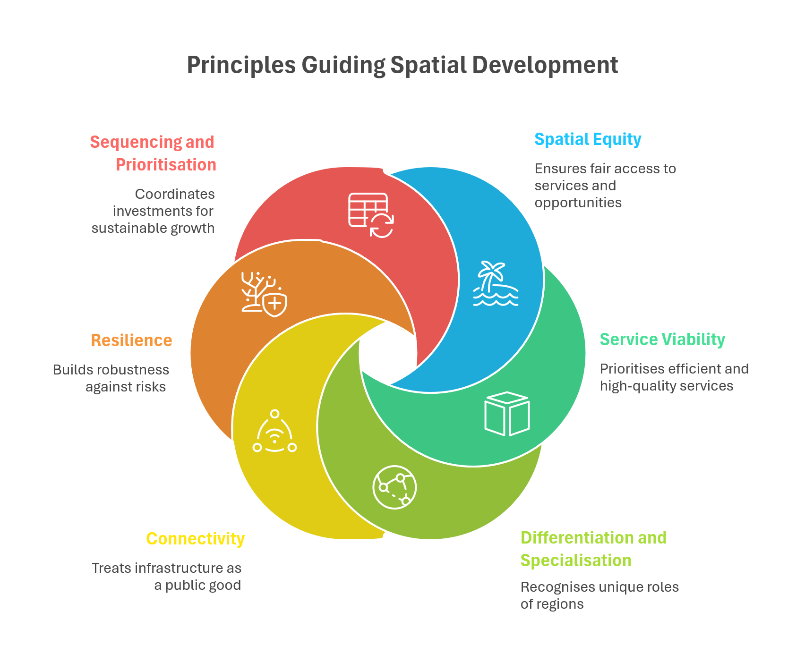
Figure 18 - Principles Guiding Spatial Development

Part D – Strategic Pillars

Pillar I: National Identity, Values and Culture
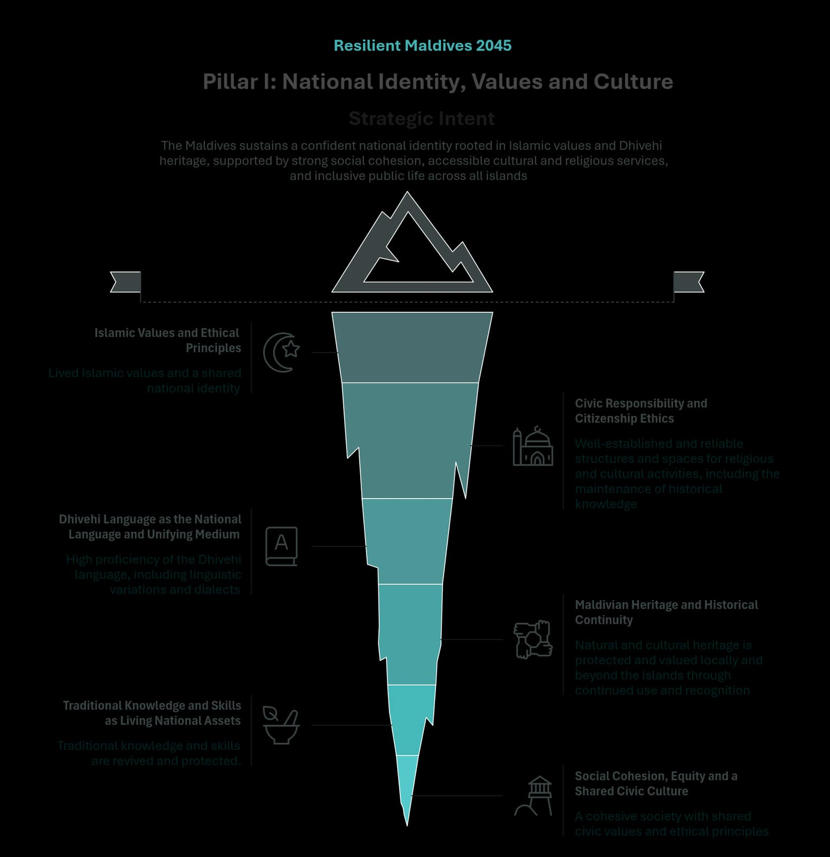
Figure 19 - Pillar I: National Identity, Values and Culture

Pillar Purpose and Strategic Intent

Strategic Intent
The Maldives sustains a confident national identity rooted in Islamic values and Dhivehi heritage, and sustained through a shared civic culture that is lived across islands and generations. Social cohesion is strengthened through inclusive public life and everyday opportunities for people to participate, contribute and collectively belong, including accessible community, cultural and religious services.

System Framing
This Pillar treats national identity and social cohesion as long-term conditions for national unity across a dispersed island geography. The purpose of this Pillar is to ensure continuity in national identity and for people to be able to live peacefully in Maldivian society. Identity is sustained when common reference points – Islamic faith, language, history, cultural events, civic culture, shared experiences, and interests – are visible in community life and jointly valued. Islamic faith is a foundational element of Maldivian national identity. Dhivehi heritage itself is multi-faceted; religion, language, creative culture, routines and rituals, traditional knowledge, food culture, shared history, cultural sites, and places of local and national significance, and lived experience of country’s unique geography and natural assets are all interrelated important aspects of shared national identity.
Social cohesion is experienced when people share a sense of belonging, feel connected to others, share common values, can manage disagreements peaceably, perceive their community as safe and fair and can access shared institutions and public spaces on equal terms. The Pillar recognises that the Maldives has deep interrelations with other countries and cultures through its rich settlement history, neighbourly relations, maritime connections, and linguistic linkages.

Pillar Focus
This Pillar focuses on strengthening the wide array of institutions, norms and lived practices that can sustain shared identity, values and culture over time and that can deepen social cohesion. The emphasis is on fair access to religious and cultural life; reliable, trusted services; shared public spaces and events; education, dialogue and exchange of knowledge, skills and perspectives; protection and continuity of Dhivehi heritage, and practical pathways for intergenerational transmission.

Pillar-level Outcomes
Achievement of this Pillar is reflected when the following outcomes are true across the Maldives:
- Outcome 1: Lived Islamic values and a shared national identity.
- Outcome 2: Well-established and reliable structures and spaces for religious, cultural and community activities, including the maintenance of historical knowledge.
- Outcome 3: High proficiency and creative use of the Dhivehi language, including linguistic variations and dialects where expressed.
- Outcome 4: A cohesive society with shared civic values and ethical principles.
- Outcome 5: Traditional knowledge and skills are revived, protected, and integrated into society and the economy.
- Outcome 6: Natural and cultural heritage is protected and valued locally and beyond the islands through continued use and recognition.
Together, these outcomes describe a society where a shared sense of belonging to the Maldives is lived in everyday life through strong Islamic faith, Dhivehi language, protected heritage, and active traditions across all islands. They also produce stronger social cohesion and fairness by widening equitable access to cultural and civic participation, so people experience development and public life as inclusive, principled, and locally rooted.

Policy Logic
This Pillar delivers its outcomes by shifting towards strengthening trusted services and spaces for community, cultural and religious activity, and sharing of historical knowledge that will reinforce Islamic values and Dhivehi heritage. Coupled with strong and creative language use, revived and economically integrated traditional knowledge, and protected natural and cultural heritage that is in active use, Maldivian national identity emerges strong and experienced across islands and population groups. Shared civic and ethical principles, acceptance of diversity and inclusion, peaceful management of disagreement and difference of opinion, and equitable access to public spaces and services create a sense of belonging, being valued and treated fairly.

Pillar-Level Themes
This Pillar is delivered through the following thematic systems, which together sustain national identity, social cohesion, and shared civic culture across islands and generations:
- Islamic Values and Ethical Principles
- Civic Responsibility and Citizenship Ethics
- Dhivehi Language as the National Language and Unifying Medium
- Maldivian Heritage and Historical Continuity
- Traditional Knowledge and Skills as Living National Assets
- Social Cohesion, Equity and a Shared Civic Culture

Islamic Values and Ethical Principles

Strategic Role
Community confidence in Islamic faith is strengthened when there is quality, accessibility, and integrity in religious services and spaces. Well-functioning mosques and related facilities ensure that daily religious life is easier to sustain and provides a common touchstone of faith. Trusted religious institutions can also reinforce cohesion by providing common reference points for decent and respectful conduct, mutual responsibility, and expectations of good social relationships and discipline.

Theme Outcomes
- Outcome 1: Religious services are accessible and reliably operated across islands, supported by well-maintained mosques and adequate associated facilities.
- Outcome 2: Religious awareness and learning opportunities are available for all ages through functioning centres and structured community programmes.
- Outcome 3: Religious guidance capacity is credible and responsive, sustaining trust in religious spaces and reinforcing lived values.

Policy Direction
- Strengthen the operational reliability of religious facilities and services, including the completion and effective use of delayed or unused assets.
- Maintain clear standards and integrity safeguards that protect trust in religious spaces.
- Support structured learning and guidance pathways that sustain the transmission of values across generations.

Civic Responsibility and Citizenship Ethics

Strategic Role
A shared civic culture involves the active participation of individuals to support their community and society, and the moral framework and principles that guide these actions to foster wellbeing or achieve a common good. This theme connects lived values to civic behaviour, shared expectations of fairness and respect, and the everyday public norms that support peaceful and cohesive communities. It supports the Pillar by making ethical principles visible in daily interactions, service settings, and community participation

Theme Outcomes
- Outcome 1: Shared civic values and ethical principles are reflected in everyday public life and community conduct across islands.
- Outcome 2: Community participation supports mutual responsibility and respect, strengthening inclusive public life and social cohesion.
- Outcome 3: Public-facing settings reinforce shared norms, supporting trust and a common sense of citizenship.

Policy Direction
- Strengthen community norms that reinforce respectful public conduct and inclusive participation.
- Align civic ethics with values transmission systems so expectations are reinforced through learning and community routines.
- Reduce barriers to participation so civic culture is shared across islands and population groups.

Dhivehi Language as the National Language and Unifying Medium

Strategic Role
A shared language is a primary vehicle for transmitting heritage, shaping distinct worldviews, and fostering social cohesion. High proficiency of Dhivehi supports educational outcomes, creativity, and confidence in cultural expression. This theme contributes directly to language-related pillar outcomes and to inclusive public life across islands.

Theme Outcomes
- Outcome 1: Dhivehi proficiency and creative use strengthen across generations, including among youth, while linguistic variations and dialects are respected within national unity.
- Outcome 2: Dhivehi teaching quality and learning resources support strong outcomes, including embedded cultural and Islamic knowledge where relevant to heritage continuity.
- Outcome 3: Public-facing services and information are accessible through Dhivehi, reducing language barriers to participation.

Policy Direction
- Strengthen learning pathways and teaching capacity that improve Dhivehi outcomes and community and civil society groups that use Dhivehi for creative expression.
- Ensure service accessibility through Dhivehi-first or Dhivehi-available channels in routine interactions.
- Recognise and value linguistic variation as part of cultural continuity, while maintaining Dhivehi as the shared national medium.

Maldivian Heritage and Historical Continuity

Strategic Role
Tangible heritage sites, valued natural features, and cultural landscapes anchor collective memory in place. Museums, cultural centres, and community spaces sustain learning and research functions that prevent historical knowledge from becoming fragmented or lost. Underperformance in this theme creates long-term and often irreversible loss, as degraded or displaced heritage weakens continuity and limits intergenerational transmission of shared history.

Theme Outcomes
- Outcome 1: Natural and cultural heritage is protected and maintained, with heritage places and cultural landscapes safeguarded within development and expansion decisions.
- Outcome 2: Community access to heritage learning strengthens through functioning heritage spaces and visible local heritage assets.
- Outcome 3: Historical knowledge and continuity are sustained through institutional structures that support learning, documentation, and research.

Policy Direction
- Protect heritage places and cultural landscapes as part of long-term spatial choices and community development pathways.
- Strengthen heritage visibility and community access so heritage is seen and valued locally and globally.
- Support institutional continuity for historical knowledge, including local learning spaces and credible stewardship arrangements.

Traditional Knowledge and Skills as Living National Assets

Strategic Role
This theme protects continuity of Maldivian heritage by keeping traditional knowledge and skills active, and by ensuring that these skills are socially respected and where possible economically viable.

Theme Outcomes
- Outcome 1: Traditional knowledge and skills are actively practised and transmitted across generations, including strong youth participation.
- Outcome 2: Living traditions remain embedded in community life, sustaining island identity and shared cultural routines.
- Outcome 3: Traditional knowledge and skills contribute to inclusive livelihoods and economic participation.

Policy Direction
- Strengthen intergenerational learning and community participation so traditions remain living practices.
- Enable viable pathways for culture-linked earning without eroding cultural integrity.
- Reduce barriers that constrain participation and market access for those sustaining traditional skills.

Social Cohesion, Equity and a Shared Civic Culture

Strategic Role
Social cohesion is both an outcome and an enabling condition for this Pillar. Inclusive public life depends on whether people can gather, learn, participate, and access services equitably and without exclusion. This theme integrates accessibility, inclusion, and shared civic culture that guides all aspects of public life.

Theme Outcomes
- Outcome 1: Inclusive public life strengthens through accessible cultural and religious services and functioning community spaces across islands.
- Outcome 2: Equity in participation improves, with reduced barriers to language access and cultural engagement in daily life.
- Outcome 3: Shared civic culture supports belonging and trust, sustaining cohesion under modernisation and development pressures.

Policy Direction
- Strengthen equitable access to cultural, religious, and community spaces across islands.
- Reduce participation barriers that undermine cohesion, including language-related exclusion in service access.
- Maintain cultural character and shared spaces as development proceeds, protecting belonging and community trust.

How Change is Expected to Occur
For change to occur under this Pillar, religious and cultural services must operate consistently, supported by trusted and well-maintained institutions. Language continuity depends on teaching quality, creative encouragement, and on service environments that enable Dhivehi access in routine interactions. Heritage protection and living traditions depend on choices that keep places, landscapes, and community routines intact. This requires coherence between cultural stewardship and island development decisions, ensuring heritage is not treated as a residual concern. Social cohesion strengthens when inclusive spaces and shared routines reinforce belonging and acceptance.
Change levers:
- Institutional reliability of religious and cultural services, including maintenance, integrity, and accessible community spaces.
- Learning quality and public language access that sustain Dhivehi proficiency and reduce exclusion.
- Heritage governance embedded in development and expansion decisions to protect places and cultural landscapes.
- Intergenerational transmission systems that keep traditions active and socially valued.
- Inclusive public life and equity in participation across islands as a sustained cohesion function.

Cross-Cutting Safeguards
Implementation of this Pillar requires safeguards that protect equity, inclusion, and trust across islands and population groups. Access to religious and cultural services should not depend on geography, local capacity gaps, or avoidable language barriers. Integrity in shared spaces must be maintained through fair and consistent oversight. Heritage protection should be applied consistently within island development choices so continuity is not undermined by short-term decisions.
Safeguards include:
- Equitable access to cultural and religious services and community spaces across islands.
- Dhivehi-accessible service environments that reduce exclusion in public life.
- Integrity safeguards for trusted religious and community institutions applied fairly and consistently.
- Protection of heritage places and cultural landscapes within development and expansion decisions.
- Inclusive participation in cultural life across generations, including youth engagement and women’s economic inclusion, where relevant.

Linkage Across NDP Vision and Framework
Pillar I provides the identity, values, and social cohesion foundations upon which the National Development Plan is built. By sustaining faith, language, heritage, and living traditions, it preserves the shared identity and sense of belonging that citizens seek to carry forward as economic, social, and environmental change unfolds.
Strong social cohesion and shared values under this Pillar reinforce participation, fairness, and trust across public life, supporting effective governance under Pillar V, inclusive wellbeing outcomes under Pillar III, and long-term resilience under Pillar IV. Together with economic transformation under Pillar II, these foundations ensure that national development remains socially grounded, culturally rooted, and widely owned as services, opportunities, and development patterns evolve.

Pillar II: A Resilient, Productive, and Inclusive Economy
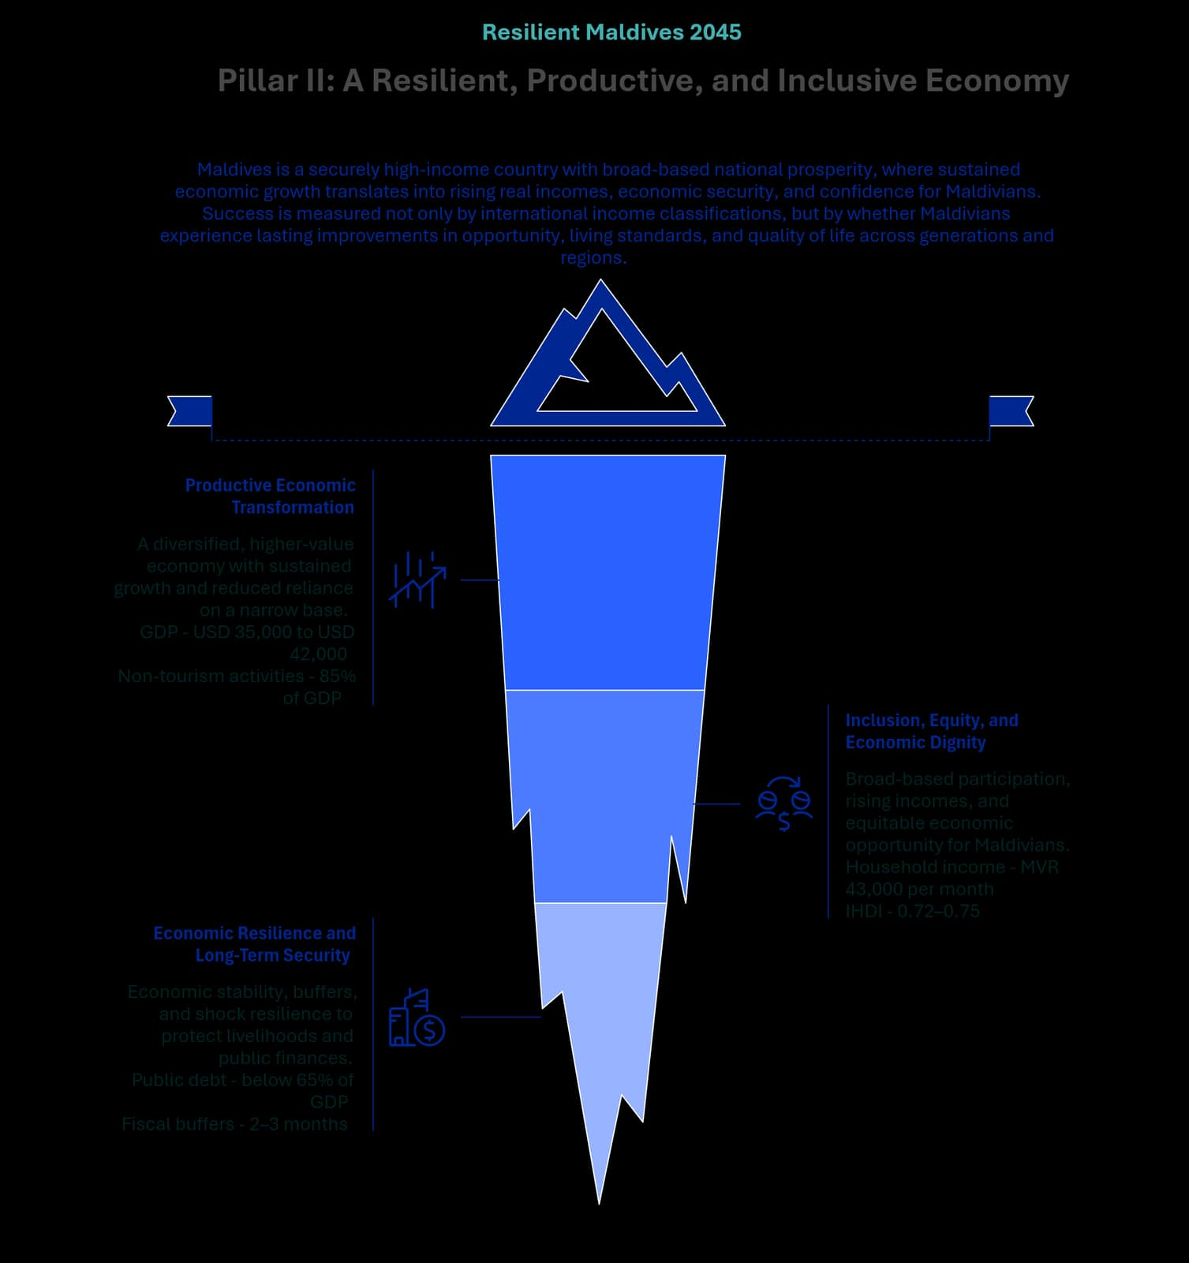
Figure 20 - Pillar II: A Resilient, Productive, and Inclusive Economy

Pillar Purpose and Strategic Intent

Strategic Intent
By 2045, the Maldives is a securely high-income country with broad-based national prosperity, where sustained economic growth translates into rising real incomes, economic security, and confidence for Maldivians. Success is measured not only by international income classifications, but by whether Maldivians experience lasting improvements in opportunity, living standards, and quality of life across generations and regions.

System Framing
This Pillar responds to a set of interlinked national challenges. The economy remains heavily reliant on a narrow, tourism-led base with high exposure to external and climate shocks. Domestic value retention, productivity growth, and spillovers are limited, while high public debt, persistent fiscal deficits, weak buffers, and constrained policy space increase vulnerability. Skills gaps, informality, and low local participation in high-value activities persist, alongside uneven access to opportunity across regions, genders, and generations in a geographically dispersed, small-population country.
If these structural conditions remain unaddressed, economic growth risks remaining fragile, import-intensive, and uneven in its benefits. Living standards and fiscal stability would remain exposed to shocks, limiting the country’s ability to sustain high-quality public services and intergenerational security.

Pillar Focus
This Pillar therefore focuses on a structural shift away from volume-driven and import-intensive growth toward a value-based, productivity-led, and resilience-oriented development model. It anchors economic transformation within ecological limits, minimum social foundations, and disciplined macro-fiscal management, treating inclusion, dignity, and intergenerational security as core economic outcomes rather than secondary social objectives.

Pillar-Level Outcomes
Achievement of this Pillar is reflected when the following outcomes are true across the Maldives:
- Outcome 1: Securely high-income prosperity that is resilient across economic cycles, with living standards protected from economic and external shocks. GNI per capita reaches and is sustained at 2.0–2.5 times the World Bank high-income threshold by 2045 (approximately USD 35,000 to USD 42,000, using current World Bank estimates adjusted annually for inflation using the Special Drawing Rights (SDR) deflator), and usable reserves are maintained at 5–6 months of import cover (approximately 1.5–2 times the IMF-recommended minimum of 3 months).
- Outcome 2: Higher real incomes and higher GNI per capita accruing to Maldivians, reflecting broad-based participation in wealth creation and ownership. Real median household income increases to approximately MVR 43,000 per month in constant prices, compared to a baseline of MVR 23,500 (HIES 2019), reflecting broad-based income growth and higher domestic value retention.
- Outcome 3: A more diversified and productive economic structure, with stronger value generation across multiple stages of value chains and reduced over-reliance on a narrow economic base. Non-tourism activities increase their direct contribution to GDP to approximately 85 percent from a baseline of 77 percent, food imports decline to around 14–16 percent of total imports from a baseline of 20 percent, and renewable energy accounts for approximately 50 percent of power generation, compared to roughly 8 percent in 2025.
- Outcome 4: Reduced disparities in income and opportunity across regions, genders, and generations, alongside higher labour-force participation, and access to high-quality employment. Inclusive development outcomes are reflected in a sustained improvement in the inequality-adjusted Human Development Index (IHDI), rising from an estimated baseline of around 0.60 to approximately 0.72–0.75 by 2045, with inequality-related losses in human development reduced to below 15 percent.
- Outcome 5: Stronger national savings and buffers, so shocks do not undermine fiscal stability, development spending, or household security. Public debt is reduced to approximately 65 percent of GDP from a baseline of 135 percent, and fiscal buffers are established equivalent to around 2–3 months of recurrent government spending.
Together, these outcomes describe an economy in which prosperity is durable, inclusive, and resilient, with growth translating into higher living standards, reduced vulnerability, and stronger fiscal and economic security across islands, population groups, and generations.

Policy Logic
This Pillar shifts the growth model toward productivity, value creation, and resilience as the basis of sustained prosperity. Growth is anchored at the firm and value-chain level, where competitiveness and innovation determine whether expansion delivers durable income gains and domestic value retention. Diversification strengthens resilience, macro-fiscal stability enables transformation, and growth is considered successful only where it raises median incomes, improves job quality, broadens participation, and remains within ecological limits that protect long-term competitiveness.

Pillar-Level Themes
This Pillar is delivered through the following thematic systems, which together shape a resilient, productive, and inclusive economic model for the Maldives:
- Productive Economic Transformation
- Inclusion, Equity, and Economic Dignity
- Economic Resilience and Long-Term Security

Productive Economic Transformation

Strategic Role
This theme re-orients the growth model from concentration and volume-led expansion toward value-based growth rooted in firm-level productivity, innovation, and stronger positioning in regional and global markets. It focuses on increasing domestic value retention, strengthening domestic linkages, including tourism-linked supply chains, and reducing structural leakages that intensify import dependence. Diversification is pursued deliberately as a resilience strategy rather than an end in itself.

Theme Outcomes
- Outcome 1: Higher firm-level productivity and innovation across the economy, including MSMEs, enabling sustained value-based growth.
- Outcome 2: Greater domestic value retention through stronger local linkages and deeper participation across value chains, reducing leakages and import-driven fragility.
- Outcome 3: A broader and more resilient economic base, with reduced vulnerability to sector-specific disruptions and external shocks.
- Outcome 4: Higher-quality employment and export capability, distributed beyond Malé and the central atolls through viable regional economic activity.

Policy Direction
- Prioritise value over volume by anchoring competitiveness in productivity, quality, and innovation rather than scale alone.
- Strengthen a rules-based, competition-supporting investment climate that rewards entrepreneurship, fairness, and innovation diffusion.
- Avoid sector-specific protection or permanent incentives that insulate firms from competition and productivity discipline.
- Align cross-government economic priorities around measurable productivity and competitiveness outcomes, reducing fragmented or siloed pathways.
- Reduce structural drivers of high business costs that constrain scaling and value-chain upgrading.
- Use key industries as transformation pathways while keeping the Pillar economy-wide and outcome-focused.

Industry-level direction statements under Industry Transformation
- Tourism Transformation and Linkages
By 2045, tourism evolves into a high-value, resilient visitor economy that increases value per visitor and strengthens domestic linkages, positioning the Maldives as a global reference point for high-value, sustainable tourism. Growth is constrained by environmental and ecological limits and enabled by world-leading standards in experience quality, branding, and deep local supply chains. Tourism becomes a platform for shared prosperity, with significantly higher Maldivian participation in ownership, management, and skilled roles, and acts as a catalyst for productivity and value creation across supporting sectors.

- Fisheries, Ocean Resources, and the Blue Economy
By 2045, fisheries and ocean resources are managed as long-term economic assets, with sustainability, traceability, and compliance as prerequisites for market access and value creation. The sector shifts from raw exports toward higher value addition through processing, certification, and downstream activities, creating credible professional and technology-enabled career pathways while strengthening resilience.

- Agriculture and Food Security
By 2045, food systems reduce import vulnerability and improve affordability through targeted, climate-smart production, technology adoption, and value-chain integration. The objective is a resilient and productive food system that stabilises prices, strengthens food security, and links domestic production to urban and tourism demand.
- Emerging Strategic Industries
By 2045, the Maldives develops a selective portfolio of strategic, export-capable industries that broaden the economic base and deepen domestic value creation. Sector selection is guided by value generation, skills feasibility, resilience contribution, and environmental sustainability, with disciplined sequencing to ensure credibility.

- MSMEs, Entrepreneurship, and Innovation
By 2045, MSMEs shift from survival-oriented activity toward scalable contributors to national wealth and employment, supported by innovation diffusion, formalisation pathways, and improved access to finance and markets.

- Construction and Real Estate Transformation
By 2045, construction and real estate operate as productivity-enhancing national assets. Productivity improves through modern methods, standards, and technology adoption, while the built environment supports competitiveness, housing quality, and spatial strategy.

- Financial Sector Development
By 2045, the financial sector supports long-term investment, SME growth, and national wealth creation, expanding access to responsible finance while maintaining stability, governance, and transparency.

Inclusion, Equity, and Economic Dignity

Strategic Role
This theme ensures Maldivians are active participants in value creation and wealth-building. It translates growth into higher median incomes, dignified work, and upward mobility, with particular attention to youth, women, and regional inclusion.

Theme Outcomes
- Outcome 1: Higher median household incomes and economic security for Maldivians.
- Outcome 2: Higher labour-force participation and improved job quality, especially for youth and women.
- Outcome 3: Reduced regional disparities through viable regional economic hubs.
- Outcome 4: Stronger dignity, fairness, and opportunity through stable livelihoods and mobility.

Policy Direction
- Anchor economic success metrics in wellbeing and participation.
- Strengthen pathways to decent work and mobility.
- Increase inclusion in value chains.
- Ensure foreign labour and capital complement domestic capability.

Economic Resilience and Long-Term Security

Strategic Role
This theme reduces vulnerability to shocks and treats intergenerational security as an explicit economic objective by strengthening national savings, fiscal buffers, and institutional resilience, ensuring the economy is prepared in advance for the demographic transition toward an ageing population.

Theme Outcomes
- Outcome 1: Lower macroeconomic vulnerability.
- Outcome 2: Higher national savings and fiscal buffers.
- Outcome 3: Improved intergenerational security.
- Outcome 4: Sustained prosperity within ecological limits.

Policy Direction
- Embed resilience as a core economic objective.
- Strengthen macro-fiscal coherence.
- Integrate climate and disaster risks.
- Balance short-term stabilisation with long-term transformation.

How Change is Expected to Occur
Change occurs through reinforcing productivity-led growth, diversification-as-resilience, disciplined macro-fiscal management, and conversion of demographic gains into durable assets, with inclusion and dignity embedded as core outcomes.
Change levers:
- Firm-level productivity and innovation.
- Diversification as resilience.
- Industrial transformation.
- Macro-fiscal discipline.
- Asset accumulation.
- Inclusive participation.

Cross-Cutting Safeguards
Transformation is safeguarded through ecological limits, competition discipline, macroeconomic stability, institutional coherence, and complementary use of foreign labour and capital.

Linkage Across the NDP Vision and Framework
Pillar II provides the economic foundation for the NDP, enabling inclusive wellbeing (Pillar III), environmental stewardship (Pillar IV), and credible governance (Pillar V).

Supporting Framework to Pillar II: Effective Resource Allocation and Factor Productivity

Purpose and Rationale
This Supporting Framework clarifies how Pillar II’s objectives of productivity-led, value-based, and resilient economic transformation are realised through the effective allocation and use of core economic resources. It focuses on the interaction between labour, land, infrastructure, capital, and migration, recognising that sustained income growth and domestic value retention depend not only on sectoral strategies, but on how these factors are structured, priced, and governed across the economy.
The Framework is explicitly anchored to Pillar II. It does not constitute a standalone pillar or a horizontal system enabler. Its role is to consolidate the underlying economic transformation logic that connects productivity, competitiveness, inclusion, and resilience, and to provide coherence across sectoral, spatial, and investment decisions.

Core Framework Components
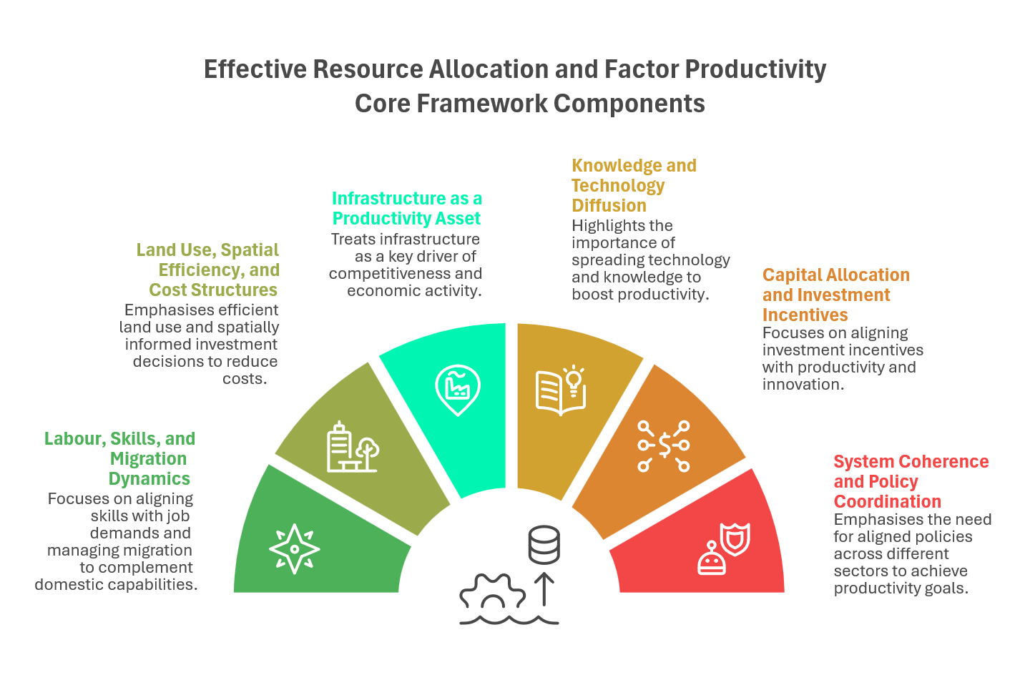
Figure 21 - Effective Resource Allocation and Factor Productivity Core Framework Components

Labour, Skills, and Migration Dynamics
Productivity growth depends on effective alignment between skills, job quality, and labour demand, alongside migration regimes that complement domestic capability. Labour and migration systems must support pathways from skills development into productive employment, enable firms to access labour where domestic supply is constrained, and ensure that foreign labour contributes to productivity, knowledge transfer, and net national wealth without suppressing wages or discouraging skills upgrading.

Land Use, Spatial Efficiency, and Cost Structures
Land and spatial constraints shape business costs, investment feasibility, and regional economic opportunity. Inefficient land use and fragmented spatial planning raise construction, logistics, and service-delivery costs, weakening competitiveness and reinforcing geographic concentration. This Framework emphasises land-use efficiency and spatially informed investment decisions that support viable regional hubs and reduce structural cost disadvantages, in alignment with spatial development priorities.

Infrastructure as a Productivity Asset
Infrastructure is treated as a productivity-enhancing economic asset rather than only a service-delivery requirement. Energy, transport, logistics, and connectivity systems directly affect firm competitiveness, import dependence, and the feasibility of value-chain upgrading. Effective resource allocation requires infrastructure systems that reduce structural business costs, support diversification, and regional economic activity, and are planned with lifecycle efficiency and resilience in mind.

Knowledge and Technology Diffusion
Technology and knowledge diffusion are cross-cutting productivity multipliers: they raise the returns to labour, capital, and infrastructure when adoption is system-wide rather than siloed. The core constraint is absorption capacity such as skills, incentives, interoperability, and governance that allow proven practices to spread from frontier actors to the wider economy. Deliberate diffusion mechanisms (standards and platforms, performance-oriented procurement, partnerships and training) are therefore structural requirements to prevent gains concentrating in a few locations and to ensure productivity improvements compound over time.

Capital Allocation and Investment Incentives
Capital allocation influences which activities scale, stagnate, or fail to emerge. Pillar II’s emphasis on value-based growth requires investment incentives that reward productivity, innovation, and domestic value retention rather than volume expansion alone. This Framework supports alignment between financial intermediation and long-term investment needs, while avoiding permanent protections or distortions that weaken productivity discipline.

System Coherence and Policy Coordination
Productivity and resilience outcomes emerge from the interaction of labour, land, infrastructure, and capital systems. Fragmented decision-making across these domains can undermine sectoral strategies. This Framework therefore emphasises coherence across economic policy, spatial planning, infrastructure investment, and labour and migration policy, aligning short-term stabilisation with long-term competitiveness and resilience objectives.

Interface with Pillars and Enablers
While anchored in Pillar II, this Framework interfaces with Pillar III through labour-market outcomes and household economic security, with Pillar IV through ecological constraints on land use and investment, and with Part E Enablers related to infrastructure systems, governance, and state capability. It provides the economic logic that guides detailed policy design and investment choices in the Implementation Plan, without prescribing specific programmes, institutional arrangements, or timelines.

Pillar III: People, Well-being, and Social Systems
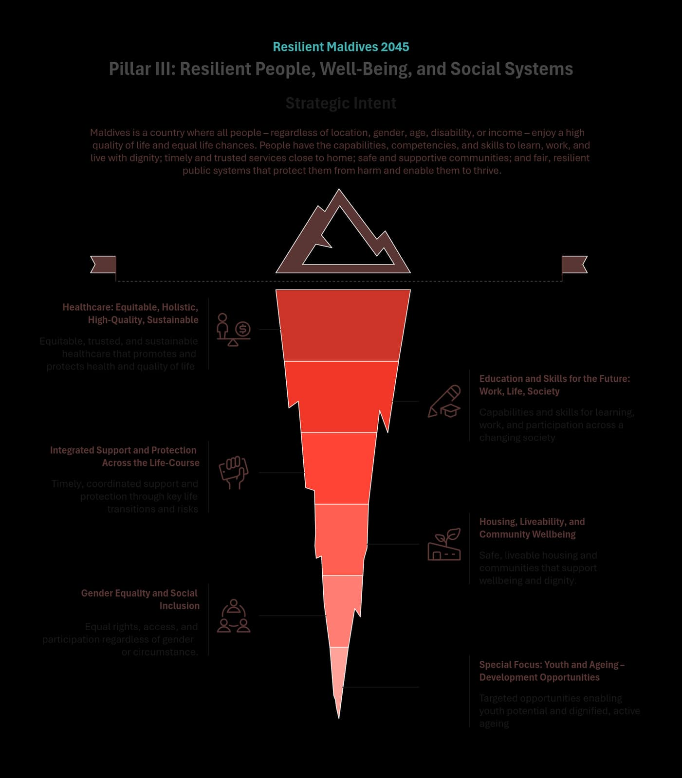
Figure 22 - Pillar III: People, Well-being, and Social Systems

Pillar Purpose and Strategic Intent
By 2045, the Maldives is a country where all people – regardless of location, gender, age, disability, or income – enjoy a high quality of life and equal life chances. People have the capabilities, competencies, and skills to learn, work, and live with dignity; timely and trusted services close to home; safe and supportive communities; and fair, resilient public systems that protect them from harm and enable them to thrive.
This Pillar focuses on strengthening the social systems that shape people’s everyday wellbeing and opportunity across the life-course. Health, education, skills, housing, protection, and inclusion are treated as interconnected systems that must work together to reduce inequality, prevent harm, and enable participation in national life and the economy.

Pillar-Level Outcomes
If this Pillar succeeds, the following outcomes will be evident:
- People benefit equitably from shared services, public systems, and social goods.
- People have the capabilities to participate in society and the economy with competence and dignity.
- People can access timely support during life transitions and protection from violence, harms, vulnerabilities, and risks.
- Life chances are not constrained by gender, age, disability, island location, income, or socio-economic starting point.
- Quality of life and shared social systems are high, trusted, and resilient.

Policy Logic
This Pillar advances a life-course approach to wellbeing by strengthening the systems that support people from early childhood through working life and into older age. Prevention, equity, proximity, and integration guide system design so that services are accessible close to home, support is timely, and outcomes are sustained over time.
Social systems are expected to function together – rather than in isolation – to enable learning, health, protection, participation, and security. When these systems are reliable, inclusive, and coordinated, people are better able to navigate change, recover from shocks, and contribute meaningfully to society and the economy.

Pillar-Level Themes
This Pillar is delivered through the following thematic systems, which together strengthen wellbeing, protection, and opportunity across the life course:
- Healthcare: Equitable, Holistic, High-Quality, Sustainable
- Education and Skills for the Future: Work, Life, Society
- Integrated Support and Protection Across the Life-Course
- Housing, Liveability, and Community Wellbeing
- Gender Equality and Social Inclusion
- Special Focus: Youth and Ageing – Development Opportunities

Healthcare: Equitable, Holistic, High-Quality, Sustainable

Strategic Role
Ensures people experience reliable, trusted healthcare close to home, reducing location-based inequities and preventing avoidable illness, suffering, and cost.

Theme Outcomes
People experience better health, fewer preventable deaths and complications, lower long-term healthcare costs, and greater trust in healthcare services, regardless of island location.

Policy Direction
- Establish a regional, tiered healthcare system with expanded on-island services, shared diagnostics and pharmaceuticals, mobile health services, and reliable emergency transfers.
- Strengthen health workforce capacity, distribution, and referral pathways.
- Prioritise population-specific needs, including maternal and child health, mental health, NCD prevention, and healthy ageing.
- Ensure existing facilities function reliably, avoiding “built but not working” services.
- Invest in prevention-first approaches and enabling environments for healthy active and creative living.

Education and Skills for the Future: Work, Life, Society

Strategic Role
Builds the capabilities, competencies, and skills people need to succeed in work, personal life, and society across their lifetimes, so they can contribute to national development through informed civic engagement and higher productivity.

Theme Outcomes
Children and young people complete education with trusted credentials and employable skills, access further learning or work without forced migration, and sustain active lifestyles, lifelong learning and civic participation.

Policy Direction
- Reduce location-based disadvantage through a regional education and training model covering general education, TVET, higher education, and lifelong learning.
- Develop learning environments that are connected, climate-resilient and inclusive.
- Improve workforce distribution and system-wide quality of education.
- Strengthen teacher capacity, retention, and specialist skills.
- Enable one-session schooling with inclusive wrap-around supports.
- Ensure equitable outcomes for vulnerable and at-risk groups.
- Balance in-person and technology-assisted learning without sacrificing quality.

Integrated Support and Protection Across the Life-Course

Strategic Role
Ensures people can live safely, navigate life transitions, and recover from crises through coordinated, trusted support and protection systems.

Theme Outcomes
People experience stronger wellbeing, safer families, cohesive communities, and fair, resilient institutions that protect them from harm and support recovery.

Policy Direction
Build integrated, community-based support and protection systems delivered close to home.
- Coordinate service pathways across health, education, social services, protection, housing, and civil society.
- Provide life-course-responsive support during key transitions and periods of risk.
- Ensure safe, supportive and enabling environments for active and creative lifestyles, including those that support sports and play ecosystems, arts and recreation, and the media landscape.

Housing, Liveability, and Community Wellbeing

Strategic Role
Creates safe, affordable housing and functional neighbourhoods that support wellbeing, cohesion, and participation.

Theme Outcomes
People live in stable, dignified housing with access to affordable utilities, services, and public spaces that support healthy, connected community life. Neighbourhoods must allow for labour mobility, workforce stability and transport connectivity.

Policy Direction
- Expand diverse, affordable housing options suited to different household needs.
- Ensure fair land use, allocation, tenancy rights, and access to finance.
- Plan complete neighbourhoods with reliable utilities, connectivity, and shared spaces.
- Invest in inclusive multi-use community facilities, “third spaces”, and the facilities for sports and play ecosystems, and arts and recreation.
- Support community events and activities that strengthen active lifestyles, creativity, cohesion, and belonging.

Gender Equality and Social Inclusion

Strategic Role
Removes structural barriers so access, participation, and outcomes are not determined by gender, disability, age, location, or income.

Theme Outcomes
People experience equal opportunities, reduced stigma and exclusion, and meaningful participation in education, work, leadership, and civic life.

Policy Direction
- Embed equality and inclusion across planning, budgeting, legislation, and service delivery.
- Enable equitable economic participation and access to finance and markets.
- Ensure equitable education and training outcomes, including for boys and young men at risk of disengagement.
- Strengthen care supports that enable participation in work and community life.
- Design inclusive services by default and strengthen survivor-centred protection systems.

Special Focus: Youth and Ageing – Development Opportunities

Strategic Role
Ensures life-stage-responsive opportunities and protections so both emerging and later-life needs are addressed.

Theme Outcomes
Young people transition smoothly into work and leadership, adults remain employable and productive, and older people age with dignity and security.

Policy Direction
- Strengthen skills-to-work pathways and youth entrepreneurship linked to growth sectors.
- Expand flexible upskilling and lifelong learning for the existing workforce.
- Improve regional connectivity and remote-work enabling infrastructure.
- Invest in prevention-first youth wellbeing systems, facilities and safe youth spaces.
- Establish diverse pathways for young people to prepare for and take up positions of leadership
- Establish the enabling environments for sports and play ecosystems, arts and recreation, and the traditional and social media landscape.
- Prepare for healthy ageing through integrated care, active lifestyles, accessible environments, and sustainable income security.

How Change is Expected to Occur
Change under this Pillar is driven by reinforcing social system levers that translate public investment into sustained wellbeing and equal life chances:
- Prevention-first system design, reducing avoidable harm and intervening early before disadvantage accumulates across the life-course.
- Equity and proximity in service access, ensuring location, income, gender, age, or disability do not determine outcomes.
- Integrated service pathways, enabling health, education, protection, housing, and social support systems to work together around people’s needs.
- Life-course responsiveness, aligning services to key transitions and periods of heightened risk rather than static eligibility categories.
- Capability and trust in frontline systems, ensuring services are reliable, dignified, and experienced as supportive rather than punitive.
- Community-based delivery and participation, strengthening local resilience, social connection, and shared responsibility for wellbeing.

Cross-Cutting Safeguards
Implementation of this Pillar is guided by safeguards that protect dignity, fairness, and long-term system sustainability:
- Equity as a binding principle, ensuring no group or location is systematically disadvantaged by design or implementation.
- Protection of rights and dignity.
- Avoidance of fragmented service delivery, reducing duplication, gaps, and institutional burden on individuals and families.
- Financial and institutional sustainability, so social systems remain viable and trusted over time.
- Resilience to shocks and stresses, including economic, health, climate, and social disruptions, in coordination with Pillar IV.
- Evidence-led learning and accountability, ensuring systems adapt based on outcomes and lived experience.

Linkage Across the NDP Vision and Framework
Pillar III underpins the National Development Plan by strengthening the people and social systems that enable all other pillars to succeed. By improving wellbeing, equity, protection, and participation across the life-course, it supports economic productivity under Pillar II, reinforces social cohesion and identity under Pillar I, and strengthens trust in public institutions and governance under Pillar V. Together, these systems ensure that national development translates into lived wellbeing and shared prosperity for all Maldivians.

Pillar IV: Climate Resilience and Environmental Stewardship
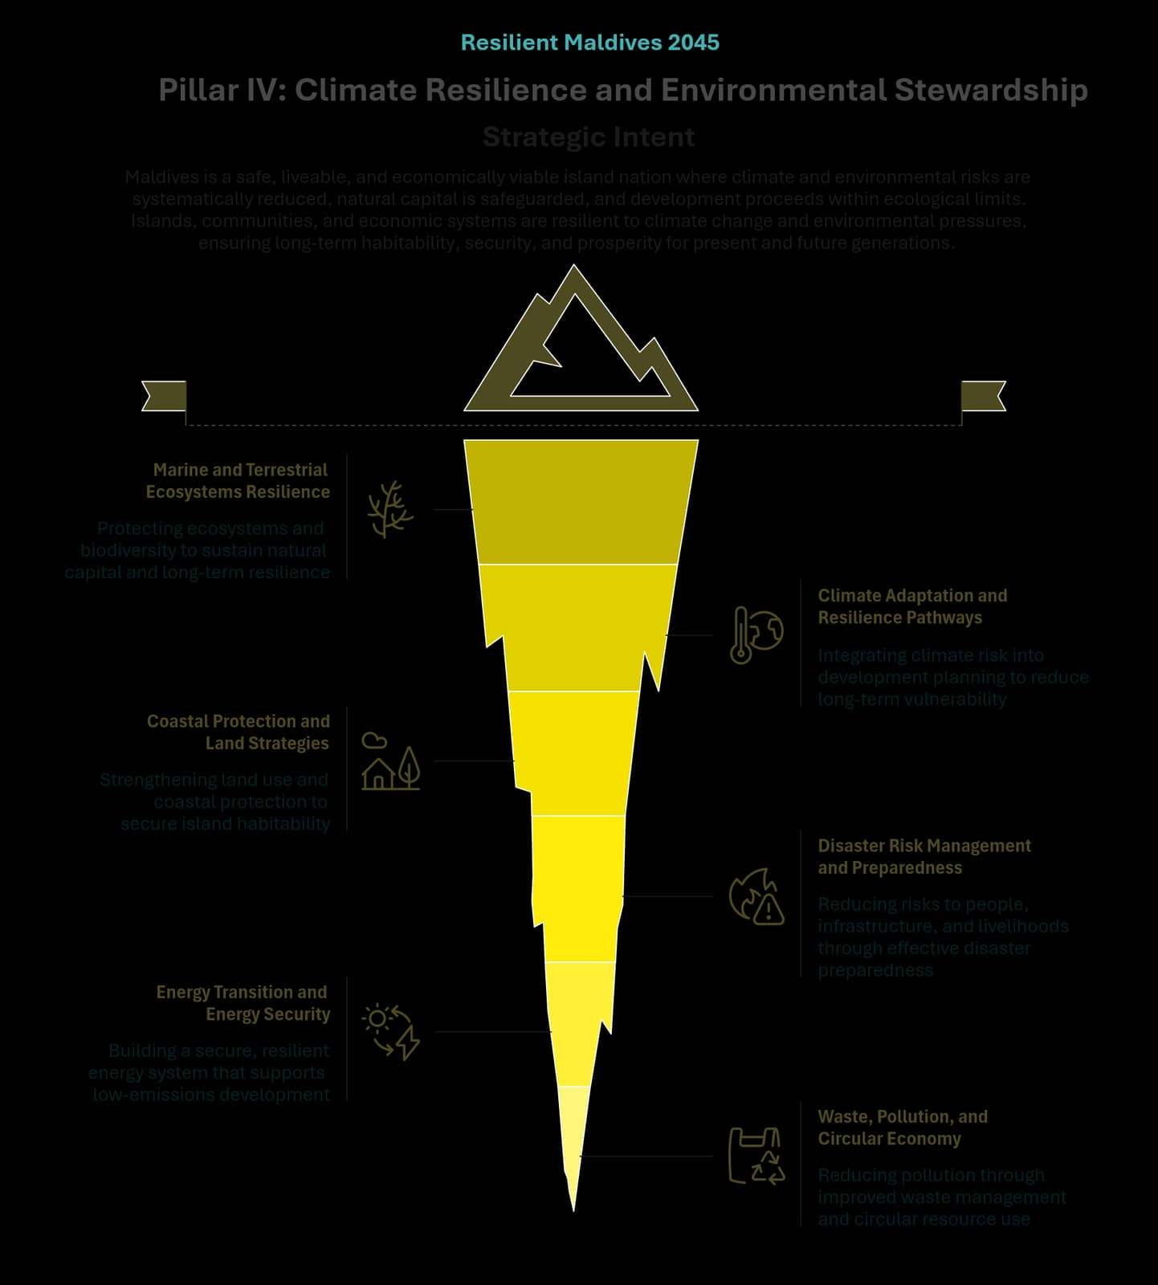
Figure 23 - Pillar IV: Climate Resilience and Environmental Stewardship

Pillar Purpose and Strategic Intent

Strategic Intent
By 2045, the Maldives is a safe, liveable, and economically viable island nation where climate and environmental risks are systematically reduced, natural capital is safeguarded, and development proceeds within ecological limits. Islands, communities, and economic systems are resilient to climate change and environmental pressures, ensuring long-term habitability, security, and prosperity for present and future generations.

System Framing
The Maldives faces a profound national challenge rooted in its geography and changing climate. As a nation of small, low-lying islands surrounded by vast ocean volumes, it is inherently vulnerable to climate change, sea-level rise, extreme weather events, and ocean-related risks. Human activities, particularly unplanned infrastructure and economic development, have intensified pressure on fragile ecosystems, increasing exposure to erosion, flooding, biodiversity loss, and environmental degradation.
If these pressures remain unmanaged, the degradation of natural capital and rising climate risks threaten island habitability, infrastructure viability, livelihoods, food security, and long-term economic stability. Development gains across other sectors cannot be sustained unless climate and environmental risks are addressed as core system conditions rather than residual concerns.

Pillar Focus
This Pillar therefore focuses on embedding climate resilience and environmental stewardship into national development pathways by integrating natural capital, ecosystem integrity, and climate risk into planning, investment, and decision-making. It strengthens ecosystems as protective infrastructure, aligns development with habitability and risk thresholds, and reduces vulnerability to climate and human-induced pressures to secure the Maldives’ long-term future

Pillar-Level Outcomes
Achievement of this Pillar is reflected when the following outcomes are true across the Maldives:
- Outcome 1: Nature, natural capital, ecosystem services, and climate risk considerations are systematically integrated into development planning, infrastructure investment, and economic decision-making.
- Outcome 2: Governance and stewardship of natural resources are strengthened, ensuring effective protection and sustainable use of biodiversity and ocean resources.
- Outcome 3: Communities live in greater harmony with nature, with reduced climate and environmental risks to infrastructure, livelihoods, and settlements through risk-informed national and island-level planning.
- Outcome 4: Ecosystem integrity and resilience are strengthened, enhancing biodiversity, coastal protection, fisheries productivity, and climate resilience.
Together, these outcomes ensure that development pathways remain environmentally viable, climate-resilient, and supportive of long-term island habitability, livelihoods, and economic prosperity across the Maldives.

Policy Logic
This Pillar treats climate resilience and environmental stewardship as foundational conditions for national survival, habitability, and long-term prosperity. Natural capital, ecosystems, and climate risk are managed as strategic assets embedded within development planning and investment decisions. Change is driven through risk-informed, evidence-led approaches that integrate ecosystem integrity, spatial planning, adaptation pathways, and disaster preparedness, reducing long-term vulnerability while avoiding maladaptive development choices and safeguarding livelihoods and critical economic zones.

Pillar-Level Themes
This Pillar is delivered through the following thematic systems, which together safeguard natural capital, reduce climate and environmental risks, and secure long-term island habitability:
- Marine and Terrestrial Ecosystems Resilience
- Climate Adaptation and Resilience Pathways
- Coastal Protection and Land Strategies
- Disaster Risk Management and Preparedness
- Energy Transition and Energy Security
- Waste, Pollution, and Circular Economy

Marine and Terrestrial Ecosystems Resilience

Strategic Role
This theme positions ecosystems and biodiversity as national resilience infrastructure that underpins island stability, ocean productivity, livelihoods, and human wellbeing. It guides development within ecological limits and secures ecosystem services that protect islands, sustain livelihoods, and support long-term habitability.

Theme Outcomes
- Outcome 1: Ecosystem degradation is slowed and reversed.
- Outcome 2: Healthy nature-based services, including coastal protection, fisheries productivity, carbon storage, and human wellbeing, are maintained.
- Outcome 3: Biodiversity is treated as a national asset.
- Outcome 4: Spatial and development planning becomes ecosystem-based.
- Outcome 5: Children and young people are empowered as environmental stewards and leaders

Policy Direction
Marine and terrestrial ecosystems are protected, restored, and sustainably managed, with technically sound and adequate safeguards maintained to ensure biodiversity integrity, robust ecosystem services, and resilience of island and ocean systems to current and future climate and human pressures.

Climate Adaptation and Resilience Pathways

Strategic Role
This theme provides the national and island-level decision framework for sequencing adaptation actions over time, guided by evidence, risk thresholds, and long-term habitability considerations.

Theme Outcomes
- Outcome 1: Climate risk is addressed proactively rather than reactively.
- Outcome 2: Adaptation decisions are phased, flexible, and evidence-based.
- Outcome 3: Public investments align with long-term resilience scenarios.
- Outcome 4: Island communities and human lives are safeguarded from climate risks.

Policy Direction
National and island-level development follows clearly defined, evidence-based climate-resilient adaptation pathways that reduce long-term vulnerability, avoid maladaptive investments, and safeguard habitability under changing climate conditions.

Coastal Protection and Land Strategies

Strategic Role
This theme applies a spatial resilience lens to shoreline protection and land-use decisions, balancing nature-based and engineered solutions to reduce long-term risk and maintenance burdens.

Theme Outcomes
- Outcome 1: Unplanned, short-term solutions are avoided, and dependence on hard engineering solutions is reduced.
- Outcome 2: Coastal and land-use decisions are strategically planned and evidence-based.
- Outcome 3: Erosion, flooding, and land loss are reduced.
- Outcome 4: Land use becomes more efficient and sustainable.

Policy Direction
Coastal protection and land-use decisions are risk-informed, ecosystem-sensitive, nature-based where appropriate, and strategically planned to ensure long-term safety, functionality, and resilience of inhabited islands and critical economic zones.

Disaster Risk Management and Preparedness

Strategic Role
This theme strengthens national readiness and continuity by prioritising prevention, preparedness, and coordinated response to disaster risk.

Theme Outcomes
- Outcome 1: Disaster risk management focuses on preparedness and prevention.
- Outcome 2: Institutional coordination for disaster risk management is strengthened.
- Outcome 3: Community-level resilience to disasters is enhanced.

Policy Direction
Disaster risk impacts are systematically reduced through strengthened preparedness, early warning, risk-informed planning, and community readiness, minimising loss of life, environmental damage, and economic disruption.

Energy Transition and Energy Security

Strategic Role
This theme treats energy as a critical enabling system for island habitability, public services, and economic continuity, while reducing exposure to fossil fuel risks.

Theme Outcomes
- Outcome 1: Energy security and affordability are improved.
- Outcome 2: Emissions and pollution are reduced.
- Outcome 3: Research outputs on renewable energy sources in the Maldives are increased.

Policy Direction
The Maldives establishes a low-carbon, secure, and resilient energy system that reduces dependence on fossil fuels, enhances reliability, and supports national climate and development objectives.

Waste, Pollution, and Circular Economy

Strategic Role
This theme reduces environmental pressure by addressing waste and pollution as systemic risks while enabling circular economy pathways and green jobs.

Theme Outcomes
- Outcome 1: Environmental and marine pollution are reduced.
- Outcome 2: Waste governance and market participation are improved.
- Outcome 3: Circular economy activities and green jobs grow.
- Outcome 4: Communities demonstrate increased awareness and practice of sustainable consumption.

Policy Direction
Waste generation, pollution, and resource inefficiency are reduced through improved sustainable consumption, waste management practices, and circular economy approaches, resulting in cleaner islands and oceans, improved public health, and sustainable material use across economic sectors.

How Change is Expected to Occur
Change under this Pillar occurs through system-level levers that embed climate resilience and environmental stewardship into development decisions:
Change levers:
- Integration of natural capital and climate risk into planning and investment.
- Evidence-led adaptation pathways that sequence actions and avoid maladaptation.
- Ecosystems treated as protective infrastructure alongside engineered solutions where required.
- Risk-informed spatial planning that reduces long-term exposure.
- Preparedness and early warning systems to prevent cascading losses.
- Energy and resource transitions that reduce vulnerability and environmental pressure.

Cross-Cutting Safeguards
Implementation is governed by safeguards that protect long-term viability and coherence, including ecological limits treated as binding constraints on development, public investment aligned with long-term climate and habitability scenarios, avoidance of fragmented or short-term infrastructure that creates future liabilities, strong institutional coordination across climate, environment, planning, and disaster risk functions, and continuous learning and community stewardship under climate uncertainty.

Linkage Across the NDP Vision and Framework
Pillar IV safeguards the environmental and resilience foundations of the National Development Plan by reducing climate and environmental risks, protecting natural capital, and strengthening island habitability. It underpins economic productivity and diversification under Pillar II, supports wellbeing and safety outcomes under Pillar III, and reinforces long-term planning discipline and public trust under Pillar V. Together with the other pillars, Pillar IV ensures that national development pathways remain viable, resilient, and equitable over time.

Pillar V: Democratic Governance, Statehood, and Public Trust
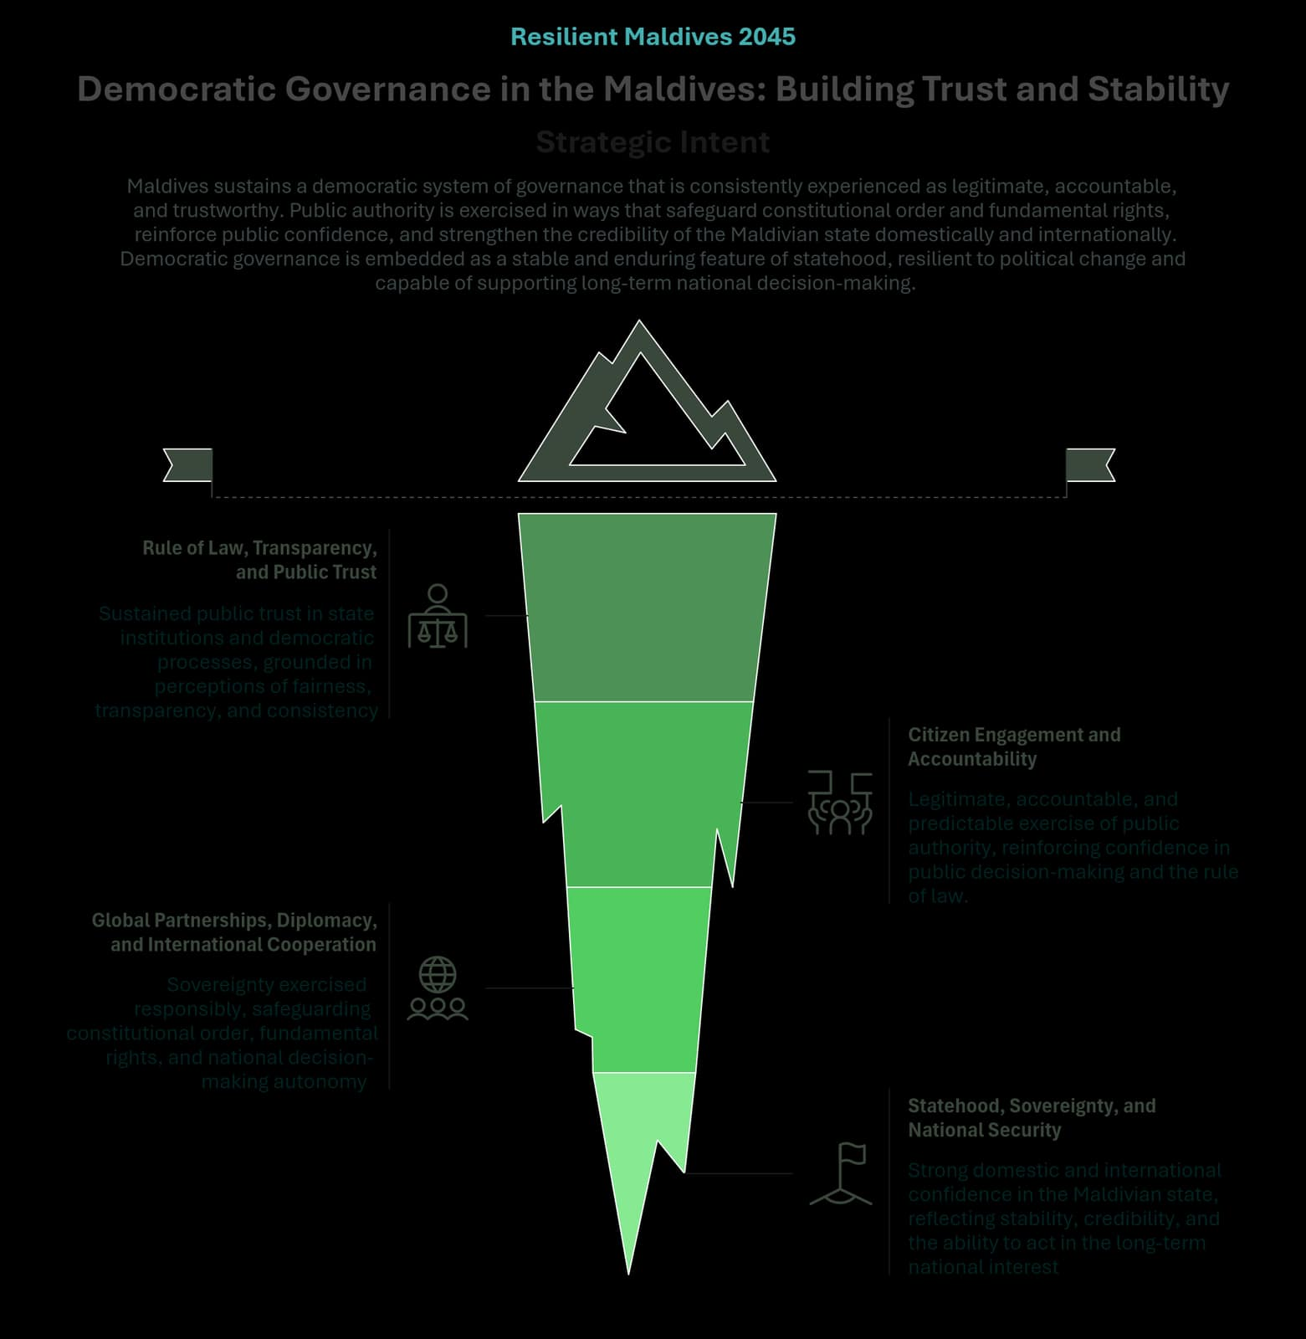
Figure 24 - Pillar V: Democratic Governance, Statehood, and Public Trust

Pillar Purpose and Strategic Intent

Strategic Intent
By 2045, the Maldives sustains a democratic system of governance that is consistently experienced as legitimate, accountable, and trustworthy. Public authority is exercised in ways that safeguard constitutional order and fundamental rights, reinforce public confidence, and strengthen the credibility of the Maldivian state domestically and internationally. Democratic governance is embedded as a stable and enduring feature of statehood, resilient to political change and capable of supporting long-term national decision-making, in social, economic and climate strategies across political cycles.

System Framing
In the Maldives’ small-island context – characterised by geographic dispersion, environmental vulnerability, fiscal constraints, and exposure to external pressures – deficits in democratic governance impose high social, political, and economic costs. Public trust, institutional legitimacy, and the credible exercise of sovereignty are therefore foundational conditions for national resilience, social cohesion, and sustained development.
Democratic governance is ultimately assessed through lived experience: whether public authority is exercised fairly and predictably, rights are protected, participation is meaningful, and state institutions act transparently and impartially across the country. Where these conditions weaken, confidence erodes, social cohesion frays, and the state’s capacity to act in the long-term national interest is undermined.

Pillar Focus
This Pillar therefore focuses on strengthening the systems, norms, and institutional practices that sustain democratic legitimacy, public trust, and responsible statehood over time. It reinforces the rule of law, accountability, participation, and principled international engagement as mutually reinforcing foundations of a resilient, credible, and trusted Maldivian state.

Pillar-Level Outcomes
Achievement of this Pillar is reflected when the following outcomes are true across the Maldives:
- Outcome 1: Sustained public trust in state institutions and democratic processes, grounded in perceptions of fairness, transparency, and consistency.
- Outcome 2: Legitimate, accountable, and predictable exercise of public authority, reinforcing confidence in public decision-making and the rule of law.
- Outcome 3: Sovereignty exercised responsibly, safeguarding constitutional order, fundamental rights, and national decision-making autonomy.
- Outcome 4: Strong domestic and international confidence in the Maldivian state, reflecting stability, credibility, and the ability to act in the long-term national interest.
Together, these outcomes describe enduring conditions of governance and society, rather than the performance of individual institutions or sectors, ensuring democratic resilience and trusted statehood across political cycles.

Policy Logic
This Pillar is grounded in the understanding that public trust, democratic legitimacy, and sovereignty are mutually reinforcing. The predictable and lawful exercise of authority builds confidence; participation and accountability sustain legitimacy; and credible governance strengthens the state’s ability to act autonomously and engage externally. Weakness in any one dimension erodes the others. The themes under this Pillar therefore function as an integrated system shaping how democracy and statehood are experienced by citizens and perceived by partners over a 20-year horizon.
Pillar V – Pillar-Level Themes
This Pillar is delivered through the following thematic systems, which together sustain democratic legitimacy, responsible statehood, and public trust over time:
- Rule of Law, Transparency, and Public Trust
- Citizen Engagement and Accountability
- Global Partnerships, Diplomacy, and International Cooperation
- Statehood, Sovereignty, and National Security

Rule of Law, Transparency, and Public Trust

Strategic Role
This theme ensures that public authority is exercised lawfully, predictably, and impartially, forming the foundation of democratic legitimacy and sustained public trust.

Theme Outcomes
- Outcome 1: Laws and regulations are applied consistently across institutions and regions.
- Outcome 2: Oversight and justice systems are widely perceived as independent and effective guarantors of rights.
- Outcome 3: Transparency is embedded as a routine feature of public decision-making and administration.
- Outcome 4: Public interactions with state institutions reinforce confidence in fairness and impartiality.

Policy Direction
- Lawful, predictable, and impartial exercise of public authority, including policing and justice functions, across institutions and regions.
- Consistent application of laws and regulations, reducing arbitrariness and unequal treatment.
- Credible, independent oversight and justice systems that are trusted as guarantors of rights.
- Transparency as a routine feature of public administration and decision-making.
- Everyday interactions between citizens and the state that reinforce fairness, dignity, and public trust.

Citizen Engagement and Accountability

Strategic Role
This theme ensures that democratic governance is participatory, responsive, and legitimate, with citizen engagement contributing meaningfully to public decision-making and accountability.

Theme Outcomes
- Outcome 1: Citizen participation is embedded as a normal feature of governance beyond electoral cycles.
- Outcome 2: Clear accountability relationships link public input, decisions, and explanations.
- Outcome 3: Democratic processes are inclusive across geography, age, and social groups.
- Outcome 4: Citizens perceive engagement with the state as meaningful and consequential.

Policy Direction
- Participation and accountability embedded routinely in governance.
- Clear and predictable relationships between public input, decision-making, justification, and redress.
- Inclusive engagement across geography, age, and social groups, ensuring participation reflects the diversity of lived experience across the country.
- Trusted participation channels, including digital and hybrid forms, that enable informed, respectful, and meaningful civic voice.
- Citizen experience of engagement as timely, consequential, and connected to real public decisions, reinforcing democratic legitimacy and public trust

Global Partnerships, Diplomacy, and International Cooperation

Strategic Role
This theme ensures that international engagement strengthens democratic governance and national development, while reinforcing sovereignty and long-term national interests.

Theme Outcomes
- Outcome 1: International partnerships are aligned with national development priorities and constitutional principles.
- Outcome 2: External commitments are managed coherently, transparently, and responsibly.
- Outcome 3: Diplomatic engagement enhances national credibility and negotiating capacity.
- Outcome 4: International cooperation supports long-term resilience and institutional legitimacy.

Policy Direction
- Alignment of external cooperation with national priorities, constitutional principles, and long-term fiscal sustainability, so partnerships strengthen national systems and coherence.
- Climate leadership consistent with Maldives’ SIDS position, prioritising adaptation, Loss and Damage support, and credible access to climate finance aligned with national commitments.
- Coherent and transparent management of international commitments, safeguarding policy autonomy, national credibility, and sovereign risk over time.
- Diplomatic agility in an increasingly complex Indo-Pacific environment, balancing external relationships to protect sovereignty and secure development outcomes.
- Partnerships that strengthen national credibility and negotiating capacity, enabling fair and mutually beneficial bilateral, regional, and multilateral cooperation.

Statehood, Sovereignty and National Security

Strategic Role
This theme safeguards the continuity, integrity, and security of the Maldivian state by protecting constitutional order, rights, and decision-making autonomy in an increasingly complex and uncertain environment.

Theme Outcomes
- Outcome 1: Constitutional order and fundamental rights are protected over time.
- Outcome 2: National decision-making autonomy is preserved in the face of internal and external pressures.
- Outcome 3: National security is exercised in a manner consistent with democratic governance and the rule of law.
- Outcome 4: Public confidence in the continuity, legitimacy, and security of the state is sustained.

Policy Direction
- Protection of constitutional order and fundamental rights over time, ensuring continuity of democratic governance across political cycles.
- Responsible exercise of sovereignty, safeguarding national decision-making autonomy while engaging constructively in regional and international affairs.
- National security functions to be consistent with democratic governance, civilian oversight, and the rule of law.
- Sustained public confidence in the continuity, legitimacy, and security of the Maldivian state, including its ability to manage emerging risks and external pressures.

How Change is Expected to Occur
Change under this Pillar occurs through reinforcing system behaviours that sustain legitimacy, accountability, and institutional credibility over time.
Change levers:
- Consistent application of the rule of law and transparent exercise of public authority
- Functioning accountability mechanisms that strengthen oversight, integrity, and public confidence
- Meaningful citizen engagement that informs decision-making and reinforces democratic legitimacy
- Protection of constitutional order, rights, and national decision-making autonomy
- Strategic international engagement that supports governance standards, sovereignty, and long-term national interests.

Cross-cutting Safeguards
Implementation of this Pillar is guided by safeguards that protect democratic integrity and state continuity, including adherence to constitutional principles and the separation of powers, transparency and access to information as foundations of public trust, institutional independence and integrity in oversight and accountability bodies, protection of fundamental rights and equal treatment under the law, and alignment of international cooperation with national sovereignty and long-term interests.

Linkage Across the NDP Vision and Framework
Pillar V provides the governance, statehood, and public trust foundations upon which the National Development Plan rests. By strengthening the rule of law, accountability, and citizen engagement, it enables effective policy implementation, credible institutions, and sustained public confidence across all areas of development.
Strong democratic governance under Pillar V supports economic stability and investor confidence under Pillar II, safeguards equity, rights, and inclusion under Pillar III, reinforces long-term planning and resilience under Pillar IV, and upholds the shared values and social cohesion articulated in Pillar I. Together, these linkages ensure that national development is legitimate, resilient, and owned by the people.

Part E – Enablers and Systems

E1: Infrastructure Systems and National Connectivity
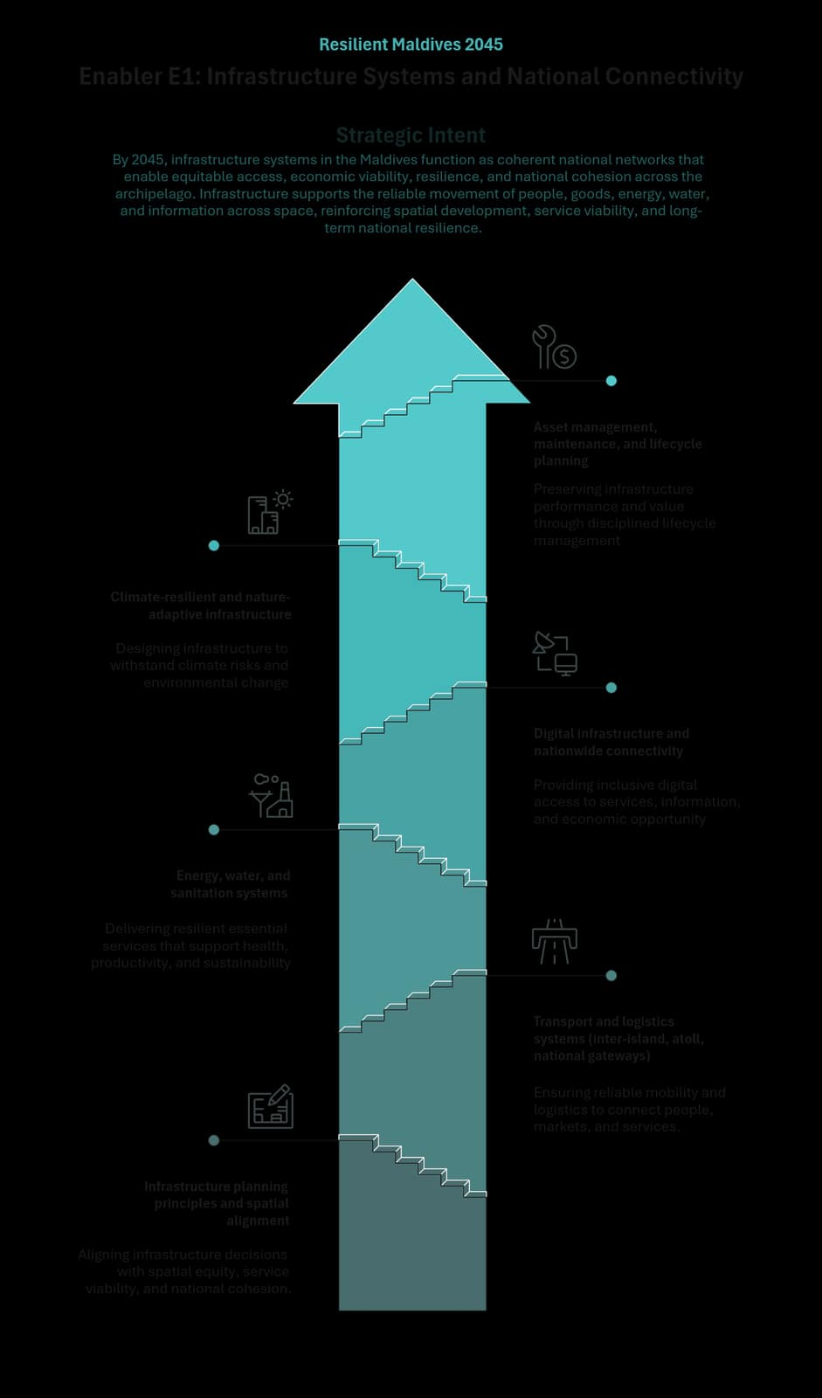
Figure 25 - E1: Infrastructure Systems and National Connectivity

Enabler Purpose and Strategic Intent

Strategic Intent
By 2045, infrastructure systems in the Maldives function as coherent national networks that enable equitable access, economic viability, resilience, and national cohesion across the archipelago. Infrastructure supports the reliable movement of people, goods, energy, water, and information across space, reinforcing spatial development, service viability, and long-term national resilience.

System Framing
In a geographically dispersed and climate-exposed context, fragmented infrastructure planning undermines service viability, increases costs, and reinforces spatial inequities. Weak coordination across transport, utilities, and digital systems constrains economic productivity beyond core centres and limits the State’s capacity to deliver reliable access under climate and fiscal pressures. Treating infrastructure as isolated assets or sectoral investments risks duplication, inefficiency, and uneven access.

Enabler Focus
This Enabler therefore focuses on how infrastructure systems are planned, aligned, and managed as coherent national networks that support spatial development, service viability, and a competitive, investment-enabling business environment, while strengthening long-term resilience. It ensures that infrastructure decisions reinforce national priorities, reduce fragmentation, and enable differentiated regional roles, without prescribing specific projects, technologies, or delivery models. By strengthening infrastructure as a system, E1 enables all strategic pillars of the NDP by supporting inclusive access, productive economic activity, environmental stewardship, and public trust in the State’s capacity to deliver.

Enabler-Level Outcomes
Achievement of this Enabler is reflected when the following system-level outcomes are realised by 2045:
- Equitable access to essential services and opportunities, achieved through reliable systems rather than uniform replication.
- Improved economic viability and productivity, supported by coherent transport, energy, water, and digital networks.
- Greater resilience of national infrastructure systems, reducing disruption from climate and external shocks.
- More efficient use of public capital, through coordinated planning and lifecycle management.
- Stronger national cohesion, enabled by connectivity across islands and regions.

Enabler Themes
The Enabler is delivered through the following functional themes, which together define the system architecture of this Enabler:
- Infrastructure planning principles and spatial alignment.
- Transport and logistics systems (inter-island, atoll, national gateways).
- Energy, water, and sanitation systems.
- Digital infrastructure and nationwide connectivity.
- Climate-resilient and nature-adaptive infrastructure.
- Asset management, maintenance, and lifecycle planning.

Infrastructure Planning Principles and Spatial Alignment

Functional Role
This theme establishes the principles through which infrastructure planning supports spatial equity, economic viability, and national cohesion. Infrastructure is treated as a coordinated system that enables differentiated settlement roles, service catchments, and connectivity patterns, while maintaining fairness of access.
Infrastructure planning aligns capital investment, service standards, and network design with spatial development logic, reducing fragmentation and inefficient duplication, and supporting viable settlement patterns.

Outcomes
- Infrastructure planning reinforces spatial equity through access rather than replication.
- Capital investments align with regional roles, service catchments, and connectivity needs.
- Fragmentation and inefficiency across systems are reduced.
- Long-term decisions support viable settlement patterns and cohesion.

Strategic Orientation (Policy Direction)
Infrastructure planning is guided by nationally consistent principles of spatial alignment, access equity, service viability, and lifecycle sustainability. Decisions are assessed for system coherence and long-term resilience. Specific plans and programmes are addressed through the Implementation Plan.

Transport and Logistics Systems (Inter-Island, Atoll, National Gateways)

Functional Role
This theme frames transport and logistics as national access systems enabling mobility, trade, service delivery, and regional integration. The emphasis is on reliability, continuity, and interoperability across island, atoll, and national scales.

Outcomes
- Reliable and predictable connectivity across regions.
- Reduced isolation and improved access to markets and services.
- Stronger logistics efficiency supporting economic activity and service delivery.

Strategic Orientation (Policy Direction)
Policy direction emphasises reliable, interoperable, and resilient transport and logistics systems. Service models, assets, and operations are addressed through the Implementation Plan.

Energy, Water, and Sanitation Systems

Functional Role
This theme treats energy, water, and sanitation as critical service systems underpinning public health, economic activity, and environmental protection. The emphasis is on reliability, redundancy, and sustainability, rather than technology choices or service models.

Outcomes
- Improved reliability and continuity of essential services.
- Reduced vulnerability to shocks and disruptions.
- More efficient and sustainable use of resources.

Strategic Orientation (Policy Direction)
Systems meet nationally defined standards of reliability, resilience, and sustainability. Technology choices and delivery mechanisms are addressed through implementation planning.

Digital Infrastructure and Nationwide Connectivity

Functional Role
This theme establishes digital infrastructure as a foundational connectivity layer enabling access to services, information, markets, and governance across all islands, with a focus on reliability, interoperability, and inclusion.

Outcomes
- Nationwide access to reliable digital connectivity.
- Reduced digital exclusion across regions and groups.
- Better integration of digital systems supporting public and private activity.

Strategic Orientation (Policy Direction)
Policy direction prioritises inclusive, interoperable, and resilient digital infrastructure. Platforms, applications, and institutional arrangements are addressed through the Implementation Plan.

Climate-Resilient and Nature-Adaptive Infrastructure

Functional Role
This theme embeds climate resilience and environmental adaptation as binding requirements for infrastructure systems, accounting for climate risks, ecological thresholds, and long-term sustainability.

Outcomes
- Reduced exposure of infrastructure to climate and environmental risk.
- Improved durability and performance of assets over time.
- Stronger alignment between infrastructure development and environmental stewardship.

Strategic Orientation (Policy Direction)
Infrastructure systems comply with climate resilience and environmental sustainability principles. Design standards and adaptation measures are addressed through implementation planning.

Asset Management, Maintenance, and Lifecycle Planning

Functional Role
This theme strengthens infrastructure stewardship through systematic asset management, maintenance, and lifecycle planning, preserving asset value, performance, and safety over time.

Outcomes
- Improved asset performance and longevity.
- Reduced lifecycle costs and fiscal risk.
- More predictable service quality and reliability.

Strategic Orientation (Policy Direction)
Lifecycle-based asset management and maintenance are core system functions. Tools, standards, and institutional arrangements are addressed through the Implementation Plan.

Linkage to Strategic Pillars
E1 enables the strategic pillars by providing infrastructure systems that support access, productivity, resilience, and trust:
- Pillar I: Connectivity and equitable access strengthen cohesion and participation.
- Pillar II: Reliable systems support productivity and diversification.
- Pillar III: Infrastructure underpins access to essential services and well-being.
- Pillar IV: Climate-resilient infrastructure protects natural capital and livelihoods.

E2: State Capacity, Public Service, and Delivery Capacity
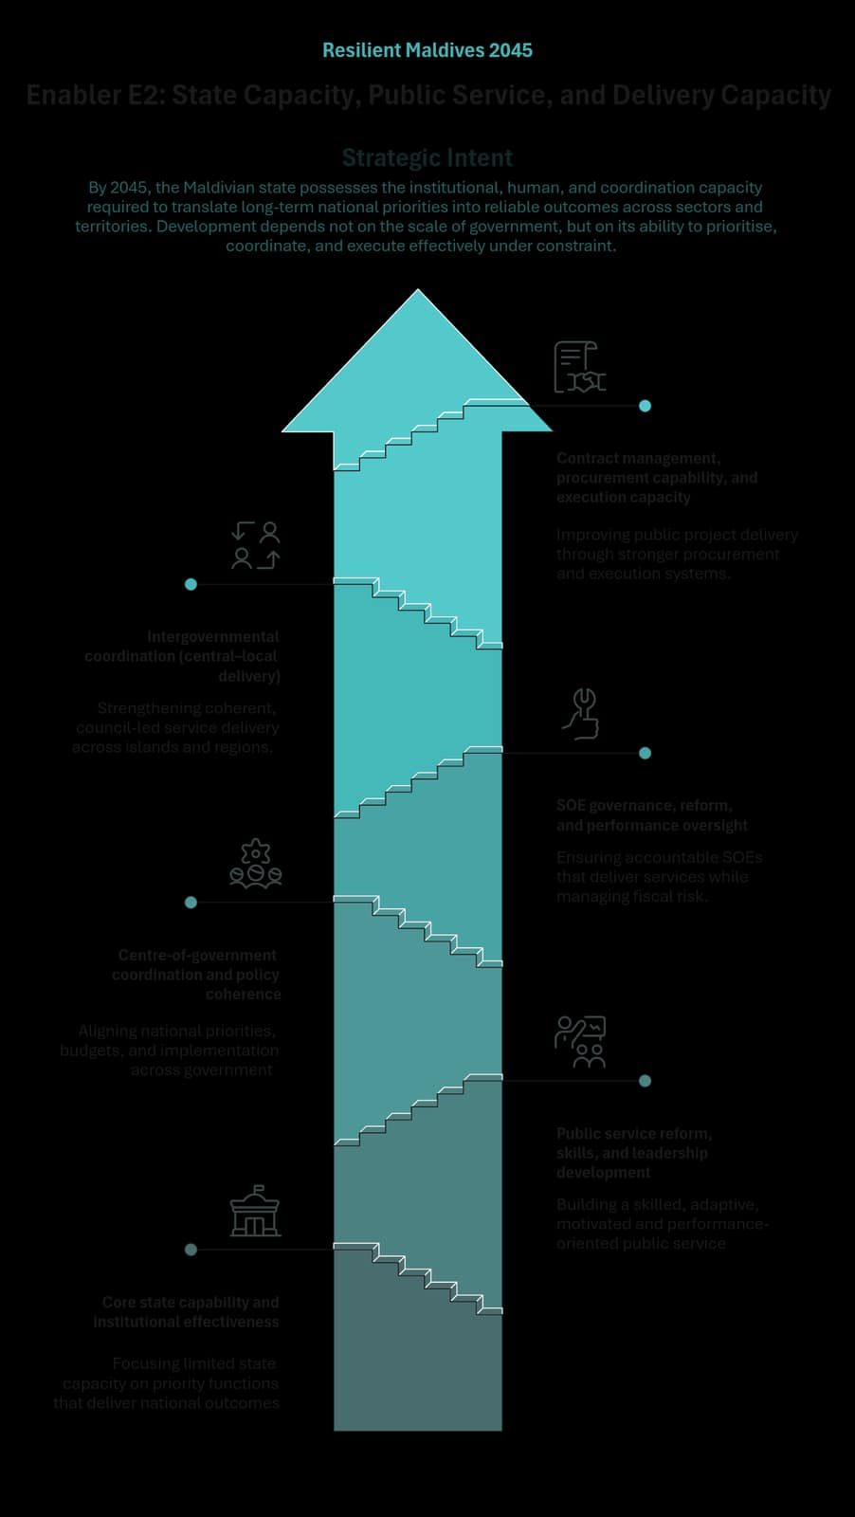
Figure 26 - E2: State Capacity, Public Service, and Delivery Capacity

Enabler Purpose and Strategic Intent

Strategic Intent
By 2045, the Maldivian state possesses the institutional, human, and coordination capacity required to translate long-term national priorities into reliable outcomes across sectors and territories. Development depends not on the scale of government, but on its ability to prioritise, coordinate, and execute effectively under constraint.

System Framing
In a small island state characterised by geographic dispersion, limited administrative depth, and fiscal constraints, delivery failure often arises from fragmented organisation, unclear roles, and weak execution discipline. Without strong coordination, accountability, and performance focus, public action risks administrative overload, inefficiency, and declining trust.

Enabler Focus
This Enabler therefore focuses on how the state organises itself to deliver policies and services, manage public resources, oversee service providers, and implement public investments with discipline and consistency. Integrity, accountability, and performance are treated as embedded properties of delivery systems, achieved through clarity of roles, aligned incentives, and execution discipline rather than institutional expansion or procedural complexity.

Enabler-Level Outcomes
Achievement of this Enabler is reflected when the following system-level outcomes are realised by 2045:
- A fit-for-purpose public administration capable of delivering priority national objectives without administrative overload.
- Coordinated government action, with clear accountability for delivery across ministries, state-owned enterprises, and levels of government.
- Reliable execution of public investments and services, reducing delays, cost overruns, and implementation failures.
- Disciplined oversight of state-owned enterprises, limiting fiscal risk while sustaining essential service provision.
- Institutional learning and adaptability, enabling continuous improvement in delivery under changing conditions.

Enabler Themes
The Enabler is delivered through the following functional themes, which together define the system architecture of this Enabler:
- Core state capability and institutional effectiveness
- Public service reform, skills, and leadership development
- Centre-of-government coordination and policy coherence
- SOE governance, reform, and performance oversight
- Intergovernmental coordination (central–local delivery)
- Contract management, procurement capability, and execution capacity

Core State Capability and Institutional Effectiveness

Functional Role
This theme ensures that core public institutions are designed and resourced to perform clearly defined mandates, with limited state capacity concentrated on functions critical to long-term national development.

Theme Outcomes
- Clear allocation of responsibilities across public institutions.
- Reduced duplication and institutional fragmentation.
- Stronger focus on outcomes and delivery performance.

Strategic Orientation (Policy Direction)
Prioritise institutional clarity and functional focus, ensuring limited administrative capacity is concentrated on high-value state functions rather than dispersed across overlapping mandates.

Public Service Reform, Skills, and Leadership Development

Functional Role
This theme strengthens the human capability of the state, recognising that a compact public service must rely on high-quality skills, leadership, and professional norms rather than scale.

Theme Outcomes
- A public service equipped to manage complexity and change.
- Strong leadership capacity at senior and middle-management levels.
- Better alignment between skills, roles, and delivery responsibilities.

Strategic Orientation (Policy Direction)
Orient public service systems toward capability development, leadership quality, and performance, with emphasis on adaptability, problem-solving, and practical delivery skills.

Centre-of-Government Coordination and Policy Coherence

Functional Role
This theme enables selective and effective coordination across government, ensuring that cross-cutting national priorities are translated into aligned action without over-centralisation or excessive coordination burdens.

Theme Outcomes
- Improved alignment between national priorities, budgets, and implementation.
- Clear ownership and accountability for delivery of priority initiatives.
- Reduced coordination failures in cross-sectoral policy areas.

Strategic Orientation
Strengthen centre-of-government functions to support strategic steering and delivery oversight for a limited number of high-priority national objectives.

SOE Governance, Reform, and Performance Oversight

Functional Role
This theme ensures that state-owned enterprises operate as reliable service delivery and commercial entities within the state system, with clear accountability, professional oversight, and disciplined management. In the Maldives’ small island context – where SOEs play a central role in infrastructure, utilities, and public services – effective SOE governance is essential to sustain service quality, contain fiscal exposure, and reinforce confidence in state delivery, without allowing SOEs to substitute for policy-making or regulatory functions.

Theme Outcomes
- Clear separation between ownership, oversight, and management roles.
- Consistent service performance and operational discipline across SOEs.
- Clear visibility and control of fiscal exposure arising from SOE activities.

Strategic Orientation
Apply a consistent, system-wide approach to SOE ownership and oversight that emphasises transparency, performance accountability, and financial sustainability. Strengthen board professionalism and management accountability, align SOE objectives with national priorities, and treat disclosure and integrity as core delivery requirements rather than compliance exercises.

Intergovernmental Coordination (Central–Local Delivery)

Functional Role
This theme ensures that local development is council-led, democratically accountable, and delivery-focused, while being coherently aligned across islands and regions within a unitary state. Local development priorities originate with elected local councils, with regional coordination mechanisms supporting alignment, scale, and coherence rather than substituting for local decision-making.

Theme Outcomes
- Clear allocation of intergovernmental roles.
- Reduced fragmentation in local development delivery.
- More consistent and timely service delivery across islands.

Strategic Orientation
Structure intergovernmental arrangements around clear vertical roles: councils as primary delivery authorities; regional bodies as non-political platforms for coordination and technical support; and central government as steward of policy, standards, financing, and equity, underpinned by predictable, rule-based fiscal arrangements.

Contract Management, Procurement Capability, and Execution Capacity

Functional Role
This theme strengthens the state’s ability to plan, procure, manage, and deliver contracts and projects, reducing execution risk in a context of limited technical and managerial capacity.

Theme Outcomes
- More predictable delivery of public projects and services.
- Fewer delays, cost overruns, and performance failures.
- Improved transparency and accountability in public contracting.

Strategic Orientation
Concentrate execution capability for complex contracts and projects, embed performance monitoring in delivery systems, and treat integrity as a design feature of procurement and contract management.

Linkage to Strategic Pillars
E2 enables the strategic pillars by ensuring that national ambitions are implemented credibly and consistently across the state:
- Pillar I – National Identity, Values and Culture: Capable public institutions that reflect civic values through effective, reliable public service.
- Pillar II – A Resilient, Productive, and Inclusive Economy: Delivery capacity to implement economic policy, infrastructure, and investment priorities efficiently.
- Pillar III – People, Well-being, and Social Systems: Consistent and equitable delivery of social services across regions and population groups.
- Pillar IV – Climate Resilience and Environmental Stewardship: Execution capability for climate adaptation, resilience, and environmental management actions.
- Pillar V – Democratic Governance, Statehood, and Public Trust: Strengthened public trust through competent, accountable, and reliable state delivery in everyday interactions.

E3: Digital Public Systems and Trust Infrastructure
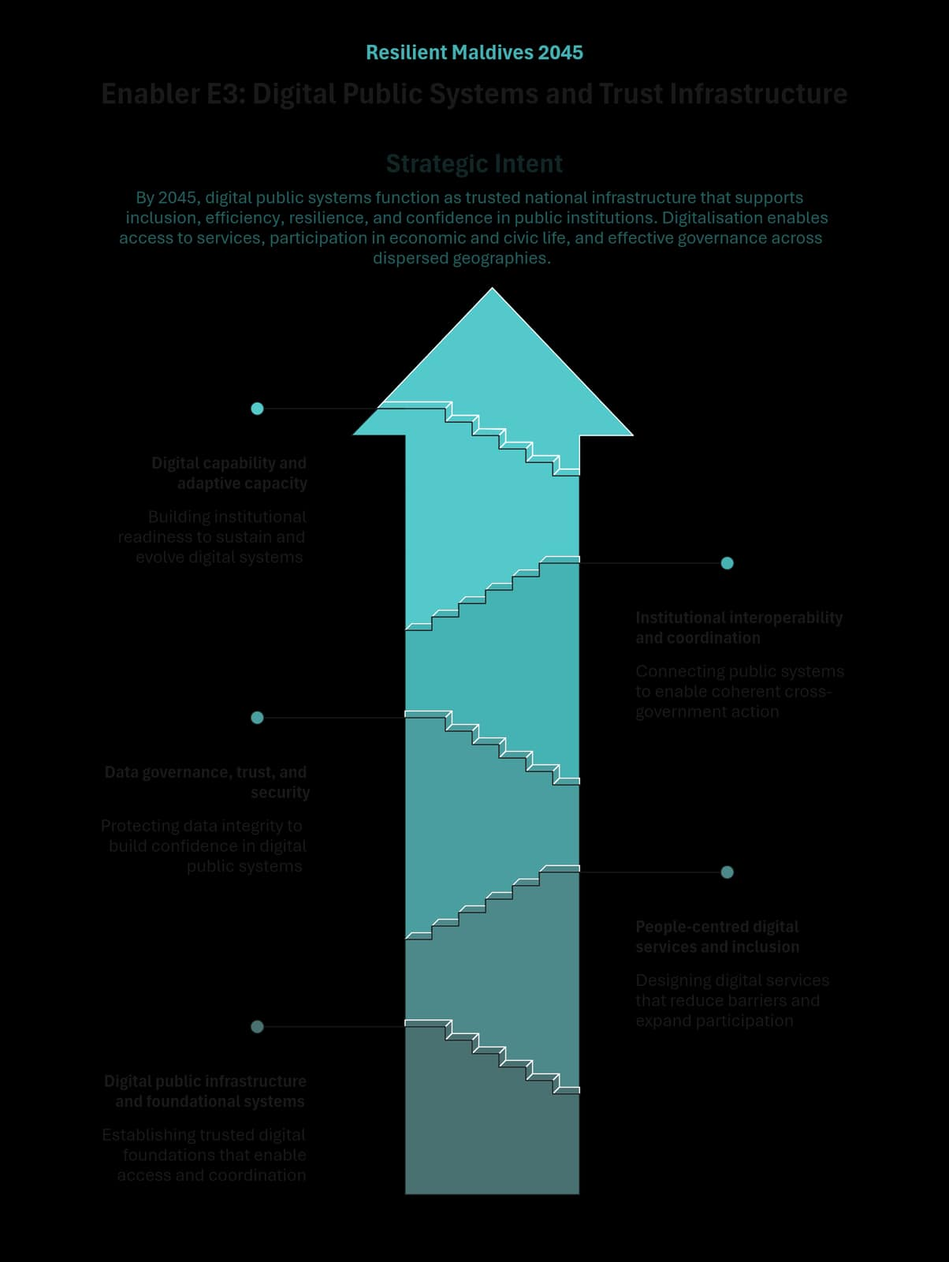
Figure 27 - E3: Digital Public Systems and Trust Infrastructure

Enabler Purpose and Strategic Intent

Strategic Intent
By 2045, digital public systems function as trusted national infrastructure that supports inclusion, efficiency, resilience, and confidence in public institutions. Digitalisation enables access to services, participation in economic and civic life, and effective governance across dispersed geographies.

System Framing
As digital systems increasingly shape how citizens experience public services and how institutions coordinate, fragmented or poorly governed digitalisation can deepen exclusion, weaken trust, and reduce state effectiveness. Without coherent system-level principles, digital investments risk duplication, interoperability failures, security vulnerabilities, and declining public confidence.

Enabler Focus
This Enabler therefore focuses on how digital public systems are designed, governed, and integrated to strengthen state capability, protect public trust, and reduce exclusion. It establishes shared conditions for reliability, security, and coherence across digital systems, while remaining adaptable to technological change and avoiding the hard-coding of specific solutions, architectures, or delivery pathways. By setting these system-level conditions, E3 enables all strategic pillars of the NDP by strengthening access, coordination, and trust across public and private interactions.

Enabler-Level Outcomes
Achievement of this Enabler is reflected when the following system-level outcomes are realised by 2045:
- Equitable digital access to public services and opportunities, reducing barriers related to geography, income, disability, or administrative complexity.
- Trusted digital interactions between citizens, businesses, and the State, strengthening confidence in public institutions and data use.
- Interoperable and coordinated public systems, enabling effective cross-government action and reducing fragmentation.
- Improved state capability and operational efficiency, through digitally enabled processes and evidence-informed decision-making.
- Adaptive digital foundations, capable of evolving with technological, societal, and environmental change.

Enabler Themes
The Enabler is delivered through the following functional themes, which together define the system architecture of this Enabler:
- Digital public infrastructure and foundational systems
- People-centred digital services and inclusion
- Data governance, trust, and security
- Institutional interoperability and coordination
- Digital capability and adaptive capacity

Digital Public Infrastructure and Foundational Systems

Functional Role
This theme establishes digital public infrastructure as a shared national foundation enabling identity, service access, transactions, and data exchange across public and private systems. Foundational digital systems are treated as public goods that must be inclusive, reliable, and interoperable to support participation across society and the economy.
By providing stable and trusted building blocks, foundational systems reduce duplication, extend service reach, and enable coordinated delivery across institutions while remaining flexible enough to evolve over time.

Outcomes
- Foundational digital systems support equitable access to services and opportunities.
- Interoperability enables coordination across institutions and sectors.
- Digital foundations remain resilient, secure, and adaptable over time.

Strategic Orientation (Policy Direction)
Digital public infrastructure is guided by nationally consistent principles of openness, interoperability, security, and inclusion. System architectures, standards, and delivery arrangements are addressed through the Implementation Plan.

People-Centred Digital Services and Inclusion

Functional Role
This theme ensures that digital systems are designed around user needs, accessibility, and dignity. Digitalisation is oriented toward simplifying interactions with the State, reducing administrative burden, and expanding access to services rather than creating new forms of exclusion or complexity.
People-centred design supports equitable participation by accounting for diverse abilities, life circumstances, and regional contexts, while reinforcing trust through transparent and understandable digital interactions.

Outcomes
- Improved accessibility and usability of public services.
- Reduced administrative burden for citizens and businesses.
- Broader participation in digital public life across regions and groups.

Strategic Orientation (Policy Direction)
Digital services prioritise accessibility, usability, and fairness. Service design approaches and delivery mechanisms are addressed through implementation planning.

Data Governance, Trust, and Security

Functional Role
This theme establishes the governance conditions under which data is collected, shared, and used responsibly to support service delivery, policy-making, and innovation. Trust, privacy, and security are treated as foundational requirements for effective digital systems and sustained public confidence.
Strong data governance enables value creation while protecting individuals and institutions from misuse, exclusion, or systemic risk, and supports evidence-informed decision-making across government.

Outcomes
- Increased public trust in digital systems and data use.
- Responsible data sharing that supports public value creation.
- Reduced risk of misuse, breaches, or system failure.

Strategic Orientation (Policy Direction)
Data governance prioritises trust, accountability, and security. Standards, safeguards, and enforcement mechanisms are addressed through the Implementation Plan.

Institutional Interoperability and Coordination

Functional Role
This theme enables coordination across public institutions by ensuring that digital systems can communicate and operate seamlessly. It reduces fragmentation, duplication, and siloed decision-making, improving the State’s ability to act coherently across sectors and levels of government.
Interoperability supports integrated service delivery, shared data use, and coordinated policy responses without requiring institutional consolidation or centralisation.

Outcomes
- Improved coordination across government institutions.
- Reduced duplication and system fragmentation.
- More coherent and timely service delivery.

Strategic Orientation (Policy Direction)
Institutional interoperability is guided by nationally consistent standards and governance principles. Technical specifications and institutional arrangements are addressed through implementation planning.

Digital Capability and Adaptive Capacity

Functional Role
This theme strengthens the capacity of public institutions and society to use, manage, and adapt digital systems over time. It emphasises institutional readiness, learning, and adaptability rather than dependence on fixed technologies or static skill sets.
Adaptive capacity ensures that digital systems continue to perform effectively as technologies, risks, and societal expectations evolve.

Outcomes
- Stronger digital capability within public institutions.
- Greater adaptability to technological and organisational change.
- Sustained performance of digital systems over time.

Strategic Orientation (Policy Direction)
Digital capability development prioritises adaptability and continuous learning. Capacity-building approaches and programmes are addressed through the Implementation Plan.

Linkage to Strategic Pillars
E3 enables the strategic pillars by providing trusted, inclusive, and interoperable digital systems:
- Pillar I: Digital access supports participation, inclusion, and social cohesion.
- Pillar II: Digital systems enhance productivity, innovation, and economic participation.
- Pillar III: Digitally enabled services improve access to health, education, and well-being.
- Pillar IV: Digital systems support data-driven resilience and environmental stewardship.
- Pillar V: Trusted digital governance strengthens state legitimacy and public trust.

E4: Innovation, Research, and Knowledge Systems
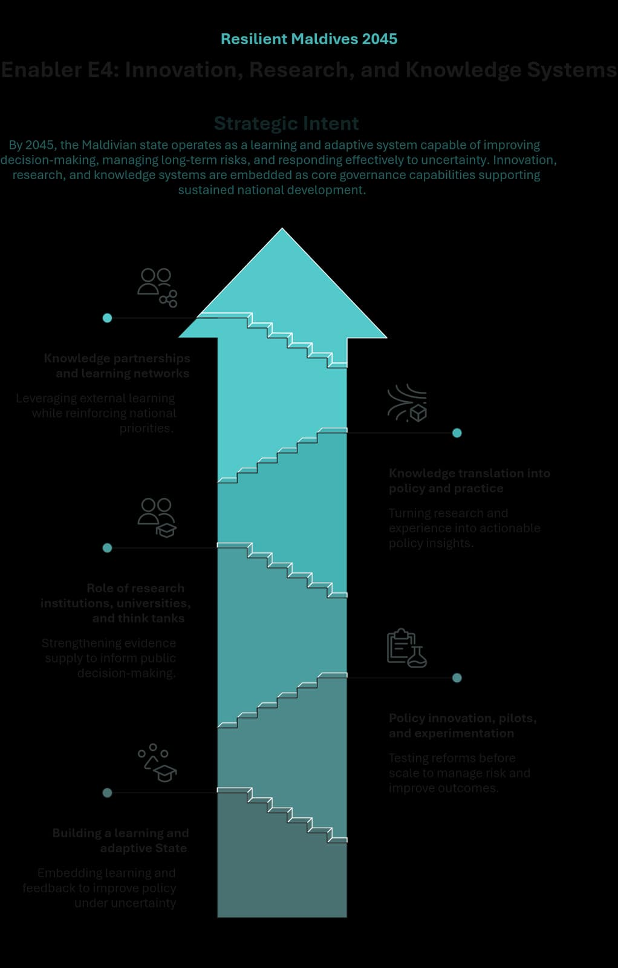
Figure 28 - E4: Innovation, Research, and Knowledge Systems

Enabler Purpose and Strategic Intent

Strategic Intent
By 2045, the Maldivian state operates as a learning and adaptive system capable of improving decision-making, managing long-term risks, and responding effectively to uncertainty. Innovation, research, and knowledge systems are embedded as core governance capabilities supporting sustained national development.

System Framing
For a small, geographically dispersed, and climate-exposed island state, rigid planning, uncritical policy transfer, and fragmented learning increase the risk of large-scale policy and delivery failure. Without structured learning and feedback, public institutions struggle to adapt, correct course, and sustain coherence over time.

Enabler Focus
This Enabler therefore focuses on how knowledge is generated, tested, interpreted, and applied in governing. It shifts research, analysis, experimentation, and learning from isolated initiatives into an integrated state learning system that informs policy formulation, implementation, and review. Over time, E4 strengthens the State’s capacity to generate, interpret, and apply knowledge relevant to Maldivian challenges, while engaging selectively with regional and global knowledge in ways that reinforce national priorities and contextual relevance.

Enabler-Level Outcomes
Achievement of this Enabler is reflected when the following system-level outcomes are realised by 2045:
- A more adaptive and resilient State, capable of responding to uncertainty and long-term risk.
- Improved quality and coherence of public policy, informed by evidence, experimentation, and implementation experience.
- Reduced incidence of large-scale policy and delivery failure, through structured learning and adjustment.
- More consistent use of evidence in governance, strengthening credibility and trust.
- Stronger domestic research and analytical capacity, contributing to long-term state capability and public debate.

Enabler Themes
The Enabler is delivered through the following functional themes, which together define the system architecture of this Enabler:
- Building a learning and adaptive State
- Policy innovation, pilots, and experimentation
- Role of research institutions, universities, and think tanks
- Knowledge translation into policy and practice
- Knowledge partnerships and learning networks

Building a Learning and Adaptive State

Functional Role
This theme embeds learning and adaptability as core properties of governance. The State operates as a learning system capable of adjusting policies, rules, and coordination arrangements as conditions evolve, rather than as a static or compliance-driven apparatus.
Learning is supported through feedback, reflection, and institutional memory, strengthening long-term performance, coherence, and resilience while maintaining continuity in national priorities.

Theme Outcomes
- Policies adapt during implementation based on evidence and experience.
- Institutional learning reduces fragmentation and repeated policy failure.
- Public decisions better manage long-term risk and uncertainty.
- Crisis preparedness and response improve through learning-based governance.

Strategic Orientation (Policy Direction)
Policy direction prioritises adaptive governance approaches that support learning and authorised adjustment within formal accountability frameworks. Learning is embedded within governance arrangements rather than dependent on individual initiative.

Policy Innovation, Pilots, and Experimentation

Functional Role
This theme enables the State to test and refine policy approaches under conditions of uncertainty before full-scale implementation. It recognises that complex challenges often require iteration during implementation rather than reliance on upfront design alone.
Experimentation supports evidence generation and learning, informing decisions on adjustment, scaling, or discontinuation while managing fiscal and institutional risk.

Theme Outcomes
- Policy assumptions are tested before full-scale commitment.
- Learning informs adjustment and scaling decisions.
- Fiscal, institutional, and delivery risks are better managed.
- Reform effectiveness improves and waste is reduced.

Strategic Orientation (Policy Direction)
Policy direction treats experimentation as a governed function of policy-making, conducted within clear institutional and fiscal guardrails. Specific mechanisms are addressed through implementation planning.

Role of Research Institutions, Universities, and Think Tanks

Functional Role
This theme strengthens the contribution of research institutions, universities, and think tanks as integral components of the national knowledge ecosystem. These institutions provide independent, policy-relevant analysis that improves policy quality and broadens understanding of complex challenges.
The focus is on strengthening linkages between research and policy needs while progressively building domestic research capability and maintaining openness to international collaboration.

Theme Outcomes
- Evidence-informed policymaking capacity is strengthened.
- Government demand for relevant research improves.
- Research more consistently informs policy design and reform.
- Domestic research capability contributes to long-term state capacity.

Strategic Orientation (Policy Direction)
Policy direction supports a system-level approach to evidence-informed policymaking that strengthens both research supply and public-sector capacity to use evidence. Institutional arrangements are addressed through implementation planning.

Knowledge Translation into Policy and Practice

Functional Role
This theme addresses the gap between knowledge generation and effective use in policy and practice. Knowledge translation enables evidence, data, and implementation experience to inform decisions across sectors and levels of government.
The emphasis is on synthesis, contextualisation, and timely interpretation, ensuring that learning informs action rather than remaining siloed.

Theme Outcomes
- Evidence is translated into decision-relevant insights.
- Policymakers and practitioners have improved access to actionable knowledge.
- Evidence more consistently informs policy and implementation.
- Institutional learning is reinforced through feedback and translation.

Strategic Orientation (Policy Direction)
Policy direction embeds knowledge translation as a core governance function within existing policy and review processes, without prescribing specific tools or procedural models at NDP level.

Knowledge Partnerships and Learning Networks

Functional Role
This theme enables learning beyond institutional boundaries through structured engagement with regional, international, and peer networks. For a small state, selective external learning strengthens institutional capability and responsiveness.
Knowledge partnerships support adaptation rather than replication, complementing domestic capacity over time.

Theme Outcomes
- External knowledge informs priority policy and delivery challenges.
- Government engagement in learning networks improves.
- External experience is adapted to Maldivian context.
- Institutional learning benefits from sustained external engagement.

Strategic Orientation (Policy Direction)
Policy direction supports purpose-driven knowledge partnerships aligned with national priorities. Partnership structures and coordination mechanisms are addressed through implementation planning.

Linkage to Strategic Pillars
E4 enables all five strategic pillars by strengthening the State’s capacity to learn, adapt, and improve decision-making over time:
- Pillar I: Supports context-responsive policy grounded in identity and values.
- Pillar II: Improves economic policy realism and responsiveness under uncertainty.
- Pillar III: Strengthens social policy and service delivery through learning and feedback.
- Pillar IV: Enables continuous adaptation of climate and environmental policy.
- Pillar V: Reinforces public trust and legitimacy through evidence-informed governance.

E5: Macro-Fiscal Stability, Public Investment, and Financing Systems
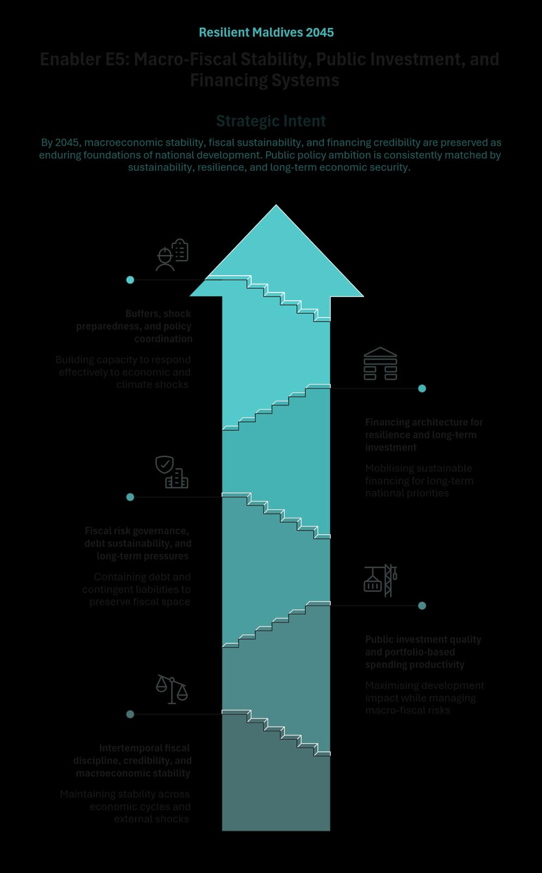
Figure 29 - E5: Macro-Fiscal Stability, Public Investment, and Financing Systems

Enabler Purpose and Strategic Intent

Strategic Intent
By 2045, macroeconomic stability, fiscal sustainability, and financing credibility are preserved as enduring foundations of national development. Public policy ambition is consistently matched by sustainability, resilience, and long-term economic security.

System Framing
In a small, open, and shock-prone economy, development outcomes depend not only on policy choices but on how fiscal policy, investment decisions, and financing strategies interact with economic cycles, foreign exchange conditions, and institutional capacity. Weak coherence across these systems can generate fiscal, external, and financial instability that undermines long-term objectives.

Enabler Focus
This Enabler therefore focuses on strengthening the coherence between macro-fiscal policy, public investment, and financing decisions so that public policy actively leans against imbalances, builds buffers during upswings, and preserves fiscal and external space. By safeguarding macroeconomic stability, E5 underpins all strategic pillars and ensures that short-term pressures do not undermine long-term national objectives.

Enabler-Level Outcomes
Achievement of this Enabler is reflected when the following system-level outcomes are realised by 2045:
- Macroeconomic stability sustained across cycles, with fiscal and external imbalances actively corrected rather than amplified.
- Strong external resilience and foreign exchange stability supporting confidence in the rufiyaa.
- Public debt sustainability preserved through prudent borrowing, risk management, and transparent fiscal frameworks.
- Public spending and investment sequenced to absorptive capacity, supporting growth without inflationary or external pressures.
- High policy credibility and institutional preparedness to manage economic and climate shocks.

Enabler Themes
The Enabler is delivered through the following functional themes, which together define the system architecture of this Enabler:
- Intertemporal fiscal discipline, credibility, and macroeconomic stability.
- Public investment quality and portfolio-based spending productivity.
- Fiscal risk governance, debt sustainability, and long-term pressures.
- Financing architecture for resilience and long-term investment.
- Buffers, shock preparedness, and policy coordination

Intertemporal Fiscal Discipline, Credibility, and Macroeconomic Stability

Functional Role
This theme anchors fiscal policy within a coordinated macroeconomic stabilisation framework alongside monetary and external-sector policies. In a small, open economy with limited buffers and high exposure to shocks, fiscal actions directly shape inflation, liquidity conditions, foreign exchange pressures, and confidence in the currency.
The functional role of this theme is to ensure that fiscal policy supports monetary and external stability rather than working at cross-purposes, by calibrating fiscal stance across the economic cycle and aligning it with monetary conditions and external constraints.

Outcomes
- Fiscal policy operates counter-cyclically, with restraint during upswings and support during downturns.
- Inflationary and external pressures arising from fiscal actions are contained.
- Fiscal stance is explicitly aligned with monetary policy and external-sector conditions
- Price and macroeconomic stability, with anchored inflation expectations and contained liquidity risks, supported by fiscally disciplined macro policy.
- External balance resilience, with fiscal and monetary policies jointly avoiding sustained pressure on foreign exchange reserves, current-account stability, and confidence in the currency.

Strategic Orientation (Policy Direction)
Fiscal policy is designed and implemented as a complementary stabilisation instrument within a coordinated fiscal–monetary–external policy framework. Counter-cyclical decision processes are informed by monetary conditions, liquidity dynamics, and foreign exchange pressures, ensuring that fiscal actions reinforce price stability, reserve adequacy, and macroeconomic credibility.

Public Investment Quality and Portfolio-Based Spending Productivity

Functional Role
This theme governs how public investment decisions are selected, sequenced, and managed to support long-term growth and resilience without generating macroeconomic instability. It treats public investment as a portfolio requiring prioritisation, sequencing, and performance discipline rather than a collection of stand-alone projects.
The theme also supports improved spatial and institutional allocation of investment decisions, ensuring alignment with absorptive capacity and regional development needs.

Outcomes
- Public investment is sequenced and scaled to absorptive capacity, limiting inflationary and foreign exchange pressures.
- Fiscal, foreign exchange, and contingent-liability risks from public and SOE-led investments are reduced.
- Climate and disaster resilience of public capital stock is strengthened.
- Investment prioritisation increasingly reflects decentralised inputs within national fiscal constraints.

Strategic Orientation (Policy Direction)
Public investment management systems are strengthened to ensure rigorous appraisal, risk screening, and sequencing. Climate resilience and lifecycle costs are systematically integrated into investment decisions, while national oversight safeguards macro-fiscal, debt, and foreign exchange stability.

Fiscal Risk Governance, Debt Sustainability, and Long-Term Pressures

Functional Role
This theme ensures that fiscal risks, public debt dynamics, and long-term pressures are identified, managed, and governed transparently. In a context of SOE activity, guarantees, and climate exposure, unmanaged risks can quickly undermine fiscal sustainability and policy credibility.
The functional role of this theme is to contain explicit and contingent liabilities within a disciplined macro-fiscal framework.

Outcomes
- Public debt follows a clearly sustainable medium- to long-term trajectory.
- Foreign-currency, refinancing, and interest-rate risks are reduced.
- Fiscal risks from guarantees, SOEs, PPPs, and blended finance are transparently identified and managed.
- Long-term fiscal pressures are anticipated and incorporated into planning.

Strategic Orientation (Policy Direction)
Debt and fiscal risk management are integrated into a coherent medium-term macro-fiscal framework. Risk identification, disclosure, and monitoring are institutionalised to reinforce transparency, investor confidence, and long-term sustainability.

Financing Architecture for Resilience and Long-Term Investment

Functional Role
This theme governs how fiscal gaps, public investments, and shocks are financed across the economic cycle. Financing choices shape debt dynamics, reserve adequacy, market confidence, and intergenerational equity, and are therefore treated as strategic instruments rather than neutral tools.
The theme establishes a coherent financing architecture that mobilises domestic and external resources in a disciplined, transparent, and growth-supportive manner.

Outcomes
- Financing strategies align with macroeconomic conditions and reserve adequacy objectives.
- Greater mobilisation of domestic institutional savings into long-term productive investment.
- Reduced reliance on short-term, rollover-intensive, and foreign-currency borrowing.
- Financing risks are priced, disclosed, and allocated transparently.

Strategic Orientation (Policy Direction)
Financing strategies are aligned with macroeconomic conditions, public investment sequencing, and long-term fiscal objectives. Concessional, long-term, and risk-sharing instruments are prioritised, while domestic capital markets are strengthened to support sustainable financing.

Buffers, Shock Preparedness, and Policy Coordination

Functional Role
This theme ensures institutional preparedness to absorb economic, external, and climate shocks without resorting to destabilising fiscal or monetary responses. It focuses on building buffers during upswings and enabling coordinated, timely responses during crises.

Outcomes
- Adequate fiscal and external buffers are available during shocks.
- Faster and more targeted policy responses to economic and climate crises.
- Stronger coordination across fiscal, monetary, SOE, and disaster-risk institutions.

Strategic Orientation (Policy Direction)
Stabilisation buffers are systematically built and protected during periods of growth. Climate and disaster risks are integrated into macro-fiscal planning, while inter-agency coordination and real-time data systems support rapid, evidence-informed crisis response.

Linkage to Strategic Pillars
E5 underpins all strategic pillars by preserving macroeconomic stability, fiscal space, and financing credibility:
- Pillar II: Enables private-sector-led growth through stable macroeconomic and financing conditions.
- Pillar III: Safeguards fiscal space for sustained social spending and service delivery.
- Pillar IV: Strengthens resilience through buffers and climate-integrated fiscal planning.
- Pillar V: Reinforces public trust through credible, disciplined, and transparent economic governance.

E6: Legal, Regulatory, and Policy Coherence
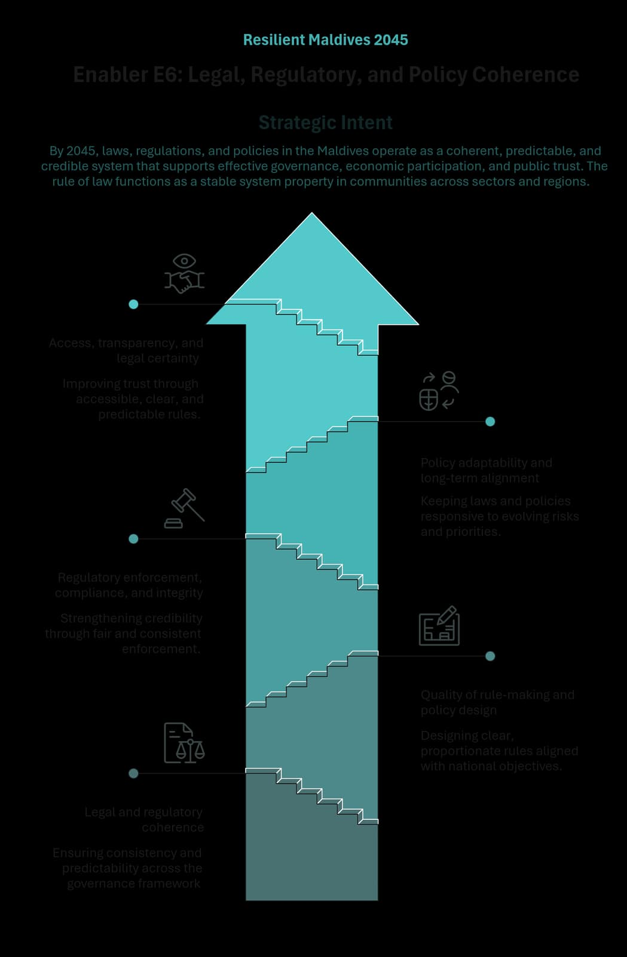
Figure 30 - E6: Legal, Regulatory, and Policy Coherence

Enabler Purpose and Strategic Intent

Strategic Intent
By 2045, laws, regulations, and policies in the Maldives operate as a coherent, predictable, and credible system that supports effective governance, economic participation, and public trust. The rule of law functions as a stable system property across sectors and regions.

System Framing
For a small, open, and rapidly changing island state, fragmented legal and policy frameworks generate uncertainty, raise compliance costs, undermine enforcement, and erode confidence among citizens, investors, and institutions. Weak alignment increases discretion, uneven application, and inconsistent outcomes.

Enabler Focus
This Enabler therefore focuses on strengthening coherence, clarity, and adaptability across the legal and regulatory system, ensuring that rules are predictable, proportionate, enforceable, and aligned with long-term national objectives. By improving how laws, regulations, and policies are designed, aligned, and applied, E6 underpins effective implementation across all strategic pillars and strengthens confidence in public authority.

Enabler-Level Outcomes
Achievement of this Enabler is reflected when the following system-level outcomes are realised by 2045:
- A coherent and predictable legal and regulatory framework that supports economic activity, social trust, and effective governance.
- Improved policy and regulatory alignment across sectors, reducing fragmentation and conflicting requirements.
- Stronger rule of law and regulatory credibility, with consistent application and enforcement.
- Enhanced institutional capacity to adapt legal and policy frameworks to emerging risks and long-term priorities.
- Greater public and investor confidence in the stability, fairness, and integrity of the governance system.

Enabler Themes
The Enabler is delivered through the following functional themes, which together define the system architecture of this Enabler:
- Legal and regulatory coherence
- Quality of rule-making and policy design
- Regulatory enforcement, compliance, and integrity
- Policy adaptability and long-term alignment
- Access, transparency, and legal certainty,

Legal and Regulatory Coherence

Functional Role
This theme ensures that laws, regulations, and policies form a coherent and internally consistent framework across sectors and levels of government. Coherence reduces ambiguity, limits conflicting obligations, and supports consistent interpretation and application of rules.
By strengthening alignment across the legal and regulatory system, this theme supports predictability, lowers compliance costs, and reinforces confidence in public authority.

Outcomes
- Legal and regulatory frameworks are internally consistent and mutually reinforcing.
- Conflicting or overlapping requirements are reduced.
- Regulatory clarity supports compliance and enforcement.
- Policy objectives are reflected coherently across instruments.

Strategic Orientation (Policy Direction)
Legal and regulatory coherence is prioritised through systematic review and alignment processes. Standards for consistency and compatibility are embedded within policy development and legislative processes, with delivery mechanisms addressed through the Implementation Plan.

Quality Of Rule-Making and Policy Design

Functional Role
This theme strengthens the quality, proportionality, and clarity of rule-making and policy design. High-quality regulation improves effectiveness, reduces unintended consequences, and ensures that rules are fit for purpose within the Maldivian context.
The focus is on evidence-informed design, clarity of obligations, and alignment with long-term development objectives.

Outcomes
- Rules and policies are clear, proportionate, and purpose-driven.
- Regulatory design reduces unnecessary burden and compliance costs.
- Policy coherence improves across the lifecycle of rule-making.
- Regulatory impacts are better understood and managed.

Strategic Orientation (Policy Direction)
Policy direction emphasises disciplined, evidence-informed rule-making practices that balance effectiveness with proportionality. Design standards and review processes are addressed through implementation planning.

Regulatory Enforcement, Compliance, and Integrity

Functional Role
This theme strengthens enforcement and compliance as system properties of governance, rather than isolated institutional functions. Effective enforcement supports fairness, credibility, and trust, ensuring that rules apply consistently across actors and sectors.
Integrity in enforcement reduces discretion, limits selective application, and reinforces the legitimacy of the regulatory system.

Outcomes
- Regulatory enforcement is consistent, fair, and credible.
- Compliance levels improve across sectors.
- Selective or uneven application of rules is reduced.
- Public confidence in regulatory integrity is strengthened.

Strategic Orientation (Policy Direction)
Enforcement approaches prioritise consistency, transparency, and proportionality. Institutional arrangements and enforcement tools are addressed through the Implementation Plan.

Policy Adaptability and Long-Term Alignment

Functional Role
This theme ensures that legal and policy frameworks remain adaptable to evolving economic, social, technological, and environmental conditions while maintaining alignment with long-term national objectives.
Adaptability reduces rigidity and enables timely adjustment, preventing outdated rules from constraining development or weakening resilience.

Outcomes
- Legal and policy frameworks adapt to emerging risks and opportunities.
- Long-term national priorities are reflected across regulatory systems.
- Policy inertia and outdated provisions are reduced.
- Regulatory systems support resilience and innovation.

Strategic Orientation (Policy Direction)
Policy direction supports structured mechanisms for review, adaptation, and alignment over time. Processes for adjustment are embedded within governance systems, with implementation details addressed separately.

Access, Transparency, and Legal Certainty

Functional Role
This theme improves access to law and policy, transparency of obligations, and certainty for citizens and businesses. Clear access to rules supports compliance, reduces dispute, and reinforces trust in public authority.
Legal certainty is essential for investment, participation, and accountable governance.

Outcomes
- Laws and regulations are accessible and understandable.
- Legal certainty improves for citizens and businesses.
- Transparency supports compliance and trust.
- Disputes and uncertainty arising from unclear rules are reduced.

Strategic Orientation (Policy Direction)
Policy direction prioritises transparency, accessibility, and clarity in legal and regulatory systems. Platforms, dissemination mechanisms, and support tools are addressed through implementation planning.

Linkage to Strategic Pillars
E6 enables the strategic pillars by providing a stable, coherent, and predictable governance framework:
- Pillar I: Supports shared norms, values, and trust in public authority.
- Pillar II: Reduces regulatory uncertainty and supports private-sector investment and productivity.
- Pillar III: Improves fairness, access, and consistency in social policy and service delivery.
- Pillar IV: Enables adaptive legal frameworks for climate and environmental resilience.
- Pillar V: Reinforces the rule of law, accountability, and public trust.

E7: Implementation, Risk Management, and Adaptive Delivery
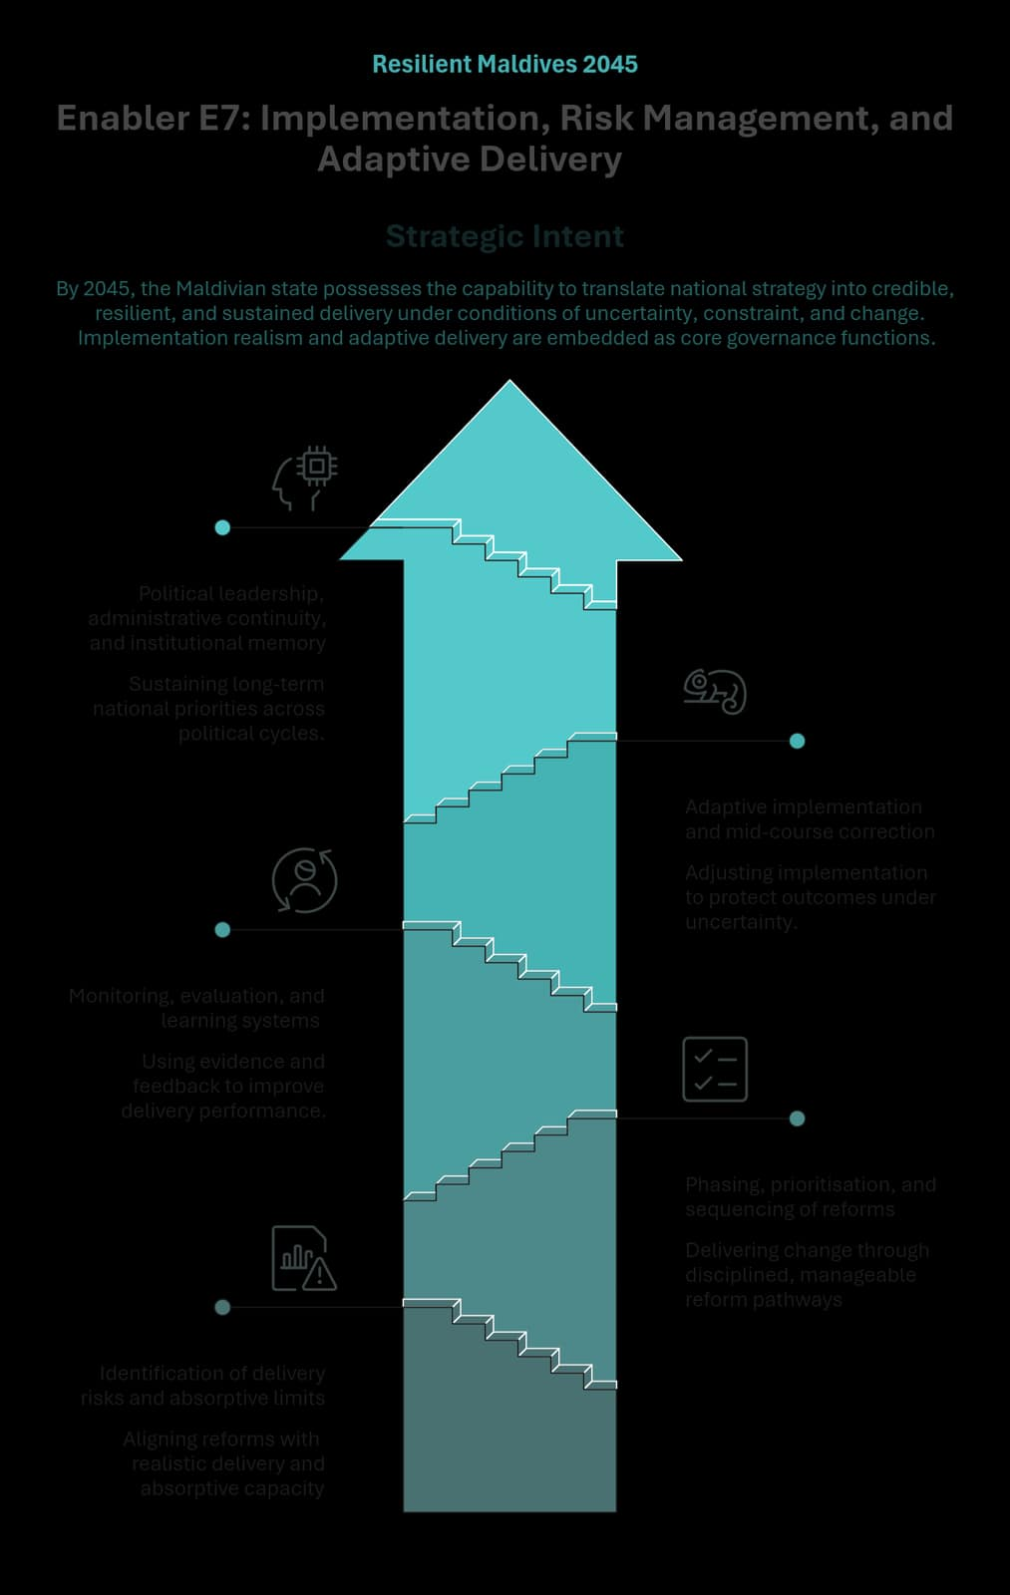
Figure 31 - E7: Implementation, Risk Management, and Adaptive Delivery

Enabler Purpose and Strategic Intent

Strategic Intent
By 2045, the Maldivian state possesses the capability to translate national strategy into credible, resilient, and sustained delivery under conditions of uncertainty, constraint, and change. Implementation realism and adaptive delivery are embedded as core governance functions.

System Framing
In a shock-exposed and capacity-constrained island state, delivery failure often arises not from weak policy intent but from unrealistic sequencing, unmanaged risk, and limited ability to adjust course. Fragmented implementation and rigid delivery models undermine outcomes, weaken fiscal discipline, and erode public trust.

Enabler Focus
This Enabler therefore focuses on strengthening delivery realism, anticipatory risk management, and authorised adaptation across the policy and investment lifecycle. By embedding implementation discipline and adaptive capability as system properties, E7 underpins effective execution across all pillars of the National Development Plan while preserving strategic intent, accountability, and coherence.

Enabler-Level Outcomes
Achievement of this Enabler is reflected when the following system-level outcomes are realised by 2045:
- Improved implementation credibility and delivery discipline, with national priorities translated into realistic and sequenced delivery pathways.
- Better prioritisation and sequencing under constraint, reducing institutional overload and unfunded mandates.
- Earlier identification and management of delivery risks, lowering the incidence of large-scale failure, delay, and waste.
- Sustained adaptive delivery across political and external volatility, protecting long-term national priorities and public trust.

Enabler-Level Themes
The Enabler is delivered through the following functional themes, which together define the system architecture of this Enabler:
- Identification of delivery risks and absorptive limits
- Phasing, prioritisation, and sequencing of reforms
- Monitoring, evaluation, and learning systems
- Adaptive implementation and mid-course correction
- Political leadership, administrative continuity, and institutional memory

Identification of Delivery Risks and Absorptive Limits

Functional Role
This theme embeds systematic consideration of delivery risk and absorptive capacity as foundational inputs to reform and investment design. It ensures that fiscal space, human resources, service delivery systems, logistics, coordination capacity, and spatial constraints are recognised early, reducing failure arising from unrealistic assumptions or fragmented responsibilities.
By surfacing delivery risks upfront, this theme supports realism, equity, and coherence in national implementation pathways.

Outcomes
- Reforms are designed within real capacity constraints.
- Delivery risks are identified early, including systemic, spatial, and external risks.
- Equity risks linked to uneven capacity or connectivity are surfaced and addressed.

Strategic Orientation (Policy Direction)
Policy direction requires delivery feasibility and absorptive capacity to inform reform design, budgeting, and sequencing at system level. Specific assessment tools and methodologies are addressed through the Implementation Plan.

Phasing, Prioritisation, and Sequencing of Reforms

Functional Role
This theme enables reforms to be delivered through deliberate phasing and prioritisation, ensuring that change occurs at a pace the system can absorb. It supports coherence by structuring reform pathways so that foundational capabilities precede scale-up and reforms reinforce rather than compete with one another.
Effective sequencing reduces institutional overload and improves the likelihood of sustained reform success.

Outcomes
- Reform sequencing improves delivery success rates.
- Resources align more effectively with priority and timing.
- Delivery burdens on frontline institutions are reduced.

Strategic Orientation (Policy Direction)
Policy direction emphasises prioritisation based on readiness, dependency order, risk reduction, public value, and equity impact. Detailed sequencing arrangements are addressed through implementation planning.

Monitoring, Evaluation, and Learning Systems

Functional Role
This theme positions monitoring, evaluation, and learning (MEL) as a governance capability that supports delivery improvement and policy review. MEL systems enable early detection of implementation challenges, understanding of outcome divergence, and informed course correction across institutions and regions.
By linking evidence and learning to decision-making, this theme strengthens accountability and continuous improvement.

Outcomes
- Performance visibility improves across the delivery system.
- Learning from implementation informs policy and delivery decisions.
- Accountability is strengthened through outcome-focused assessment.

Strategic Orientation (Policy Direction)
Policy direction embeds MEL within policy and delivery cycles, linking review and learning to decision-making and resource allocation. Indicator frameworks and reporting tools are addressed through the Implementation Plan.

Adaptive Implementation and Mid-Course Correction

Functional Role
This theme enables authorised adjustment of implementation pathways in response to uncertainty, shocks, and real-world variation. It treats adaptation as a governed feature of delivery rather than an exception, allowing course correction while preserving coherence, accountability, and policy intent.
Adaptive delivery protects outcomes under volatility without undermining discipline or trust.

Outcomes
- Policies and programmes adjust during delivery based on evidence and feedback.
- Underperforming initiatives are corrected early.
- Service continuity and equity are maintained during disruptions.

Strategic Orientation (Policy Direction)
Policy direction supports adaptive delivery through structured review and decision rules embedded in governance systems. Operational mechanisms are addressed through implementation planning.

Political Leadership, Administrative Continuity, and Institutional Memory

Functional Role
This theme safeguards delivery continuity across political and administrative transitions by strengthening institutional memory and administrative stability. It focuses on retaining knowledge, sustaining momentum, and avoiding repeated resets when leadership or personnel change.
Continuity reduces restart costs, preserves learning, and reinforces public confidence in long-term national direction.

Outcomes
- Long-term priorities are sustained across political cycles.
- Institutional memory reduces restart costs and loss of learning.
- Public trust is reinforced through continuity and reliability.

Strategic Orientation (Policy Direction)
Policy direction supports continuity through system-level arrangements that preserve institutional knowledge and delivery coherence. Specific transition and handover mechanisms are addressed through the Implementation Plan.

Linkage to Strategic Pillars
E7 enables the strategic pillars by ensuring that national priorities are deliverable, resilient, and sustained over time:
- Pillar I: Credible and equitable delivery reinforces legitimacy and cohesion.
- Pillar II: Disciplined implementation supports economic transition without destabilisation.
- Pillar III: Adaptive delivery protects service continuity and equity.
- Pillar IV: Iterative implementation enables climate actions to adjust as risks evolve.
- Pillar V: Implementation credibility and continuity strengthen public trust.

Concluding Statement: A Living National Framework to 2045
Resilient Maldives 2045: Prosperity for All is designed to serve as the Maldives’ shared long-term development reference and hold the nation steady across political cycles, external shocks, and changing social, economic, and environmental conditions. It provides a stable national direction while allowing implementation to adapt as realities change.
This National Development Plan is structured in two volumes to safeguard both credibility and usability.
- Volume I presents the National Vision and Development Framework, the Implementation Plan, a Monitoring and Evaluation (M&E) Framework, and the Financing Plan.
- Volume II comprises the Analytical Foundations and Technical Papers that support the assertions and choices presented in Volume I. It consolidates the evidence base, key assessments, and supporting analysis that inform the development models, policy choices, and trade-offs. By separating analysis from direction-setting, the Plan ensures that the national framework remains readable and accessible, while also remaining anchored in research, data, and tested reasoning.
This draft – which comprises Section I of Volume I – establishes the enduring National Vision and Development Framework. Based on extensive consultations with the people of the country and deep sectoral analyses, it sets out the strategic diagnosis, the long-term development model the Maldives is choosing, the national pillars that organise priorities, and the enabling systems required to make progress durable. In doing so, it sets a direction: outlining what the Maldives is seeking to build, the trade-offs it faces and the choices ahead in order to protect intergenerational equity, resilience, and national sovereignty.
Section I of Volume II does not include the Implementation Plan, a Monitoring and Evaluation (M&E) Framework, and the Financing Plan, which constitute Section II of Volume I. The absence of these instruments in this draft is intentional.
Implementation plans must be dictated by evidence, institutional capacity, and evolving conditions. They require detailed sequencing, delivery arrangements, and measurable milestones that must be updated as realities change. Similarly, M&E systems must define indicators, baselines, reporting responsibilities, and review processes that are practical for institutions to sustain and they must be capable of evolving as better data and stronger systems become available. Financing plans must also reflect macro-fiscal realities, investment pipelines, and changing cost structures over time.
For these reasons, the finalisation of the National Vision and Development Framework must precede the development of the Implementation Plan, M&E Framework and the Financing Plan.
With the completion of the Section I – the National Vision and Development Framework, the Maldives now holds a map and a set direction on the compass. Section II will lay out the journey on the map for setting of the ship.

ANNEXes

Annex I:
Illustrative Regional Governance Model for Coordinated Development

Disclaimer and Purpose of the Annex
This annex presents an illustrative regional governance model to support the strategic governance principles set out in Section 5.5. of the National Development Plan. It is included to demonstrate how coordinated decentralisation and multi-island development challenges could be addressed during implementation, while maintaining the integrity of a unitary state and central fiscal discipline.
The model presented in this annex does not constitute a binding institutional design, legal framework, or implementation decision under the National Development Plan. Detailed institutional arrangements, sequencing, and operational mechanisms will be developed through subsequent policy, legislative, and consultative processes as part of the Implementation Plan.
The inclusion of this annex is intended to inform discussion, support coherence across national, regional, and local development functions, and provide a conceptual reference for future implementation planning.

Rationale
Over the past decade, the Maldives has strengthened administrative decentralisation through elected local councils, enhancing local representation and responsiveness. At the same time, the nature of development challenges facing the country has evolved. Many priority issues, such as urban infrastructure and housing, transport connectivity, waste management, specialised health and education services, and climate adaptation, operate at scales larger than individual islands.
Under current arrangements, planning and investment remain fragmented. Local councils plan largely in isolation, while public investment is managed centrally through the national budget and the Public Sector Investment Programme (PSIP), primarily on a project-by-project basis. There is no structured mechanism to aggregate, prioritise, and sequence investments across island clusters. This fragmentation has contributed to stop–start infrastructure delivery, duplication and inefficiencies, weak alignment between plans and budgets, and increasing fiscal pressure in a constrained debt environment.
The Regional Governance Model responds to these challenges by strengthening coordination across decentralised actors while preserving the unitary structure of the state, existing fiscal decentralisation at local level, and central control over fiscal risk.

Core Design of the Model
The Regional Governance Model introduces a structured coordination and investment programming mechanism operating between national government and local councils. Its purpose is to improve how development across island clusters is planned, prioritised, sequenced, and linked to national investment systems.
At the centre of the model is a regional coordination function with a technocratic mandate to:
- coordinate planning across councils within a region;
- identify, prioritise, and sequence multi-island initiatives;
- develop a coherent regional investment pipeline aligned with approved plans; and
- serve as the formal interface between councils and national institutions on regional development.
The model does not create a new tier of government, does not devolve regional budgets, and does not replace local councils as service providers. Regions do not spend public funds; they shape how public investment is organised and sequenced.
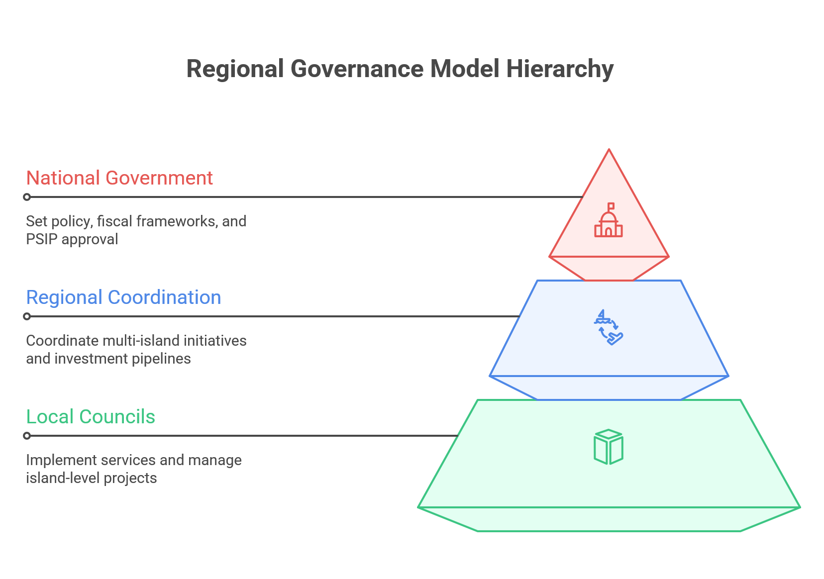

Governance and Decision-Making Logic
The model establishes a clear allocation of roles across levels of government:
- National level: responsible for policy, fiscal frameworks, budget ceilings, PSIP approval, borrowing, and management of fiscal risk.
- Regional level: responsible for coordination, prioritisation, sequencing, and investment programming for multi-island and regionally significant initiatives.
- Local level: responsible for implementation, service delivery, and operations and maintenance at island level.
Decision-making authority follows scale, impact, and fiscal risk. Strategic or high-risk investments are determined at national level; multi-island and regionally significant initiatives are coordinated at regional level; and island-level projects and services remain within the authority of local councils. This tiered logic is a fixed feature of the model.

Investment Domains and Fiscal Authority
The Regional Governance Model differentiates fiscal authority according to the nature of development investments:
- Strategic National Investments – projects and programmes of national significance with economy-wide impacts or high fiscal exposure, are planned, financed, and governed centrally. These investments are protected across political cycles and are not subject to regional prioritisation mechanisms.
- Regional and multi-island development investments – including infrastructure and services that require scale and coordination across islands, are centrally financed but regionally coordinated. Regional bodies aggregate priorities, sequence investments, and structure pipelines, while fiscal authority and budget control remain at national level.
- Island-level development and local infrastructure – particularly investments that primarily serve individual islands, continue to be supported through existing mechanisms of fiscal decentralisation. Local councils retain decision-making authority over these investments and manage block grants and other transfers in line with national accountability frameworks.
This differentiated approach preserves local autonomy where proximity and responsiveness matter most, while ensuring that larger-scale investments with systemic fiscal implications are managed in a coordinated and fiscally disciplined manner.

Fiscal Intergovernmental Framework and Investment Programming
The Regional Governance Model is supported by a Fiscal Intergovernmental Framework (FIF) that aligns responsibilities, planning authority, and public investment decisions across levels of government within a centrally managed public finance system.
A key instrument under this framework is the Regional Development Investment Programme (RDIP). RDIPs are rolling, multi-year, prioritised pipelines of regional and multi-island initiatives that are:
- aligned with approved spatial, urban, and sectoral plans;
- fiscally constrained and indicative, rather than entitlement-based; and
- used to structure and inform PSIP prioritisation.
Through RDIPs, regional development priorities are systematically linked to national budgeting and investment decisions, improving sequencing, completion, and value for money.

Contribution to the Governance Model
The Regional Governance Model does not reverse decentralisation; it reforms how decentralisation functions in practice. It preserves elected local councils as the foundation of local governance, strengthens coordination across islands for services and infrastructure that require scale, and improves alignment between plans and budgets under tight fiscal constraints.
By shifting the system from isolated decentralisation to coordinated decentralisation, the model provides a governance and financing framework better suited to a small island state with limited institutional capacity and fiscal space, and critical to delivering long-term national priorities under the National Development Plan.
The Regional Governance Model also operationalises the core principles of the Governance and Institutional Model. It strengthens strategic stewardship by creating a structured mechanism to translate long-term national priorities into sequenced regional investments. It enhances institutional coherence by clarifying roles and decision-making authority across national, regional, and local levels within a unitary state. By embedding coordination and investment programming into routine public sector processes, the model supports continuity across political cycles, improves accountability for results, and reinforces trust in the state’s ability to deliver complex, cross-cutting development outcomes.

Annex II:
Spatial Reference for Policy Alignment with the National Urban Policy (Non-Exhaustive)

Purpose of this Annex
This annex provides an explicit reference point for alignment between the National Development Plan (NDP) and the National Urban Policy, adopted under the Urban Development Act (Act No. 28/2024), which was developed in parallel with the preparation of the NDP.
The purpose of this annex is to:
- recognise spatial structures and classifications already adopted under the National Urban Policy,
- support coherence across national, regional, and sectoral planning and investment decisions, and
- ensure transparent alignment between the NDP and existing statutory policy instruments.
This annex does not form part of the National Spatial Development Framework (Chapter 6) and does not establish, amend, or supersede any spatial regions, urban centres, boundaries, thresholds, or governance arrangements defined under the National Urban Policy or its associated instruments.

Recognition of the National Urban Policy Spatial Framework
At the time of preparation of the NDP, the National Urban Policy establishes a polycentric urban and settlement framework for the Maldives, organised around differentiated urban regions, urban centres, and supporting island clusters, based on service viability, functional catchments, connectivity, and environmental constraints.
For the purposes of alignment with the NDP:
- The spatial regions and urban centres identified under the National Urban Policy are recognised as the prevailing spatial policy context.
- Their definitions, classifications, boundaries, and functional roles remain governed exclusively by the National Urban Policy and relevant statutory instruments, and not by this NDP.
- Recognition in this annex does not confer constitutional, legislative, or permanent status on the current configuration within the NDP.

Recognised Urban Areas
(as defined under the National Urban Policy at the time of NDP preparation)
The following urban areas are recognised for alignment purposes, as proposed under the National Urban Policy, including but not limited to:
 | Urban Area | Urban Classification
1 | Southern Integrated Development Zone | Urban Region / Zone
2 | Northern Integrated Development Zone | Urban Region / Zone
3 | Greater Malé Urban Region | Metropolitan
4 | R. Ugoofaaru | Urban Centre
5 | R. Dhuvaafaru | Urban Centre
6 | B. Eydhafushi | Urban Centre
7 | Lh. Naifaru | Urban Centre
8 | A.Dh. Mahibadhoo | Urban Centre
9 | F. Nilandhoo | Urban Centre
10 | Dh. Kudahuvadhoo | Urban Centre
11 | L. Fonadhoo | Urban Centre

The urban centres function as:
- regional or sub-regional service anchors,
- focal points for higher-order social and economic infrastructure, and
- hubs within shared service catchments and island clusters, in accordance with the roles and classifications assigned under the National Urban Policy.

Relationship to the National Spatial Development Framework (Chapter 6)
The National Spatial Development Framework (Chapter 6 of the NDP) establishes national-level principles, intended outcomes, and spatial logic, including:
- equity as access rather than uniformity,
- service viability through shared catchments,
- differentiated settlement pathways,
- connectivity as a national access system, and
- resilience through redundancy and ecological limits.
Accordingly:
- The NDP does not restate or codify regional boundaries, urban hierarchies, or planning instruments contained in the National Urban Policy.
- Alignment between the NDP and the National Urban Policy is assessed based on consistency with national principles and outcomes, rather than identical spatial delineations or implementation mechanisms.
- The National Urban Policy operationalises the spatial logic of the NDP through sector-specific tools, plans, and regulations.

Future Review and Adaptation
Spatial regions, urban centres, and settlement classifications may evolve over time in response to demographic change, environmental risk, infrastructure development, or policy reform.
Such evolution is anticipated and supported under the NDP, provided that future revisions to the National Urban Policy and related instruments remain consistent with the principles and national development objectives articulated in Chapter 6.

